**A**

**Report On**

**Full Stack Development**

Submitted

In partial fulfilment

For the award of the Degree of B. Tech

Submitted By: L.Ramya Submitted To:

**Department of Computer Science and Engineering**

Candidate’s Declaration

(Name and Signature of Candidate)

Counter Signed By

**ACKNOWLEDGEMENT**

I take this opportunity to express my profound gratitude and deep regards to our mentors for their exemplary guidance, monitoring and constant encouragement throughout the course of this project. The blessing, help and guidance given by them time to time shall carry me a long way in the journey of life on which I am about to embark. The project helped me learn how to do proper Research and I learned about many new things while doing the project. Lastly, I thank almighty, my parents and friends for their constant encouragement without which this project would not be possible.

H.O.D(Computer Science Department)

**TABLE OF CONTENTS**

|  |  |  |  |  |  |
| --- | --- | --- | --- | --- | --- |
|  | | TITLE | | PG NO | |
| 1 | | INTRODUCTION | | 6 | |
|  | | 1.1 WEB DEVELOPMENT | | 6 | |
|  | | 1.2 WEB SITE | | 7 | |
|  | | 1.3 WEB PAGE | | 9 | |
| 2 | | FRONTEND AND BACKEND | | 10 | |
|  | | 2.1 TECHNOLOGY RELATED TO FULL STACK | | 10 | |
|  | | 2.1.1 FRONTEND | | 10 | |
|  | | 2.1.2 FRONTEND LANGUAGES | | 10 | |
|  | | 2.1.3 FRONTEND FRAMEWORKS AND LIABRARIES | | 11 | |
|  | | 2.2 BACKEND | | 11 | |
|  | | 2.2.1 BACKEND TOOLS | | 12 | |
| 3 | | STEPS TO CREATE WEBSITE | | 13 | |
|  | | 3.1 UI DEVELOPMENT | | 13 | |
|  | | 3.1.1 HTML | | 14-20 | |
|  | | 3.1.2 CSS | | 20-30 | |
|  | | 3.1.3 BOOTSTRAP | | 30-34 | |
|  | | 3.2 SCRIPTING | | 35 | |
|  | | 3.2.1 SERVER-SIDE SCRIPTING | | 35-36 | |
|  | | 3.2.2 CLIENT-SIDE SCRIPTING | | 36-37 | |
|  | | 3.2.3 SCRIPTING LANGUAGES | | 37-42 | |
|  | | 3.3 DATABASE | | 42 | |
|  | | 3.4 MY SQL | | 43-45 | |
| 4 | | REQUIREMENTS | | 46 | |
|  | | 4.1 HARDWARE REQUIREMENTS | | 46 | |
|  | | 4.2 SOFTWARE REQUIREMENTS | | 46 | |
| 5 | | DATA FLOW DIAGRAMS | | 47-49 | |
| 6 | | PROJECT | | 50 | |
| 7 | | CODES AND OUTPUTS | | 51-114 | |
| 8 | | MAINTAINACE | | 115 | |
| 9 | | FUTURE SCOPE AND ENHANCMENT | | 116 | |
| 10 | | CONCLUSION | | 117 | |

**CHAPTER-1**

**FULL STACK WEB DEVELOPMENT**

**1.1 INTRODUCTION:**

Web development has become one of the most innovative and important areas of the IT industry. The advancements in the realm of dynamic content have enabled us to buy and sell products on the Internet, share our daily lives (for better or worse) with all of our friends, and create complex International banking and trading websites. It was not long ago when the idea of dynamically storing and providing content through the Internet was an unrealistic concept – certainly in terms of modern usage at least. Primarily through the advancement of databases like MySQL and server-side programming languages like Perl, Ruby, and most significantly PHP, dynamic and responsive websites have become standard and are expected by consumers. The amount of knowledge and skill-set diversity that a modern web developer must have is significant, though the process is much more manageable than it seems at first glance. Let’s take a look at what a dynamic website actually is from a technology standpoint and then investigate what role each of these technologies play.

**1.1.2 A Basic Full-Stack Document Request Sequence**:

The following are the bare bones steps for providing dynamic content to the client:

* Client requests a PHP document from the server (the HTML is within this file)
* PHP pulls the blog entries from the database.
* PHP inserts the records into your HTML code.
* PHP then serves the PHP document to the client.
* Client receives the PHP document.
* Client’s browser loads the HTML mark-up and establishes the Document Object Model (DOM)
* Client’s browser runs any client-side scripts (CSS, JavaScript, jQuery)
* The website request process is complete.

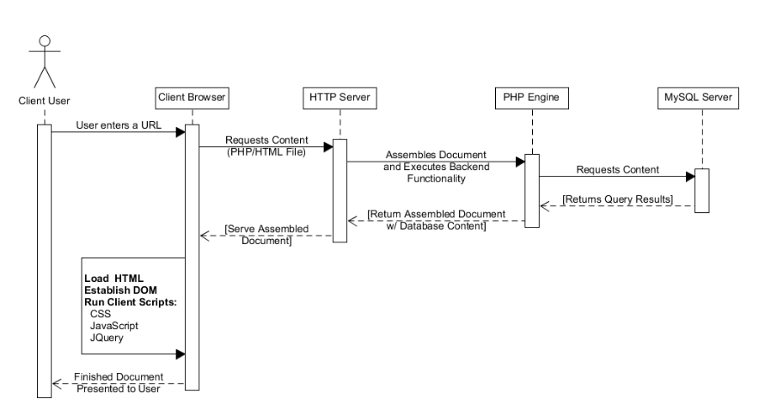

Fig: 1.1.2

The advantage of being a full stack web developer is:

* You can master all the techniques involved in a development project
* You can make a prototype very rapidly
* You can provide help to all the team members
* You can reduce the cost of the project
* You can reduce the time used for team communication
* You can switch between front and back end development based on requirements
* You can better understand all aspects of new and upcoming technologies

Disadvantages

* The solution chosen can be wrong for the project
* The solution chosen can be dependent on developer skills
* The solution can generate a key person risk
* Being a full stack developer is increasingly complex

**1.2 WEB-DEVELOPMENT**

Web development is a broad term for the work involved in developing a web site for the Internet (World Wide Web) or an intranet (a private network). Web development can range from developing the simplest static single page of plain text to the most complex web-based internet applications, electronic businesses, and social network services. A more comprehensive list of tasks to which web development commonly refers, may include web engineering, web design, web content development, client liaison, client-side/side scripting, web server and network security configuration, and e-commerce development. Among web professionals, "web development" usually refers to the main non-design aspects of building web sites: writing mark-up and coding. Most recently Web development has come to mean the creation of content management systems or CMS. These CMS can be made from scratch, proprietary or open source. In broad terms the CMS acts as middleware between the database and the user through the browser. A principle benefit of a CMS is that it allows non-technical people to make changes to their web site without having technical knowledge.

For larger organizations and businesses, web development teams can consist of hundreds of people (web developers) and follow standard methods like Agile methodologies while developing websites. Smaller organizations may only require a single permanent or contracting developer, or secondary assignment to related job positions such as a graphic designer or information systems technician. Web development may be a collaborative effort between departments rather than the domain of a designated department. There are three kind of web developer specialization: front-end developer, back-end developer, and full-stack developer.

**1.2.1 WEB-SITE:**

A website is a collection of related web pages, including multimedia content, typically identified with a common domain name, and published on at least one web server. A website may be accessible via a public Internet Protocol (IP) network, such as the Internet, or a private local area network (LAN), by referencing a uniform resource locator (URL) that identifies the site.

Websites have many functions and can be used in various fashions; a website can be a personal website, a commercial website for a company, a government website or a non-profit organization website. Websites are typically dedicated to a particular topic or purpose, ranging from entertainment and social networking to providing news and education. All publicly accessible websites collectively constitute the World Wide Web, while private websites, such as a company's website for its employees, and are typically a part of an intranet.

Web pages, which are the building blocks of websites, are documents, typically composed in plain text interspersed with formatting instructions of Hypertext Mark-up Language (HTML, XHTML). They may incorporate elements from other websites with 10 suitable mark-up anchors. Web pages are accessed and transported with the Hypertext Transfer Protocol (HTTP), which may optionally employ encryption (HTTP Secure, HTTPS) to provide security and privacy for the user. The user's application, often a web browser, renders the page content according to its HTML mark-up instructions onto a display terminal.

Hyperlinking between web pages conveys to the reader the site structure and guides the navigation of the site, which often starts with a home page containing a directory of the site web content. Some websites require user registration or subscription to access content. Examples of subscription websites include many business sites, news websites, academic journal websites, gaming websites, file-sharing websites, message boards, web-based email, social networking websites, websites providing real-time stock market data, as well as sites providing various other services. As of 2016 end users can access websites on a range of devices, including desktop and laptop computers, tablet computers, smartphones and smart TVs.

A web site consists of web pages which are interconnected to each other and contain various data and functionalities.

**1.3 WEB-PAGE:**

A web page, or webpage, is a document that is suitable for the World Wide Web and web browsers. A web browser displays a web page on a monitor or mobile device. The web page is what displays, but the term also refers to a computer file, usually written in HTML or comparable mark-up language. Web browsers coordinate the various web resource elements for the written web page, such as style sheets, scripts, and images, to present the web page.

Typical web pages provide hypertext that includes a navigation bar or a sidebar menu to other web pages via hyperlinks, often referred to as links.

On a network, a web browser can retrieve a web page from a remote web server. On a higher level, the web server may restrict access to only a private network such as a corporate intranet or it provides access to the World Wide Web. On a lower level, the web browser uses the Hypertext Transfer Protocol (HTTP) to make such requests.

A static web page is delivered exactly as stored, as web content in the web server's file system, while a dynamic web page is generated by a web application that is driven by server-side software or client-side scripting. Dynamic website pages help the browser (the client) to enhance the web page through user input to the server.

**CHAPTER 2**

**FRONTEND AND BACKEND**

* 1. **Technology related to full stack development:**

**2.1.1Frontend:**

It is the visible part of website or web application which is responsible for user experience. The user directly interacts with the front-end portion of the web application or websites.

**2.1.2 Frontend Languages:** The front-end portion is built by using some languages which are discussed below:

* **HTML:** HTML stands for Hyper Text Mark-up Language. It is used to design the front-end portion of web pages using mark-up language. HTML is the combination of Hypertext and Mark-up language. Hypertext defines the link between the web pages. The mark-up language is used to define the text documentation within tag which defines the structure of web pages.
* **CSS:** Cascading Style Sheets, fondly referred to as CSS, is a simply designed language intended to simplify the process of making web pages presentable. CSS allows you to apply styles to web pages. More importantly, CSS enables you to do this independent of the HTML that makes up each web page.
* **JAVASCRIPT:** JavaScript is a famous scripting language used to create the magic on the sites to make the site interactive for the user. It is used to enhancing the functionality of a website to running cool games and web-based software.

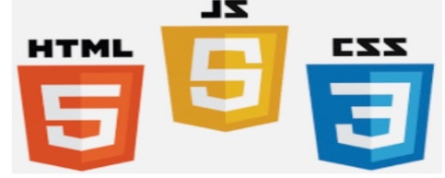

**Fig2.1.2.**

**2.1.3 Front End Frameworks and Libraries:**

* **AngularJS:** Angular is a JavaScript open source front-end framework that is mainly used to develop single page web applications (SPAs). It is a continuously growing and expanding framework which provides better ways for developing web applications. It changes the static HTML to dynamic HTML. It is an open source project which can be freely used and changed by anyone. It extends HTML attributes with Directives, and data is bound with HTML.
* **React.js:** React is a declarative, efficient, and flexible JavaScript library for building user interfaces. ReactJS is an open-source, component-based front-end library responsible only for the view layer of the application. It is maintained by Facebook.
* **Bootstrap:** Bootstrap is a free and open-source tool collection for creating responsive websites and web applications. It is the most popular HTML, CSS, and JavaScript framework for developing responsive, mobile-first web sites.
* **jQuery:** jQuery is an open source JavaScript library that simplifies the interactions between an HTML/CSS document, or more precisely the Document Object Model (DOM), and JavaScript. Elaborating the terms, jQuery simplifies HTML document traversing and manipulation, browser event handling, DOM animations, Ajax interactions, and cross-browser JavaScript development.
* **SASS:** It is the most reliable, mature and robust CSS extension language. It is used to extend the functionality of an existing CSS of a site including everything from variables, inheritance, and nesting with ease.

Some other libraries and frameworks are: Semantic-UI, Foundation, Materialize,

Backbone.js, Express.js, Ember.js etc.

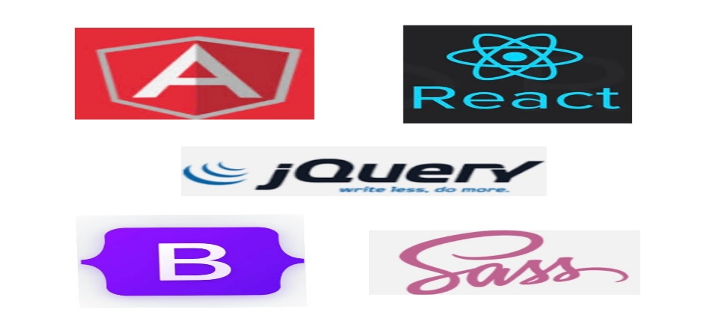

**Fig 2.1.3.**

**2.2Back End:**

While front end development centres on every aspect that users interact with, the back-end development handles everything that is appearing behind the scenes. It provides the necessary support to the front-end development. While PHP, Python, Ruby, etc. are included in back end programming languages. While you may not see many jobs seeking out especially for backend developers, rather you do see a job listed as PHP developers, Ruby developers, etc. This is because the knowledge of a particular language is an important factor, wholly deciding if a candidate is fit for the specific job title.

**2.2.1 Back end Tools:**

* **Web Servers**

Web servers are computer programs that store, process and deliver web pages to the users. The most popular ones include Apache (an open-source web server which is currently used by 50% of all websites) and NGINX which is good for reverse proxying, caching, load balancing and media streaming processes.

* **Database Management Systems**

A Database Management System (DBMS) is a collection of programs that enables its users to access a database, manipulate, interpret and represent data. MySQL is the world’s most popular open-source relational database. It’s not only accessible but also free. Its ease of setup and speedy performances make it a favourite among many backend developers. On the other hand, MongoDB is an open-source NoSQL database system which is closely associated with a JavaScript-based set of technologies like Express’s, AngularJS, and NodeJS.

**CHAPTER-3**

**THE STEPS TO CREATE A WEBSITE:**

Creating a web site requires multiple steps which includes the following:

* Creating a UI (User Interface)
* Scripting (Both at server end and client end)
* Creating a backend or database

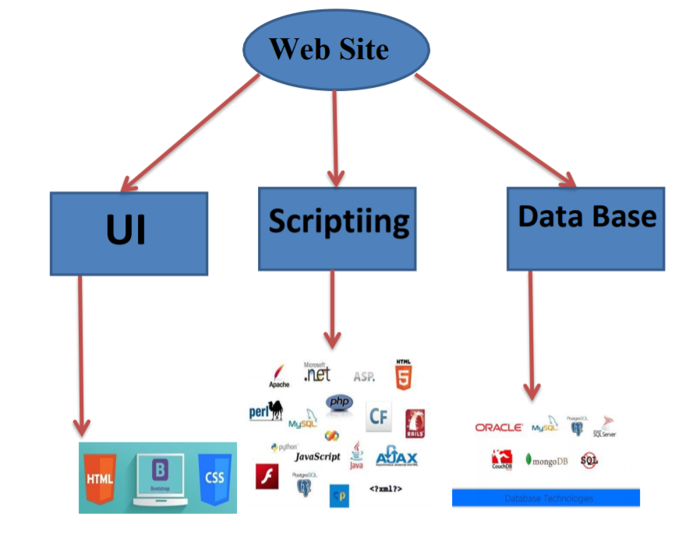

Fig: 3

**3.1 UI DEVELOPMENT**

Technologies that are mostly used to develop a User Interface are:

* HTML
* CSS
* Bootstrap

**3.1.1 HTML**

Hypertext Mark-up Language (HTML) is the standard mark-up language for creating web pages and web applications. With Cascading Style Sheets (CSS) and JavaScript it forms a triad of cornerstone technologies for the World Wide Web. Web browsers receive HTML documents from a webserver or from local storage and render them into multimedia web pages. HTML describes the structure of a web page semantically and originally included cues for the appearance of the document.

HTML elements are the building blocks of HTML pages. With HTML constructs, images and other objects, such as interactive forms, may be embedded into the rendered page. It provides a means to create structured documents by denoting structural semantics for text such as headings, paragraphs, lists, links, quotes and other items. HTML elements are delineated by tags, written using angle brackets. Tags such as <img/> and <input/> introduce content into the page directly. Others such as <p>…</p> surround and provide information about document text and may include other tags as such elements. Brower’s do not display the HTML tags, but use them to interpret the content of the page.

HTML can embed programs written in a scripting language such as JavaScript which affect the behaviour and content of web pages. Inclusion of CSS defines the look and layout of content. The World Wide Web Consortium (W3C), maintainer of both the HTML and the CSS standards, has encouraged the use of CSS over explicit presentational HTML since 1997.

Another important component is the HTML document type declaration, which triggers standards mode rendering

The following is an example of the classic Hello world program, a common test employed for comparing programming languages, scripting languages and mark-up languages. This example is made using 9 lines of code:

General Syntax of HTML

|  |
| --- |
| <!DOCTYPE html>  <head>  </head>  <body>  <p>HELLO WORLD!</p>  </body>  </html> |

Fig:3.1.1

(The text between <html> and </html> describes the web page, and the text between <body>

And </body> is the visible page content. The mark-up text "<title>" This is a title "</title> defines the browser page title.)

The Document Type Declaration is for HTML5. If a declaration is not included, various browsers will revert to "quirks mode" for rendering.

Different of Tags of HTML

As told earlier, HTML is a markup language and makes use of various tags to format the content. These tags are enclosed within angle braces . <Tag Name> Except few tags, most of the tags have their corresponding closing tags. For example, <html> has its closing tag <html> and <body> tag has its closing tag </body> tag etc.

|  |  |
| --- | --- |
| **Tag** | **Description** |
| <!DOCTYPE…...> | This tag defines the document type and HTML version. |
| <html> | This tag encloses the complete HTML document and mainly comprises of document header which is represented by <head>….</head> and  Document body which is represented by <body>…</body> tags |
| <head> | This tag represents the document's header which can keep other HTML tags like <title>,<link> etc. |
| <title> | The <title> tag is used inside the <head> tag to mention the document title. |
| <body> | This tag represents the documents body which keeps other HTML tags  Like <h1>,<div>,<p> etc. |
| <h1> | This tag represents the heading. |
| <p> | This tag represents a paragraph. |

* Use the HTML <table> element to define a table
* Use the HTML <tr> element to define a table row
* Use the HTML <td> element to define a table data
* Use the HTML <th> element to define a table heading
* Use the HTML <caption> element to define a table caption
* Use the CSS border property to define a border
* Use the CSS border-collapse property to collapse cell borders
* Use the CSS padding property to add padding to cells
* Use the CSS text-align property to align cell text
* Use the CSS border-spacing property to set the spacing between cells
* Use the colspan attribute to make a cell span many columns
* Use the rowspan attribute to make a cell span many rows
* Use the id attribute to uniquely define one table

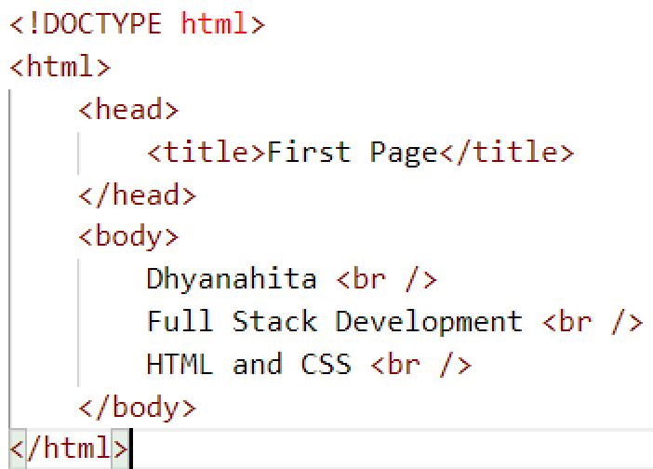

Fig:3.1.2

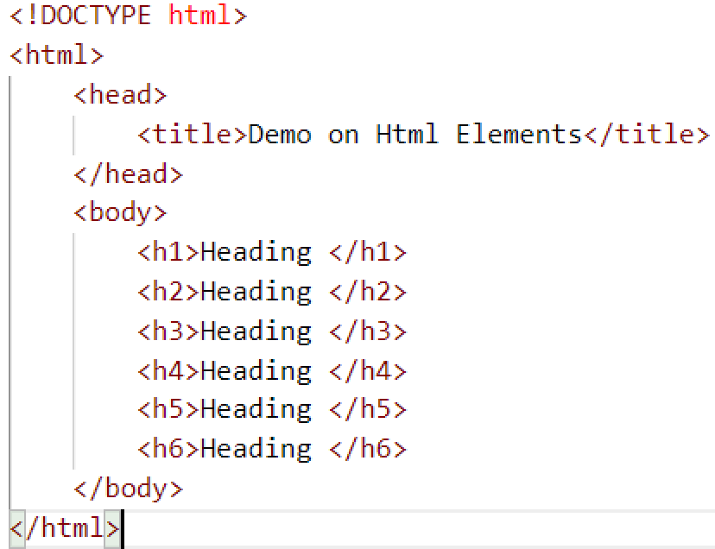

Fig:3.1.3

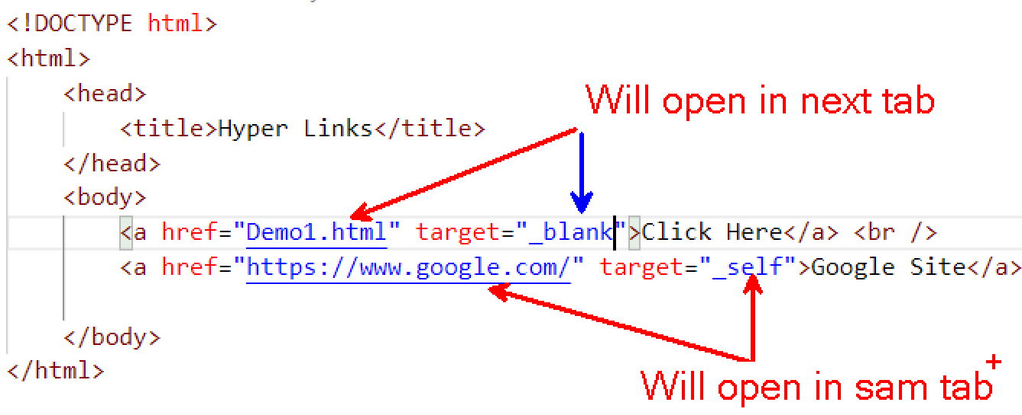

Fig:3.1.4

# The src attribute:

The required src attribute specifies the path (URL) to the image.

**Note:** When a web page loads; it is the browser, at that moment, that gets the image from a web server and inserts it into the page. Therefore, make sure that the image actually stay in the same spot in relation to the web page, otherwise your visitors will get a broken link icon. The broken link icon is shown if the browser cannot find the image.

**Syntax:**

<img src="img_chania.jpg" alt="Flowers in Chania">

# The alt attribute:

The required alt attribute provides an alternate text for an image, if the user for some reason cannot view it (because of slow connection, an error in the src attribute, or if the user uses a screen reader).

The value of the alt attribute should describe the image:

**Syntax:**

<img src="img_chania.jpg" alt="Flowers in Chania">

* Use the HTML <img> element to define an image
* Use the HTML src attribute to define the URL of the image
* Use the HTML alt attribute to define an alternate text for an image, if it cannot be displayed
* Use the HTML width and height attributes or the CSS width and height properties to define the size of the image

|  |  |
| --- | --- |
| Tag | Description |
| [<form>](https://www.w3schools.com/tags/tag_form.asp) | Defines an HTML form for user input |
| [<input>](https://www.w3schools.com/tags/tag_input.asp) | Defines an input control |
| [<textarea>](https://www.w3schools.com/tags/tag_textarea.asp) | Defines a multiline input control (text area) |
| [<label>](https://www.w3schools.com/tags/tag_label.asp) | Defines a label for an <input> element |
| [<fieldset>](https://www.w3schools.com/tags/tag_fieldset.asp) | Groups related elements in a form |
| [<legend>](https://www.w3schools.com/tags/tag_legend.asp) | Defines a caption for a <fieldset> element |
| [<select>](https://www.w3schools.com/tags/tag_select.asp) | Defines a drop-down list |
| [<optgroup>](https://www.w3schools.com/tags/tag_optgroup.asp) | Defines a group of related options in a drop-down list |
| [<option>](https://www.w3schools.com/tags/tag_option.asp) | Defines an option in a drop-down list |
| [<button>](https://www.w3schools.com/tags/tag_button.asp) | Defines a clickable button |
| [<datalist>](https://www.w3schools.com/tags/tag_datalist.asp) | Specifies a list of pre-defined options for input controls |
| [<output>](https://www.w3schools.com/tags/tag_output.asp) | Defines the result of a calculation |

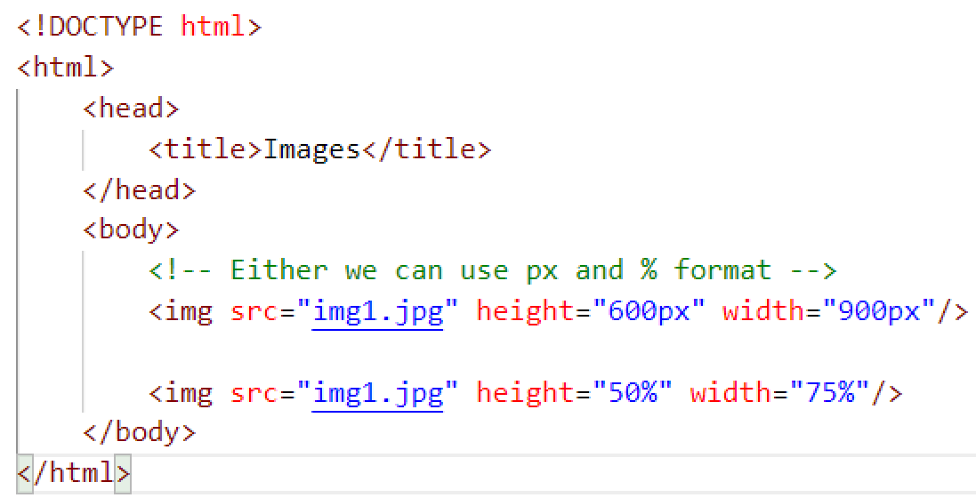

Fig:3.1.5

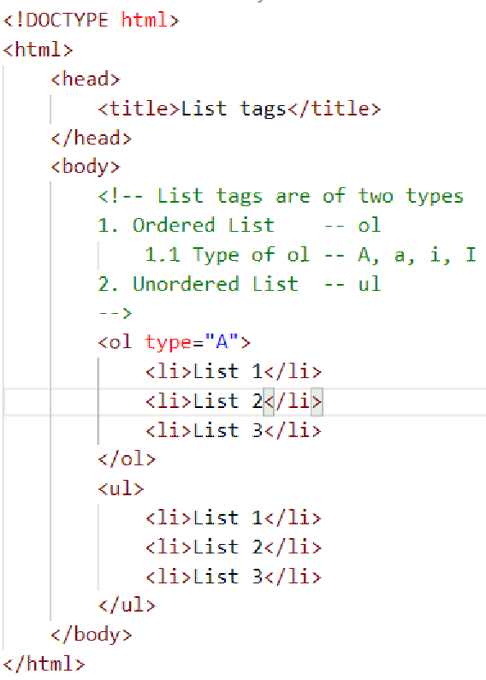

Fig: 3.1.6

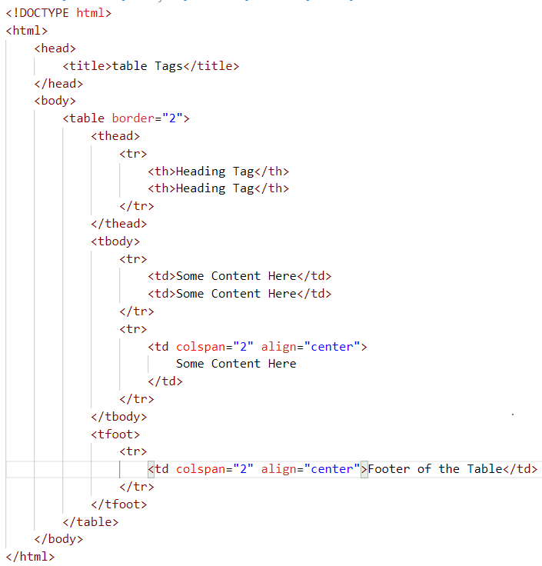

**3.1.2** **CSS**

Cascading Style Sheets (CSS) is a style sheet language used for describing the presentation of a document written in a mark-up language. Although most often used to set the visual style of web pages and user interfaces written in HTML and XHTML, the language can be applied to any XML document, including plain XML, SVG and XUL, and is applicable to rendering in speech, or on other media. Along with HTML and JavaScript, CSS is a cornerstone technology used by most websites to create visually engaging webpages, user interfaces for web applications, and user interfaces for many mobile applications.

CSS is designed primarily to enable the separation of presentation and content, including aspects such as the layout, colours, and fonts. This separation can improve content accessibility, provide more flexibility and control in the specification of presentation characteristics, enable multiple HTML pages to share formatting by specifying the relevant CSS in a separate .CSS file, and reduce complexity and repetition in the structural content.

Tags, Elements and Attributes

**Tag:** Sometimes it has open and Close, some tags have only one tag.

<tag NAME> -- OPEN

</tag NAME> -- CLOSE

Fig: 3.1.2

**Attributes:**

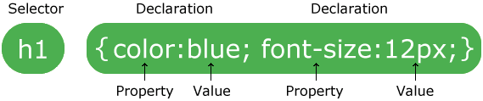

The CSS specification describes a priority scheme to determine which style rules apply if more than one rule matches against a particular element. In this so-called cascade, priorities (or weights) are calculated and assigned to rules, so that the results are predictable.

The CSS specifications are maintained by the World Wide Web Consortium (W3C). Internet media type (MIME type) text/CSS is registered for use with CSS by RFC 2318 (March 1998). The W3C operates a free CSS validation service for CSS documents.

**Types of CSS:**

**Inline CSS:**

An inline style may be used to apply a unique style for a single element.

To use inline styles, add the style attribute to the relevant element. The style attribute can contain any CSS property.

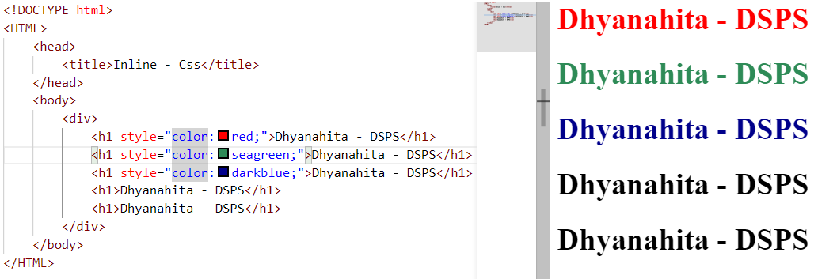

Fig: 3.1.3

* **Internal or Embedded CSS:**

In this the CSS code is defined inside the style tag in the head section of the HTML page. The CSS which applies to all the html elements which are of same type.

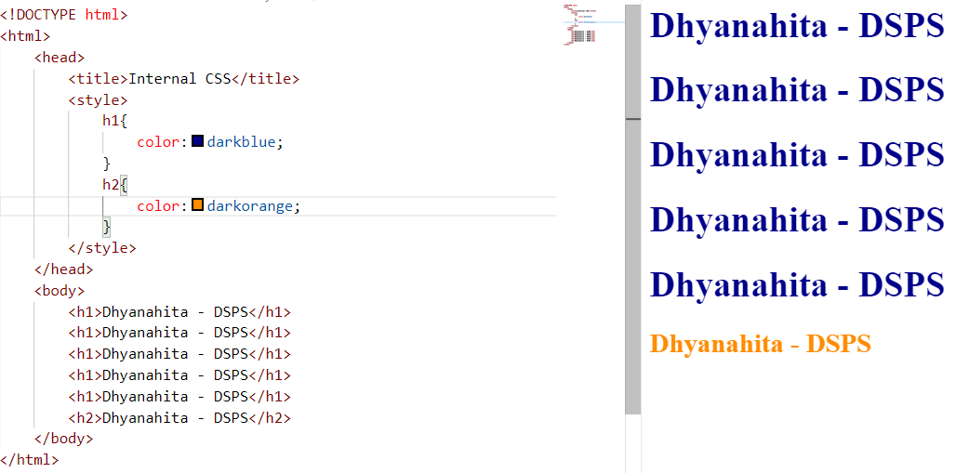

Fig: 3.1.4

* **External CSS:**

In this the CSS code is written on another page and is linked to the HTML page. It is advantageous to use this type of styling as we can use the same file to style various HTML pages.

* + 1. You need to Design the CSS document separately
    2. You have to link that to html document by using link tag on head part of the browser

Step 1: Design the CSS Doc:

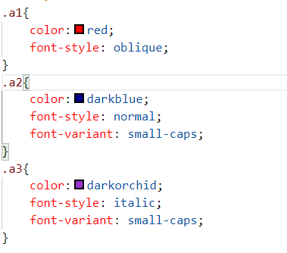

Fig: 3.1.5

Step 2**:** Link the CSS document to html document

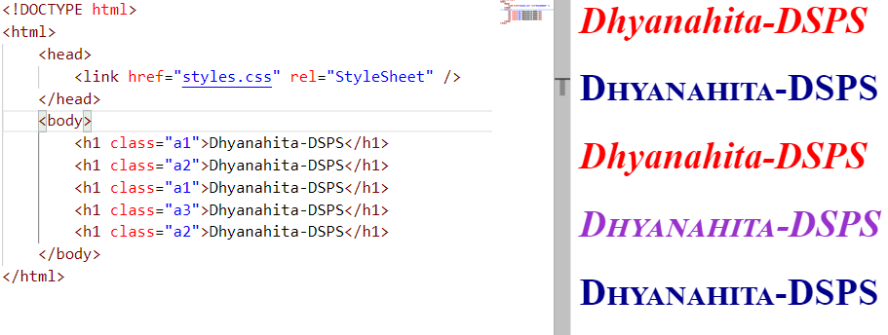

Fig: 3.1.6

**CSS Properties**

1. **Text Properties**

* Colour: can be represented by Name of the colour, Hex code of the colour and rgb colour codes also
* Text-align

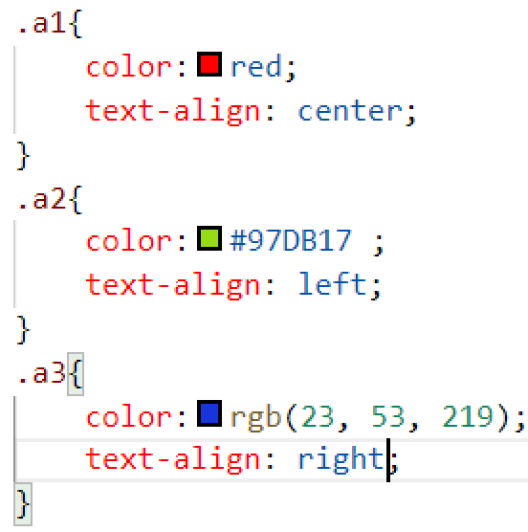

Fig: 3.1.7

* **Text-transform**

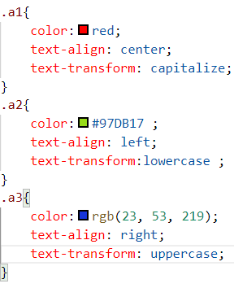

Fig: 3.1.8

* **Background properties:**

## 1.CSS background-color

The background-color property specifies the background color of an element.

## 2. CSS background-image

The background-image property specifies an image to use as the background of an element.

## 3. CSS background-repeat

By default, the background-image property repeats an image both horizontally and vertically.

## 4. CSS background-attachment

The background-attachment property specifies whether the background image should scroll or be fixed (will not scroll with the rest of the page).

## 5. CSS background - Shorthand property

To shorten the code, it is also possible to specify all the background properties in one single property. This is called a shorthand property.

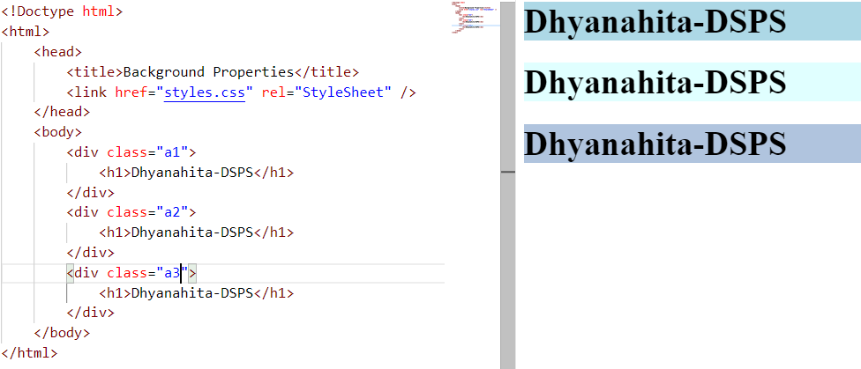

Fig: 3.1.9

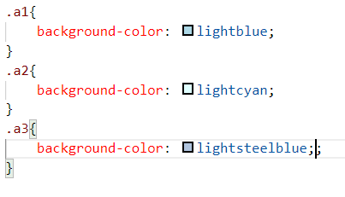

Fig: 3.1.10

* **Link Properties:**

Links can be styled with any CSS property (e.g. color, font-family, background, etc.).

In addition, links can be styled differently depending on what **state** they are in.

The four links states are:

* a:link - a normal, unvisited link
* a:visited - a link the user has visited
* a:hover - a link when the user mouses over it
* a:active - a link the moment it is clicked

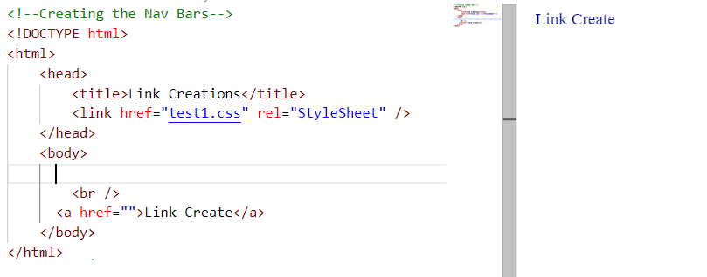

Fig: 3.1.11

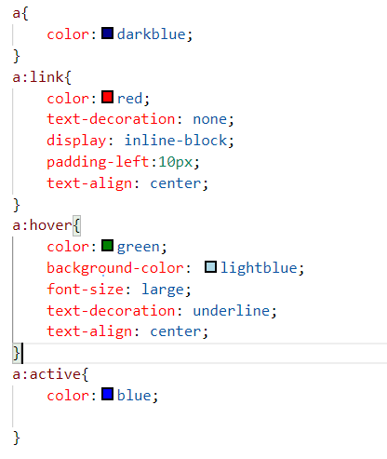

Fig: 3.1.12

* **Navigation Bar:**

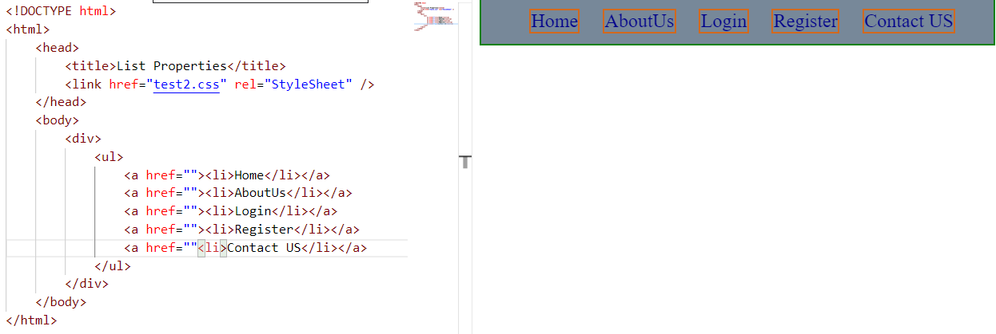

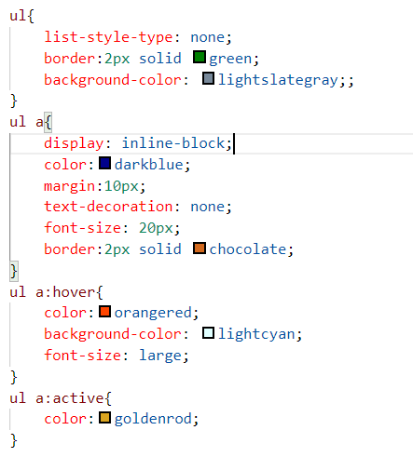

Fig: 3.1.13

* **Border Properties:**

1. dotted - Defines a dotted border
2. dashed - Defines a dashed border
3. solid - Defines a solid border
4. double - Defines a double border
5. groove - Defines a 3D grooved border. The effect depends on the border-color value
6. ridge - Defines a 3D ridged border. The effect depends on the border-color value
7. inset - Defines a 3D inset border. The effect depends on the border-color value
8. outset - Defines a 3D outset border. The effect depends on the border-color value
9. none - Defines no border
10. hidden - Defines a hidden border

* **Table Properties:**

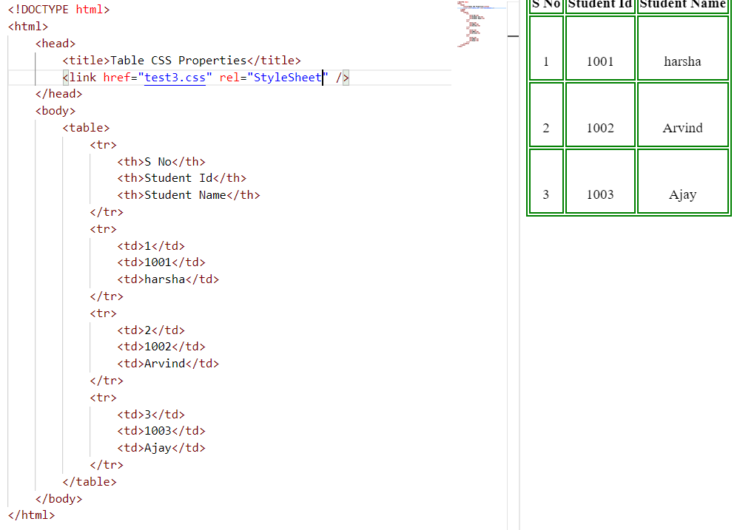

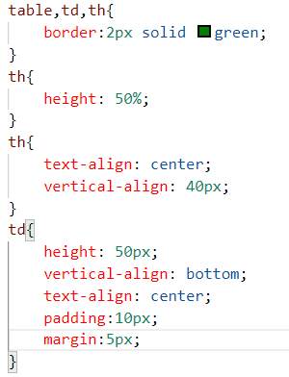

Fig: 3.1.14

* **Margin Properties:**

The CSS margin properties are used to create space around elements, outside of any defined borders.

With CSS, you have full control over the margins. There are properties for setting the margin for each side of an element (top, right, bottom, and left).

CSS has properties for specifying the margin for each side of an element:

* margin-top
* margin-right
* margin-bottom
* margin-left

All the margin properties can have the following values:

* auto - the browser calculates the margin
* *length* - specifies a margin in px, pt, cm, etc.
* *%* - specifies a margin in % of the width of the containing element
* inherit - specifies that the margin should be inherited from the parent element

**Tip:** Negative values are allowed.

* **Float Properties:**

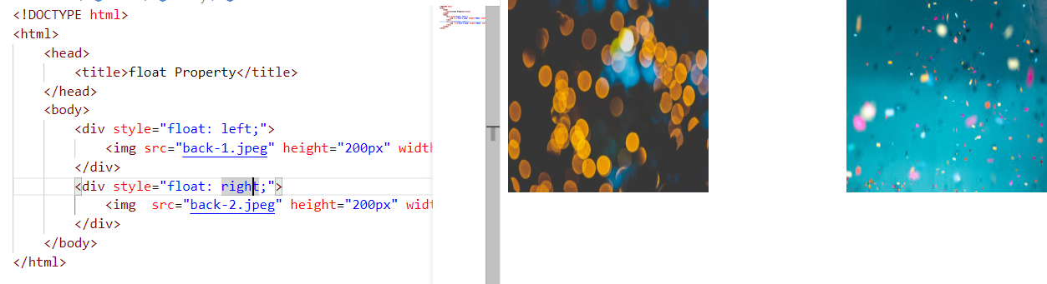

Both HTML and CSS are used to create a UI but CSS behaves like a makeup on the face of an actress which makes her look even more beautiful than she is in reality.

And here is the difference:

Before using CSS in HTML page:

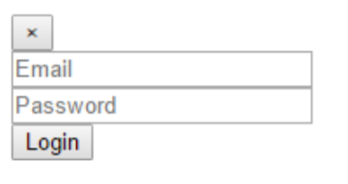

After using CSS in HTML page:

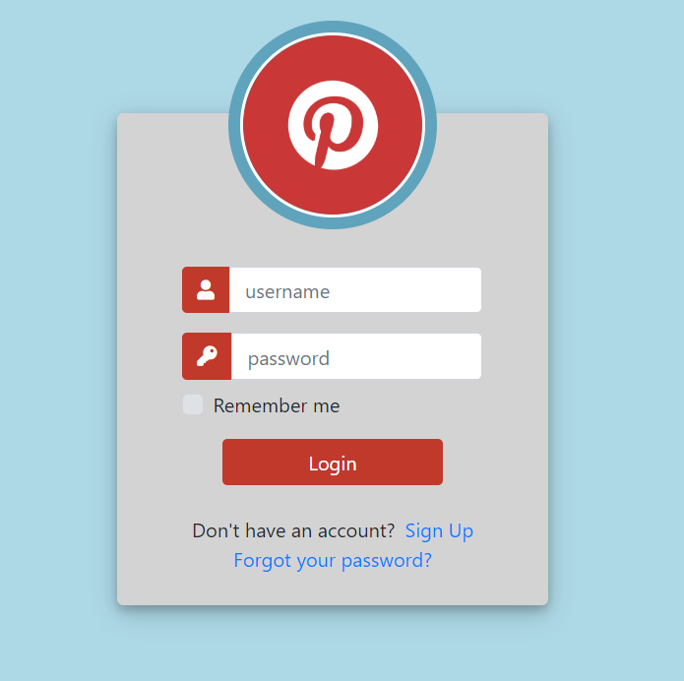

Fig: 3.1.15

**3.1.3 BOOTSTRAP**

Bootstrap is a free and open-source front-end web framework for designing websites and web applications. It contains HTML- and CSS-based design templates for typography, forms, buttons, navigation and other interface components, as well as optional JavaScript extensions. Unlike many web frameworks, it concerns itself with front-end development only.

Bootstrap is the second most-starred project on GitHub, with more than 107,000 stars and 48,000 forks.

Bootstrap, originally named Twitter Blueprint, was developed by Mark Otto and Jacob Thornton at Twitter as a framework to encourage consistency across internal tools. Before Bootstrap, various libraries were used for interface development, which led to inconsistencies and a high maintenance burden. According to twitter developer Mark Otto:

After a few months of development by a small group, many developers at Twitter began to contribute to the project as a part of Hack Week, a hackathon-style week for the Twitter development team. It was renamed from Twitter Blueprint to Bootstrap, and released as an open source project on August 19, 2011. It has continued to be maintained by Mark Otto, Jacob Thornton, and a small group of core developers, as well as a large community of contributors.

Bootstrap 3 supports the latest versions of the Google Chrome, Firefox, Internet Explorer, Opera, and Safari (except on Windows). It additionally supports back to IE8 and the latest Firefox Extended Support Release (ESR).

Since 2.0, Bootstrap supports responsive web design. This means the layout of web pages adjusts dynamically, taking into account the characteristics of the device used (desktop, tablet, mobile phone).

Starting with version 3.0, Bootstrap adopted a mobile-first design philosophy, emphasizing responsive design by default.

The version 4.0 alpha release added Sass and flexbox support.

Installing and linking bootstrap to the HTML page:

Install bootstrap from <https://getbootstrap.com/>

• Copy the bootstrap.min.css file to your CSS folder and link it to the HTML page in the similar manner to how any other CSS file is linked.

• Link the bootstrap.min.js file which is present in the JS folder of the bootstrap. It can be linked using script tag.

Now use bootstrap classes to reduce the work of designing which was earlier done through CSS.

Example:

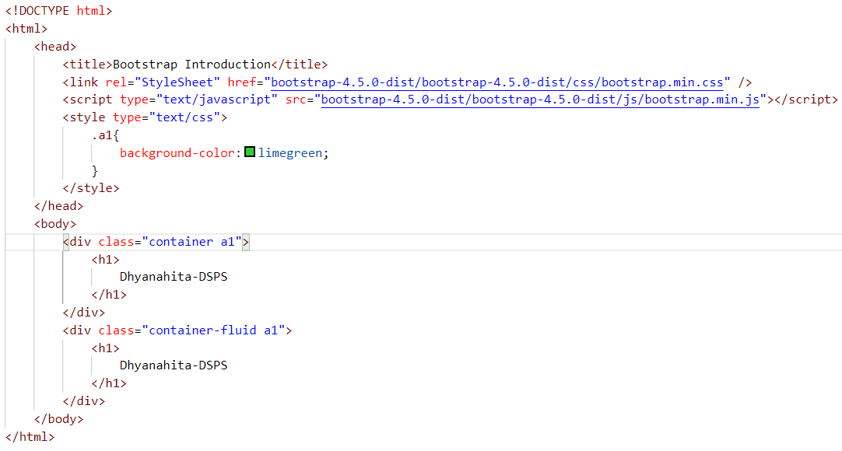

**Bootstrap Images**

1. Rounded
2. Rounded-circle
3. Rounded-thumbnail
4. Img-fluid for responsive of the images

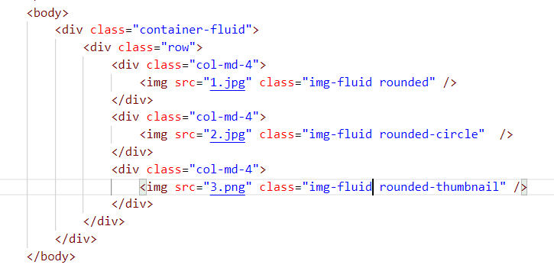

Fig: 3.1.3

**Bootstrap Forms**

1. Stacked form
2. Inline form

**Stacked Form**

1. We have class name as. form-group (wrapper class)
2. Form-control for the input fields

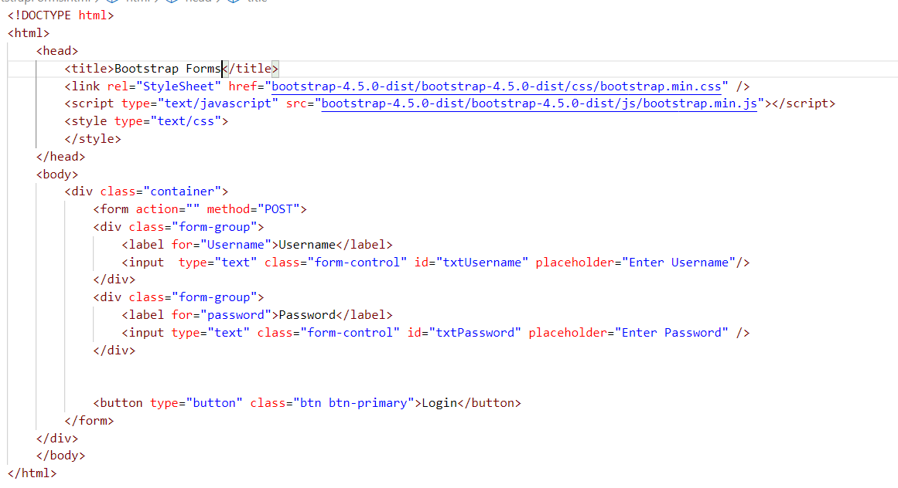

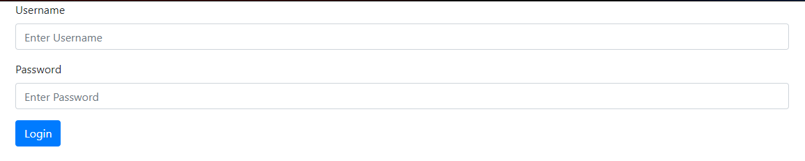

Fig: 3.1.4

**Inline form**

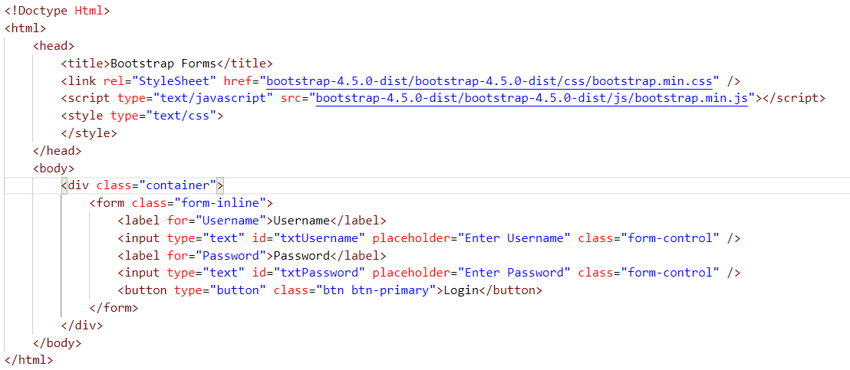



Fig: 3.1.5

Navbar Example:

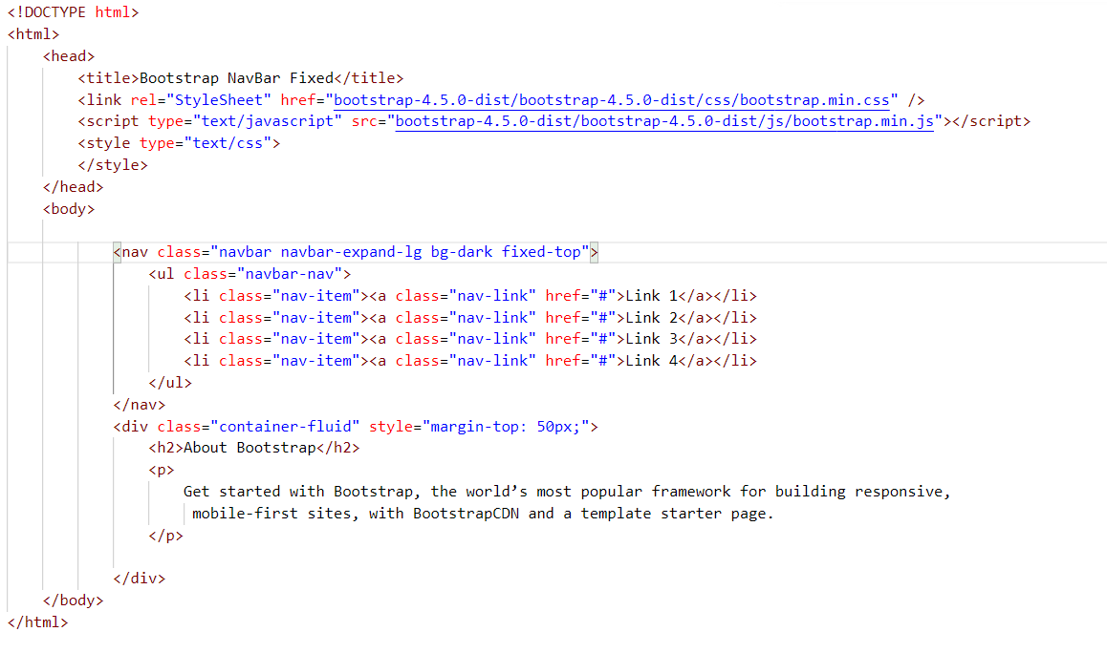

Fig: 3.1.6



Modal Pop-Up:

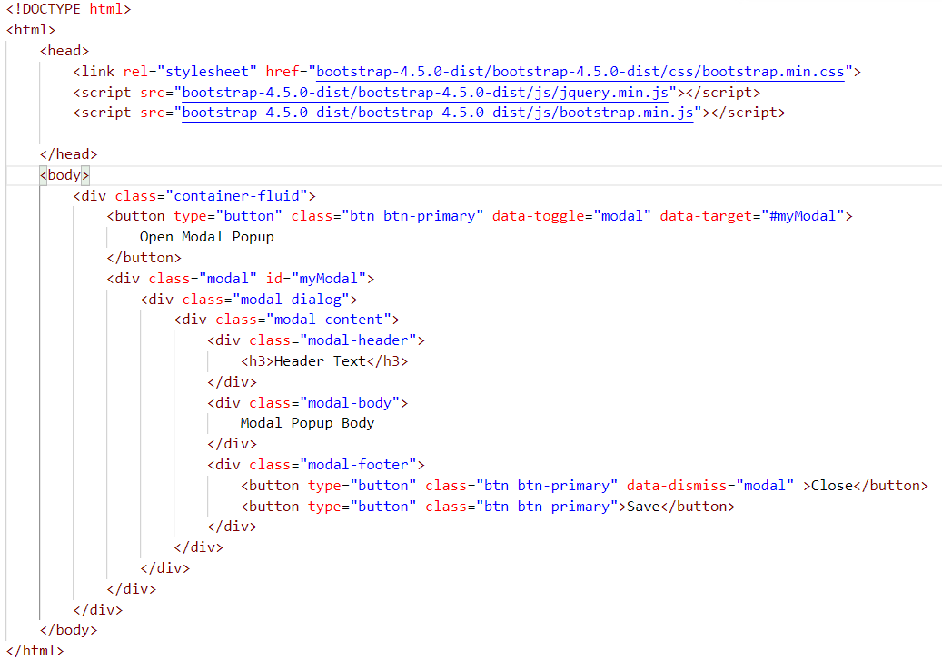

Fig: 3.1.7

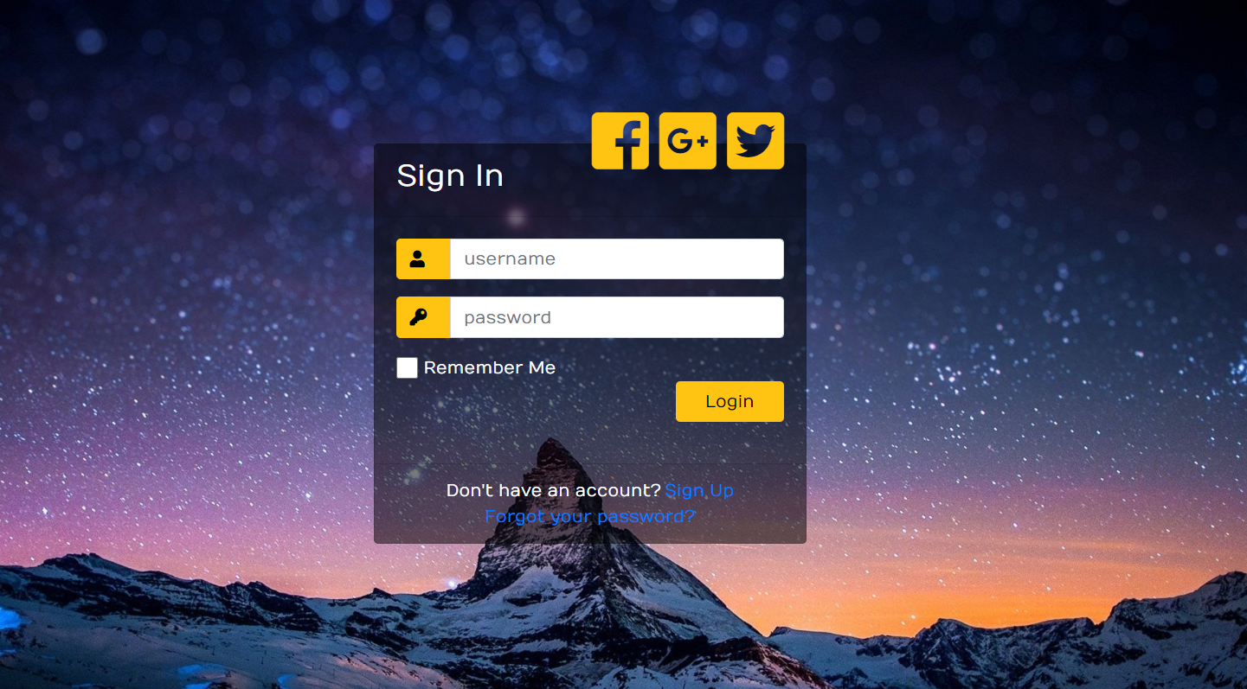

Fig: 3.1.8

**3.2 SCRIPTING**

There are two scripting methodologies.

1. Server-side scripting: This scripting is done at the server end

2. Client-side scripting: This scripting is done at the client end or the browser

**3.2.1 SERVER-SIDE SCRIPTING**

Server-side scripting is a technique used in web development which involves employing scripts on a web server which produce a response customized for each user’s (client’s) request to the website. The alternative is for the web server itself to deliver a static web page. Scripts can be written in any of a number of server-side scripting languages that are available (see below). Server-side scripting is distinguished from client-side scripting where embedded scripts, such as JavaScript, are run client-side in a web browser, but both techniques are often used together.

Server-side scripting is often used to provide a customized interface for the user. These scripts may assemble client characteristics for use in customizing the response based on those characteristics, the user’s requirements, access rights, etc. Server-side scripting also enables the website owner to hide the source code that generates the interface, whereas with client-side scripting, the user has access to all the code received by the client. A down-side to the use of server-side scripting is that the client needs to make further requests over the network to the server in order to show new information to the user via the web browser. These requests can slow down the experience for the user, place more load on the server, and prevent use of the application when the user is disconnected from the server.

When the server serves data in a commonly used manner, for example according to the HTTP or FTP protocols, users may have their choice of a number of client programs (most modern web browsers can request and receive data using both of those protocols). In the case of more specialized applications, programmers may write their own server, client, and communications protocol that can only be used with one another.

Programs that run on a user’s local computer without ever sending or receiving data over a network are not considered clients, and so the operations of such programs would not be considered client-side operations.

There are several languages that can be used for server-side programming:

• ASP.NET (C# OR Visual Basic)

• C++

• Java and JSP

• Python

• Ruby on Rails and so on.

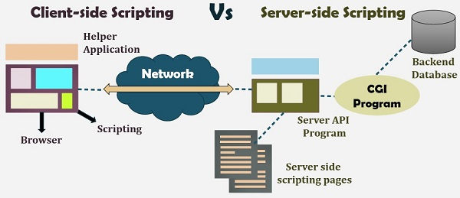

Fig: 3.2.2

Programming Language Popularity by GitHub Projects.

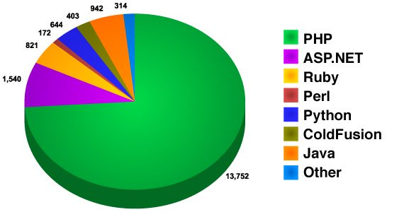

Fig:3.2.3

**3.2.2 CLIENT-SIDE SCRIPTING**

Client-side scripting is changing interface behaviours within a specific web page in response to mouse or keyboard actions, or at specified timing events. In this case, the dynamic behaviour occurs within the presentation. The client-side content is generated on the user's local computer system.

Such web pages use presentation technology called rich interfaced pages. Client-side scripting languages like JavaScript or ActionScript, used for Dynamic HTML (DHTML) and Flash technologies respectively, are frequently used to orchestrate media types (sound, animations, changing text, etc.) of the presentation. Client-side scripting also allows the use of remote scripting, a technique by which the DHTML page requests additional information from a server, using a hidden frame, XML Http Requests, or a Web service.

The first widespread use of JavaScript was in 1997, when the language was standardized as ECMAScript and implemented in Netscape 3.

Example:

The client-side content is generated on the client's computer. The web browser retrieves a page from the server, then processes the code embedded in the page (typically written in JavaScript) and displays the retrieved page's content to the user.

The most popularly used client-side scripting languages is Java Script. Flow of request from browser to server:

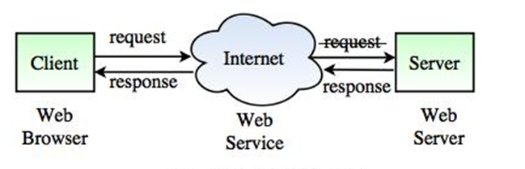

Fig:3.2.4 Client Side Scripting

**3.2.3 SCRIPTING LANGUAGES:**

* **PHP**
* PHP is a server-side scripting language designed primarily for web development but also used as a general-purpose programming language. Originally created by RasmusLerdorf in 1994, the PHP reference implementation is now produced by The PHP Development Team. PHP originally stood for *Personal Home Page*, but it now stands for the recursive acronym PHP*:* Hypertext *Pre-*processor.
* PHP code may be embedded into HTML or HTML5 mark-up, or it can be used in combination with various web template systems, web content management systems and web frameworks. PHP code is usually processed by a PHP interpreter implemented as a module in the web server or as a Common Gateway Interface (CGI) executable. The web server software combines the results of the interpreted and executed PHP code, which may be any type of data, including images, with the generated web page. PHP code may also be executed with a command-line interface (CLI) and can be used to implement standalone graphical applications.
* The standard PHP interpreter, powered by the Zend Engine, is free software released under the PHP License. PHP has been widely ported and can be deployed on most web servers on almost every operating system and platform, free of charge.
* The PHP language evolved without a written formal specification or standard until 2014, leaving the canonical PHP interpreter as a *de facto* standard. Since 2014 work has gone on to create a formal PHP specification.

**Installing PHP**

Step 1: download the files. Download the latest PHP 5 ZIP package from www.php.net/downloads.php.

Step 2: extract the files

Step 3: configure php.ini.

Step 4: add C: php to the path environment variable. ... V. Step 5: configure PHP as an Apache module.

Step 6: test a PHP file.

Or we can install **Xampp** which have inbuilt php, MySQL, apache server.

* **JAVASCRIPT**

 JavaScript is a dynamic computer programming language. It is lightweight and most commonly used as a part of web pages, whose implementations allow client-side script to interact with the user and make dynamic pages. It is an interpreted programming language with object-oriented capabilities.

JavaScript was first known as Live Script, but Netscape changed its name to JavaScript, possibly because of the excitement being generated by Java. JavaScript made its first

appearance in Netscape 2.0 in 1995 with the name Live Script. The general-purpose core of the language has been embedded in Netscape, Internet Explorer, and other web browsers.

Applications of JavaScript Programming

As mentioned before, JavaScript is one of the most widely used programming languages (Front-end as well as Back-end). It has its presence in almost every area of software development. I'm going to list few of them here:

Client-side validation - This is really important to verify any user input before submitting it to the server and JavaScript plays an important role in validating those inputs at front-end itself.

Manipulating HTML Pages - JavaScript helps in manipulating HTML page on the fly. This helps in adding and deleting any HTML tag very easily using JavaScript and modify your HTML to change its look and feel based on different devices and requirements.

User Notifications - You can use JavaScript to raise dynamic pop-ups on the webpages to give different types of notifications to your website visitors.

Back-end Data Loading - JavaScript provides Ajax library which helps in loading back-end data while you are doing some other processing. This really gives an amazing experience to your website visitors.

Presentations - JavaScript also provides the facility of creating presentations which gives website look and feel. JavaScript provides Reveals and Bespoke libraries to build a web-based slide presentation.

Server Applications - Node JS is built on Chrome's JavaScript runtime for building fast and scalable network applications. This is an event-based library which helps in developing very sophisticated server applications including Web Servers.

This list goes on, there are various areas where millions of software developers are happily using JavaScript to develop great websites and others software’s.

Advantages of JavaScript

The merits of using JavaScript are −

Less server interaction − You can validate user input before sending the page off to the server. This saves server traffic, which means less load on your server.

Immediate feedback to the visitors − They don't have to wait for a page reload to see if they have forgotten to enter something.

Increased interactivity − You can create interfaces that react when the user hovers over them with a mouse or activates them via the keyboard.

Richer interfaces − You can use JavaScript to include such items as drag-and-drop components and sliders to give a Rich Interface to your site visitors.

Limitations of JavaScript

We cannot treat JavaScript as a full-fledged programming language. It lacks the following important features −

Client-side JavaScript does not allow the reading or writing of files. This has been kept for security reason.

JavaScript cannot be used for networking applications because there is no such support available.

JavaScript doesn't have any multi-threading or multiprocessor capabilities.

* **JQUERY:**

jQuery is a cross-platform JavaScript library designed to simplify the client-side scripting of HTML. It is free, open-source software using the permissive MIT license. Web analysis indicates that it is the most widely deployed JavaScript library by a large margin.  create animations, handle events, and develop Ajax applications. jQuery also provides capabilities for developers to create plug-ins on top of the JavaScript library. This enables developers to create abstractions for low-level interaction and animation, advanced effects and high-level, theme able widgets. The modular approach to the jQuery library allows the creation of powerful dynamic web pages and Web applications.

 The set of jQuery core features—DOM element selections, traversal and manipulation—enabled by its selector engine (named "Sizzle" from v1.3), created a new "programming style", fusing algorithms and DOM data structures. This style influenced the architecture of other JavaScript frameworks like YUI v3 and Dojo, later stimulating the creation of the standard Selectors API.

 Microsoft and Nokia bundle jQuery on their platforms. Microsoft includes it with Visual Studio for use within Microsoft's ASP.NET AJAX and ASP.NET MVC frameworks while Nokia has integrated it into the Web Run-Time widget development platform.

1.**Downloading jQuery**

There are two versions of jQuery available for downloading:

* Production version - this is for your live website because it has been minified and compressed
* Development version - this is for testing and development (uncompressed and readable code)

Both versions can be downloaded from [jQuery.com](http://jquery.com/download/).

The jQuery library is a single JavaScript file, and you reference it with the HTML <script> tag (notice that the <script> tag should be inside the <head> section):

<head>  
<script src="jquery-3.5.1.min.js"></script>  
</head>

**Tip:** Place the downloaded file in the same directory as the pages where you wish to use it.

## 2.jQuery CDN

If you don't want to download and host jQuery yourself, you can include it from a CDN (Content Delivery Network).

Google is an example of someone who host jQuery:

### Google CDN:

<head>  
<script src="https://ajax.googleapis.com/ajax/libs/jquery/3.5.1/jquery.min.js"></script>  
</head>

* **AJAX**

**Ajax** (also **AJAX** short for "asynchronous JavaScript and XML") is a set of Web development techniques using many Web technologies on the client side to create asynchronous Web applications. With Ajax, Web applications can send data to and retrieve from a server asynchronously (in the background) without interfering with the display and behaviour of the existing page. By decoupling the data interchange layer from the presentation layer, Ajax allows for Web pages, and by extension Web applications, to change content dynamically without the need to reload the entire page. In practice, modern implementations commonly substitute JSON for XML due to the advantages of being native to JavaScript.

 Ajax is not a single technology, but rather a group of technologies. HTML and CSS can be used in combination to mark up and style information. The DOM is accessed with JavaScript to dynamically display – and allow the user to interact with – the information presented. JavaScript and the XMLHttpRequest object provide a method for exchanging data asynchronously between browser and server to avoid full page reloads.

* **JSON:**

[p](https://en.wikipedia.org/wiki/Web_server)ackage developed by Apache Friends, consisting mainly of the Apache HTTP Server, MariaDB database, and interpreters for scripts written in the PHP and Perl programming languages. XAMPP stands for Cross-Platform (X), Apache (A), MariaDB (M), PHP (P) and Perl (P). It is a simple, lightweight Apache distribution that makes it extremely easy for developers to create a local web server for testing and deployment purposes. Everything needed to set up a web server – server application (Apache), database (MariaDB), and scripting language (PHP) – is included in an extractable file. XAMPP is also cross-platform, which means it works equally well on Linux, Mac and Windows. Since most actual web server deployments use the same components as XAMPP, it makes transitioning from a local test server to a live server extremely easy as well In **JavaScript Object Notation** or **JSON** (/ˈdʒeɪsən/***JAY****-son*), is an open- standard file format that uses human-readable text to transmit data objects consisting of attribute–value pairs and array data types (or any other serializable value). It is a very common data format used for asynchronous browser/server communication, including as a replacement for XML in some AJAX-style systems.

 JSON is a language-independent data format. It was derived from JavaScript, but as of 2017 many programming languages include code to generate and parse JSON-format data. The official Internet media type for JSON is application/json. JSON filenames use the extension. json.  0s; two competing standards, RFC 7159 and ECMA-404, defined it in 2013. The ECMA standard describes only the allowed syntax, whereas the RFC covers some security and interoperability considerations.[3]

 A restricted profile of JSON, known as **I-JSON** (short for "Internet JSON"), seeks to overcome some of the interoperability problems with JSON. It is defined in RFC 7493.

* **FEATURES**

to the latest releases of Apache, MariaDB, PHP and Perl. It also comes with a number of other modules including OpenSSL, phpMyAdmin, Miyawaki, Joomla, WordPress and more. Self-contained, multiple instances of XAMPP can exist on a single computer, and any given instance can be copied from one computer to another. XAMPP is offered in both a full and a standard version (Smaller version).

* **USAGE**

Officially, XAMPP's designers intended it for use only as a development tool, to allow website designers and programmers to test their work on their own computers without any access to the Internet. To make this as easy as possible, many important security features are disabled by default. XAMPP has the ability to serve web pages on the World wide web. A special tool is provided to password-protect the most important parts of the package.

 XAMPP also provides support for creating and manipulating databases in MariaDB and SQLite among others. Once XAMPP is installed, it is possible to treat a localhost like a remote host by connecting using an FTP client. Using a program like FileZilla has many advantages when installing a content management system (CMS) like Joomla or WordPress. It is also possible to connect to localhost via FTP with an HTML editor.

**3.3 DATABASE**

A database is an organized collection of data, generally stored and accessed electronically from a computer system. Where databases are more complex, they are often developed using formal design and modelling techniques.

The database management system (DBMS) is the software that interacts with end users, applications, and the database itself to capture and analyse the data. The DBMS software additionally encompasses the core facilities provided to administer the database. The sum total of the database, the DBMS and the associated applications can be referred to as a "database system". Often the term "database" is also used to loosely refer to any of the DBMS, the database system or an application associated with the database.

Computer scientists may classify database-management systems according to the database models that they support. Relational databases became dominant in the 1980s. These model data as rows and columns in a series of tables, and the vast majority use SQL for writing and querying data. In the 2000s, non-relational databases became popular, referred to as NoSQL because they use different query languages.

Formally, a "database" refers to a set of related data and the way it is organized. Access to this data is usually provided by a "database management system" (DBMS) consisting of an integrated set of computer software that allows users to interact with one or more databases and provides access to all of the data contained in the database (although restrictions may exist that limit access to particular data). The DBMS provides various functions that allow entry, storage and retrieval of large quantities of information and provides ways to manage how that information is organized.

Because of the close relationship between them, the term "database" is often used casually to refer to both a database and the DBMS used to manipulate it.

Outside the world of professional information technology, the term database is often used to refer to any collection of related data (such as a spreadsheet or a card index) as size and usage requirements typically necessitate use of a database management system.

**3.4 SQL**

# Download and Install the MySQL

Link for download: <https://dev.mysql.com/downloads/>

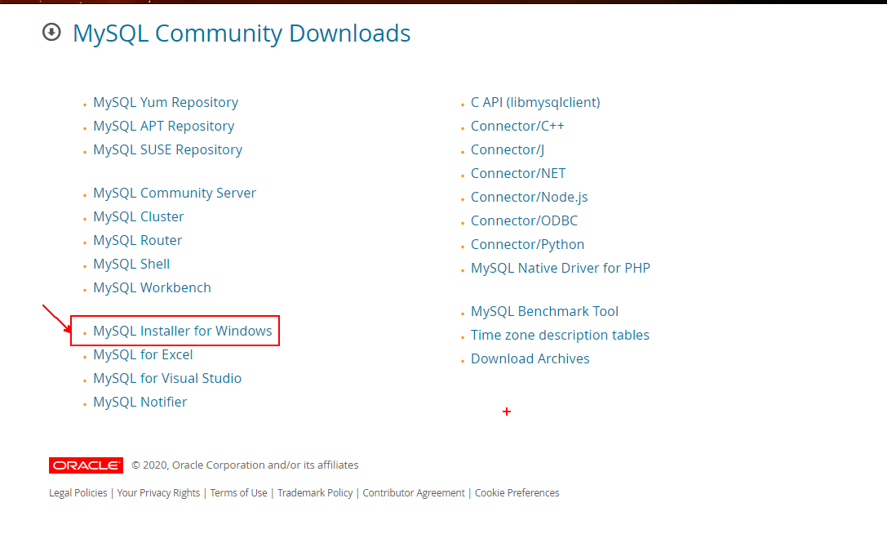

Open the Download software

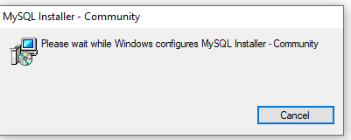

Fig:3.4.1

SQL is a language to operate databases.It includes databases creation,deletion,fetching,

rows,modifying rows etc.

SQL (pronounced "ess-que-el") stands for Structured Query Language. SQL is used to communicate with a database. According to ANSI (American National Standards Institute), it is the standard language for relational database management systems. SQL statements are used to perform tasks such as update data on a database, or retrieve data from a database. Some common relational database management systems that use SQL are: Oracle, Sybase, Microsoft SQL Server, Access, Ingres, etc. Although most database systems use SQL, most of them also have their own additional proprietary extensions that are usually only used on their system. However, the standard SQL commands such as "Select", "Insert", "Update", "Delete", "Create", and "Drop" can be used to accomplish almost everything that one needs to do with a database. This tutorial will provide you with the instruction on the basics of each of these commands as well as allow you to put them to practice using the SQL Interpreter.

SQL is case insensitive. But it is a recommended practice to use keywords (like SELECT, UPDATE, CREATE, etc.) in capital letters and use user defined things (liked table name, column name, etc.) in small letters.

We can write comments in SQL using — (double hyphen) at the beginning of any line.

SQL is the programming language for relational databases (explained below) like MySQL, Oracle, Sybase, SQL Server, Postgre, etc. Other non-relational databases (also called NoSQL) databases like MongoDB, Dynamo DB, etc. do not use SQL

Although there is an ISO standard for SQL, most of the implementations slightly vary in syntax. So, we may encounter queries that work in SQL Server but do not work in MySQL.

The Most Important SQL Statements:

SELECT - extracts data from a database

UPDATE - updates data in a database

DELETE - deletes data from a database

INSERT INTO - inserts new data into a database

CREATE DATABASE - creates a new database

ALTER DATABASE - modifies a database

CREATE TABLE - creates a new table

ALTER TABLE - modifies a table

DROP TABLE - deletes a table

CREATE INDEX - creates an index (search key)

DROP INDEX - deletes an index

SQL keywords are NOT case sensitive: select is the same as SELECT

**3.4.2 QUERIES**

The most common operation in SQL, the query, makes use of the declarative SELECT statement. SELECT retrieves data from one or more tables, or expressions. Standard SELECT statements have no persistent effects on the database. Some non-standard implementations of SELECT can have persistent effects, such as the SELECT INTO syntax provided in some databases.

Queries allow the user to describe desired data, leaving the database management system (DBMS) to carry out planning, optimizing, and performing the physical operations necessary to produce that result as it chooses.

A query includes a list of columns to include in the final result, normally immediately following the SELECT keyword. An asterisk ("*") can be used to specify that the query should return all columns of the queried tables. SELECT is the most complex statement in SQL, with optional keywords and clauses that include:

* The FROM clause, which indicates the table(s) to retrieve data from. The FROM clause can include optional JOIN subclauses to specify the rules for joining tables.
* The WHERE clause includes a comparison predicate, which restricts the rows returned by the query. The WHERE clause eliminates all rows from the result set where the comparison predicate does not evaluate to True.
* The GROUP BY clause projects rows having common values into a smaller set of rows. GROUP BY is often used in conjunction with SQL aggregation functions or to eliminate duplicate rows from a result set. The WHERE clause is applied before the GROUP BY clause.
* The HAVING clause includes a predicate used to filter rows resulting from the GROUP BY clause. Because it acts on the results of the GROUP BY clause, aggregation functions can be used in the HAVING clause predicate.
* The ORDER BY clause identifies which column[s] to use to sort the resulting data, and in which direction to sort them (ascending or descending). Without an ORDER BY clause, the order of rows returned by an SQL query is undefined.
* The DISTINCT keyword eliminates duplicate data.

**CHAPTER 4**

**SOFTWARE REQUIREMENTS**

Software and hardware requirements are very essential 50% of work is done only by choosing the efficient and essential software. So, choosing the software makes your work easier and simpler. When it comes to hardware requirements, we need to have the fastest and need to have the disk with high space.

**4.1 HARDWARE REQUIREMENTS:**

|  |  |
| --- | --- |
| Processor | Intel CORE i5 |
| RAM | 8.0 GB |
| Hard Disk Drive | 1 TB |

**4.2 SOFTWARE REQUIREMENTS:**

|  |  |
| --- | --- |
| **NUMBER** | **Description** |
| 1 | Windows 10 |
| 2 | HTML, CSS, JS, BOOTSTRAP. |
| 3 | MYSQL, NODEJS |
| 4 | Compiler: (visual studio code) |

**CHAPTER-5**

**DATA FLOW DIAGRAMS**

A **data-flow diagram** is a way of representing a flow of data through a process or a system. The DFD also provides information about the outputs and inputs of each entity and the process itself. A data-flow diagram has no control flow, there are no decision rules and no loops.



Fig: 5.1 Data Flow Diagram

There are four symbols and components for drawing DFDs they are mainly

Rectangle Ellipse arrows open-ended rectangle

Process Warehouse Dataflow Terminator

Each process within the system is first shown as a Context Level DFD and later as a Detailed DFD. The Context Level DFD provides a conceptual view of the process and its surrounding input, output and data stores. The Detailed DFD provides a more detailed and comprehensive view of the interaction among the sub-processes within the system. Figures below are the Data Flow Diagrams for the current system.

CONTEXT LEVEL DIAGRAM

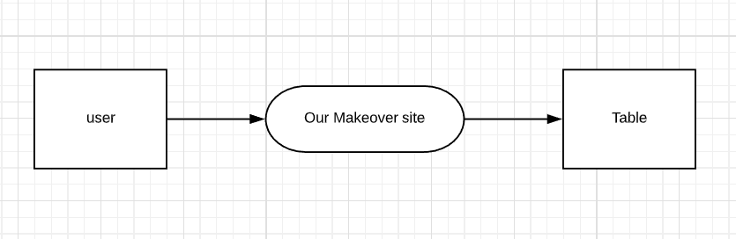

Fig: 5.2 Context Level Diagram

FIRST LEVEL DFD

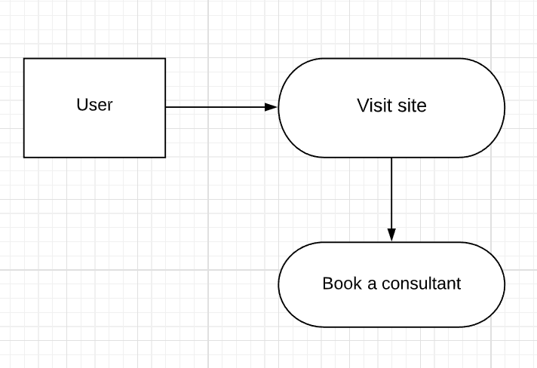

Fig:5.3 First Level DFD

SECOND LEVEL DFD

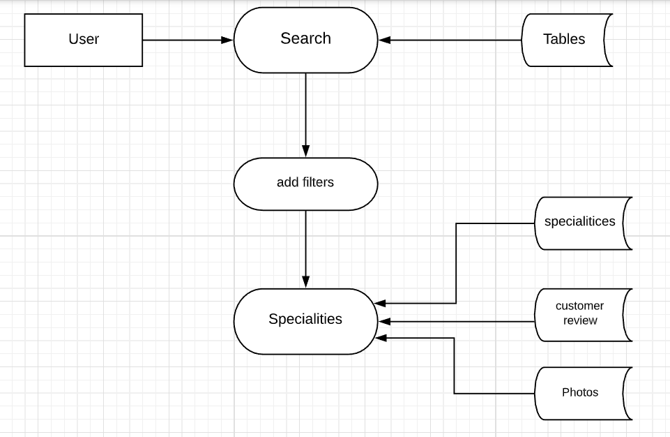

Fig: 5.4 Second Level DFD1

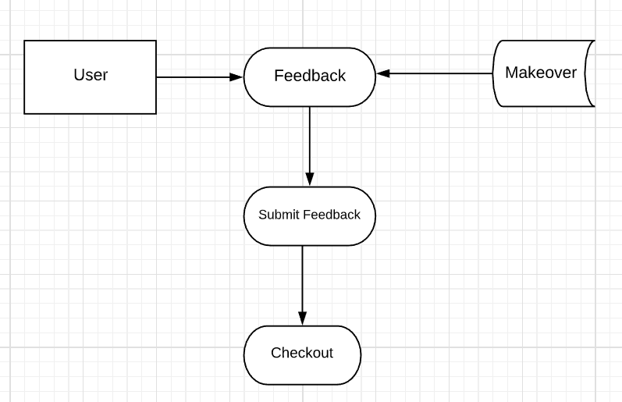

Fig: 5.5 Second Level Diagram2

**CHAPTER 6**

**PROJECT**

NAME: MODERN HOME MAKEOVER WEBSITE

USED TECHNOLOGIES:

* HTML
* CSS
* JQUERY UI
* JAVASACRIPT
* AJAX
* BOOTSTRAP

TECHNICAL DETAILS:

* We used different technologies for designing our project i.e. both frontend and backend.
* To design frontend i.e. UI design we used html, CSS, bootstrap, jQuery.
* To design the backend of our project we used a database named MySQL database and also, we used NodeJS to write the code for designing the backend.

**Team details :( size-3) work done:**

P Reshma Tejasvi (221710302046) -----🡪 Frontend (Js), Backend (Nodejs api), backend (MySQL)

ASL Gayathri (221710302005) --------------🡪 Frontend (HTML, CSS), backend (creating tables), uml diagram.

L Ramya (221710302032) -------🡪 Backend (Nodejs), wireframes.

Database: MySQL

Operating System: Windows7/8/8.1/10

Wire framing tool: ([wireframepro.mockflow.com/](https://wireframepro.mockflow.com/))

Data flow Diagram tool: (<https://www.lucidchart.com/>)

**CHAPTER 7**

**Codes and Output Screenshots**

**LOGIN PAGE:**

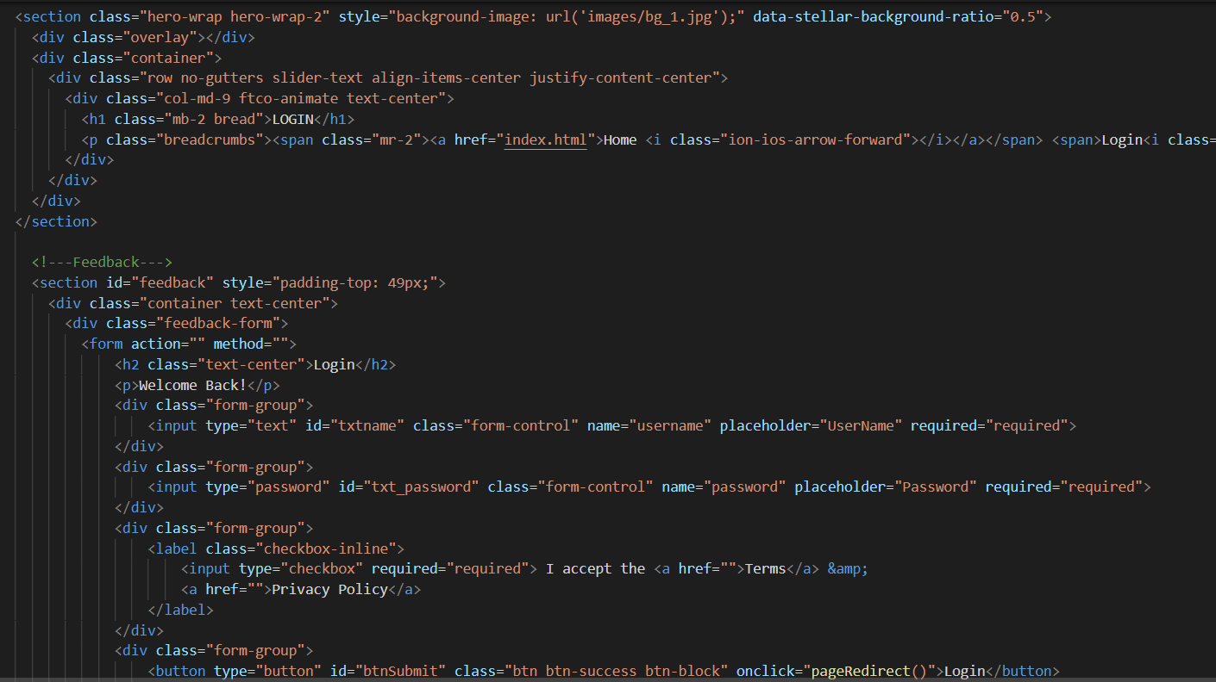

Fig: 7.1.1

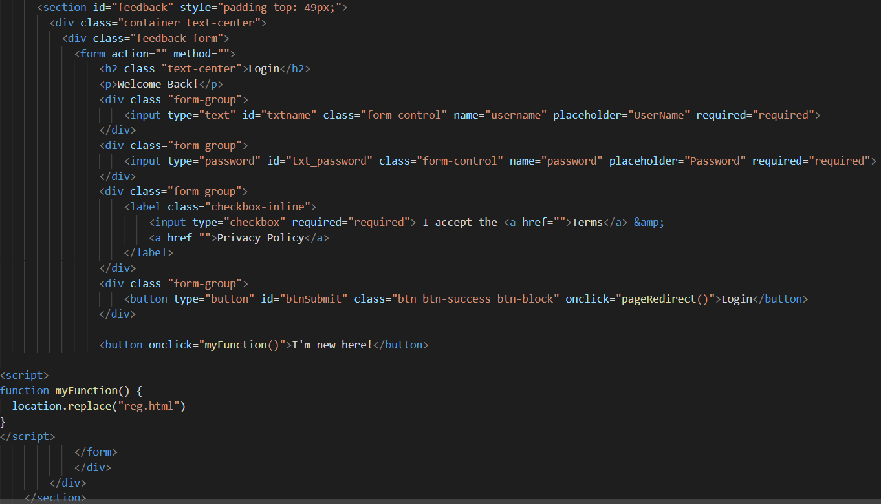

Fig: 7.1.2

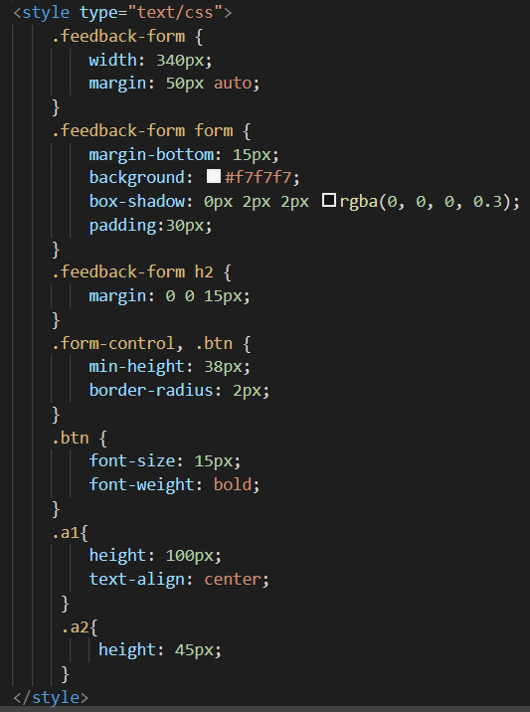

Fig: 7.1.3

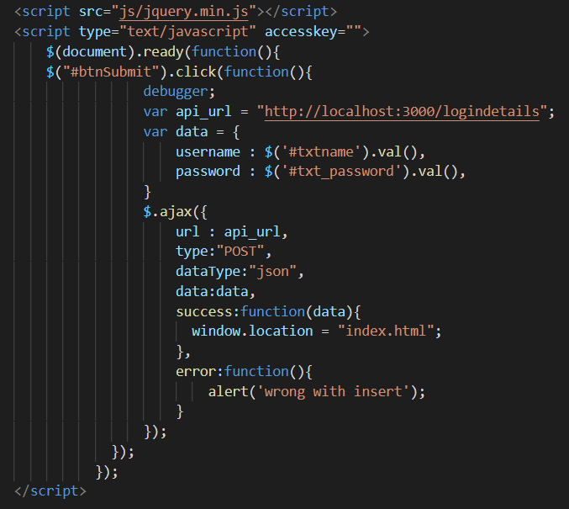

Fig: 7.1.4

**Wireframe of Login Page:**

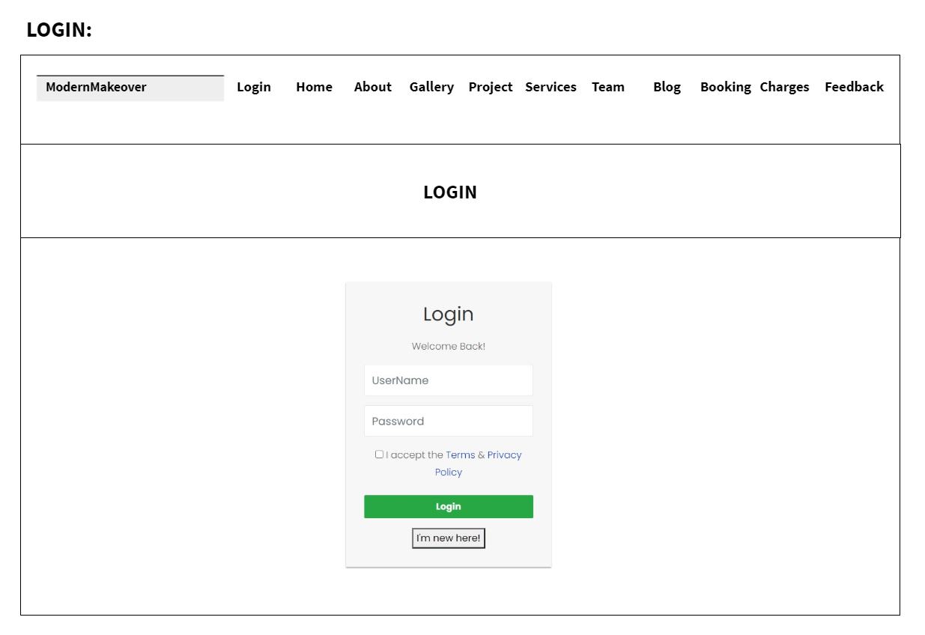

Fig: 7.1.5

Output:

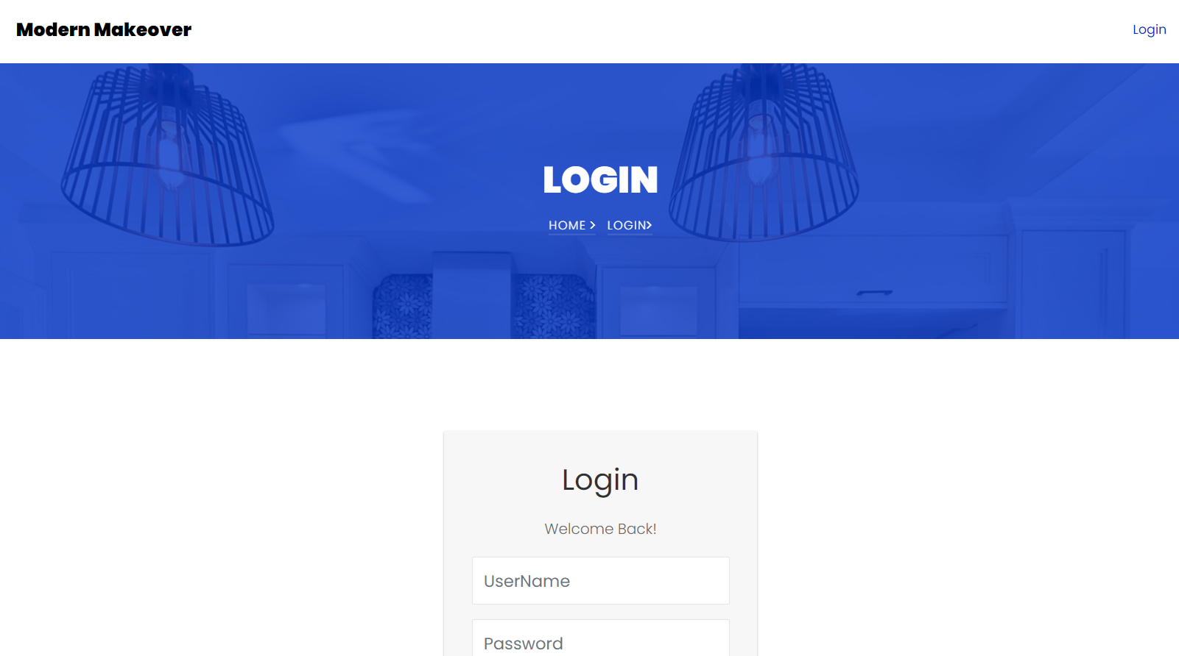

Fig: 7.1.6

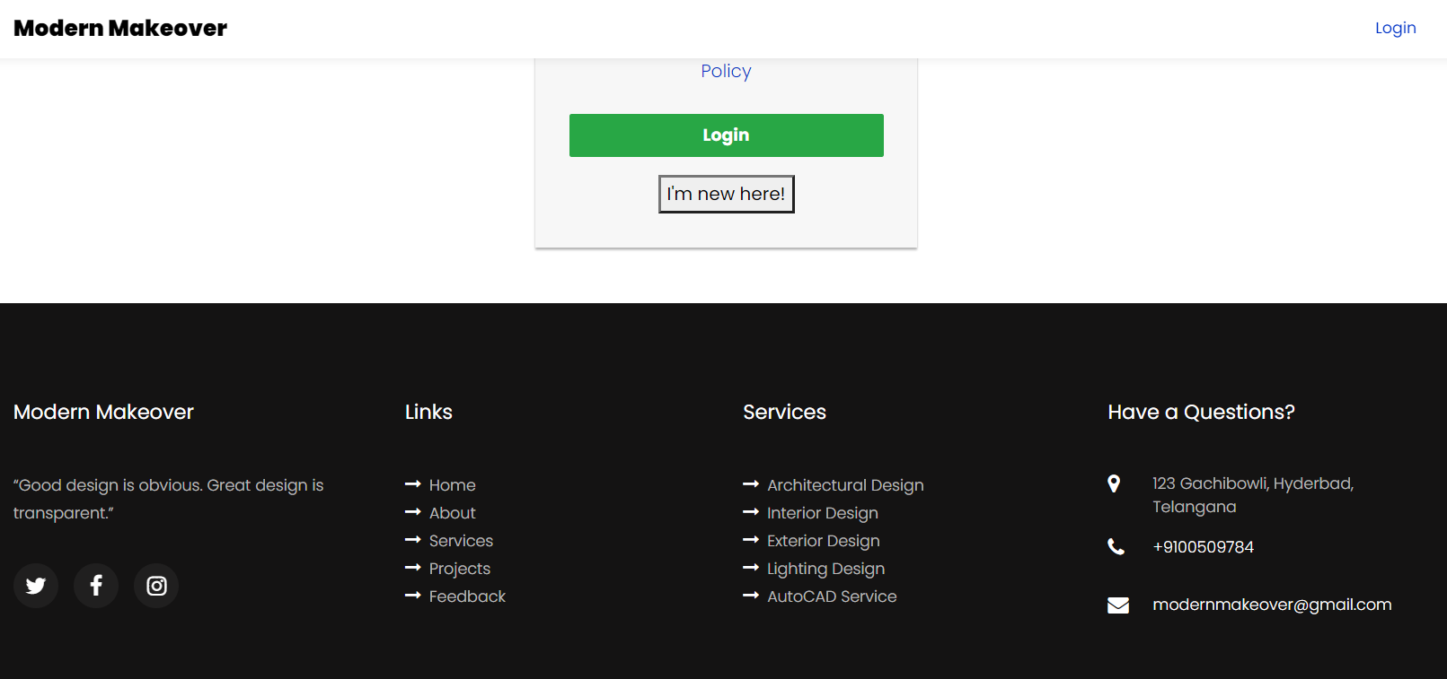

Fig: 7.1.7

**REGISTRATION PAGE:**

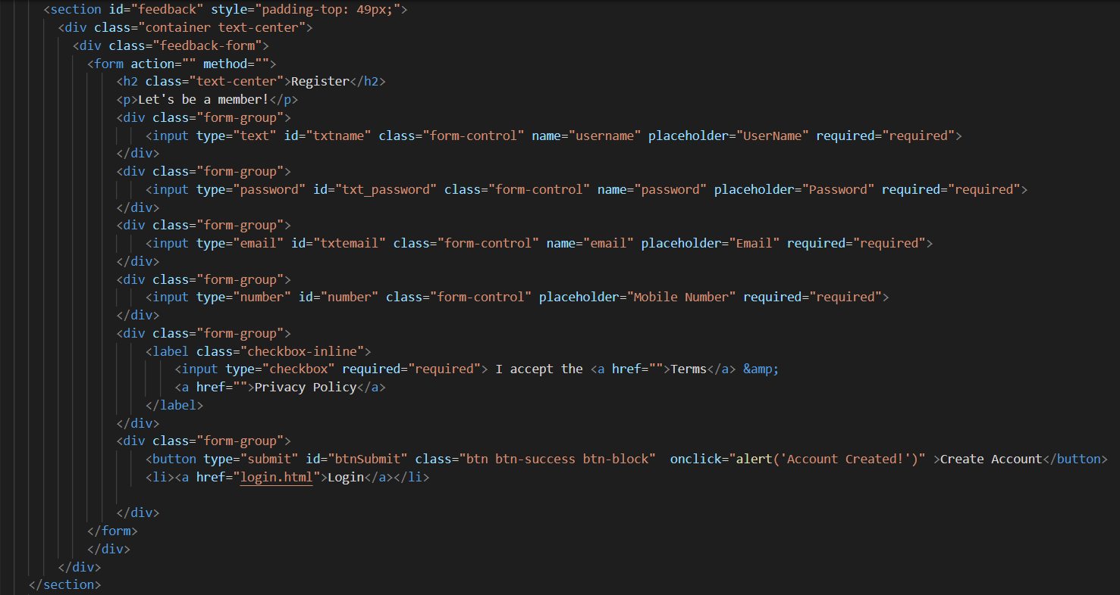

Fig: 7.1.8

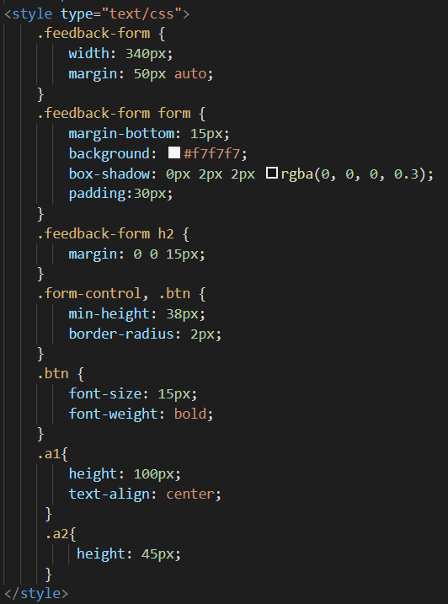

Fig: 7.1.9

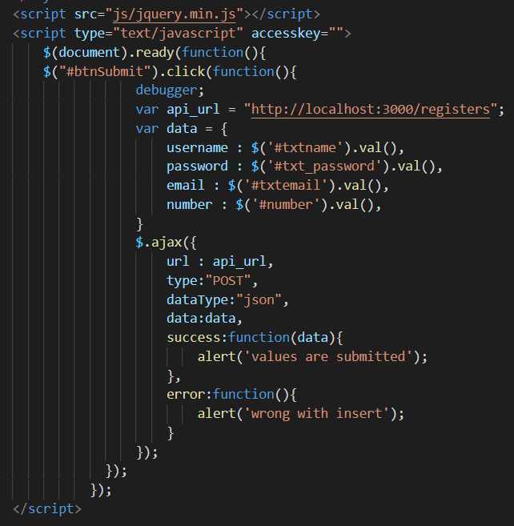

Fig: 7.1.10

Output:

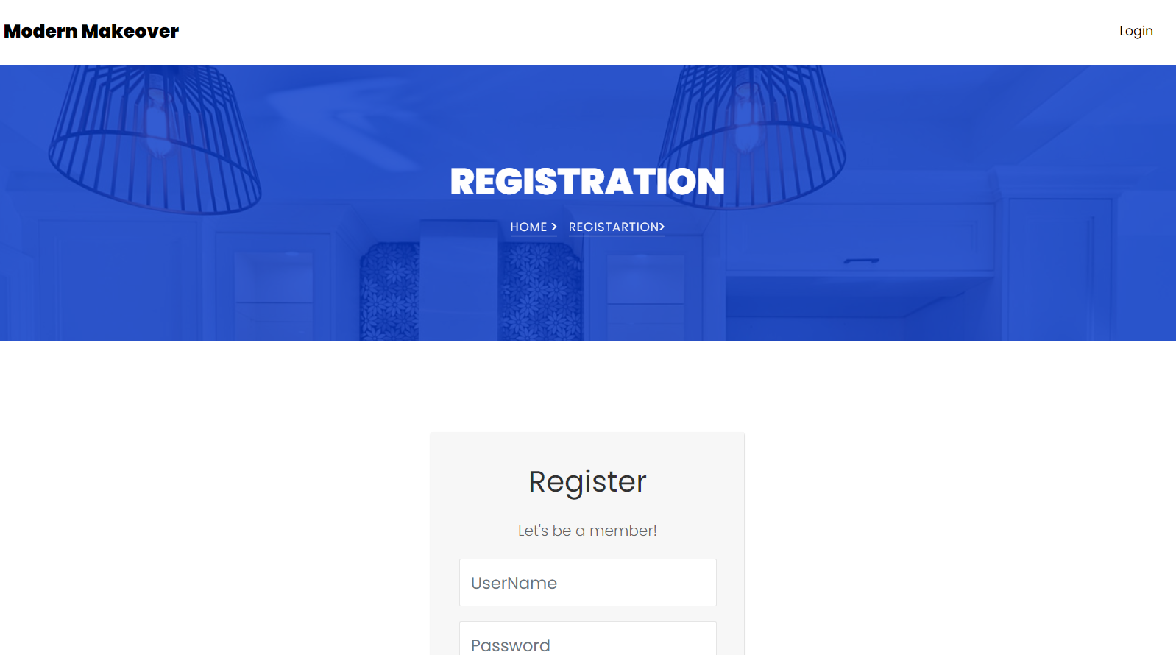

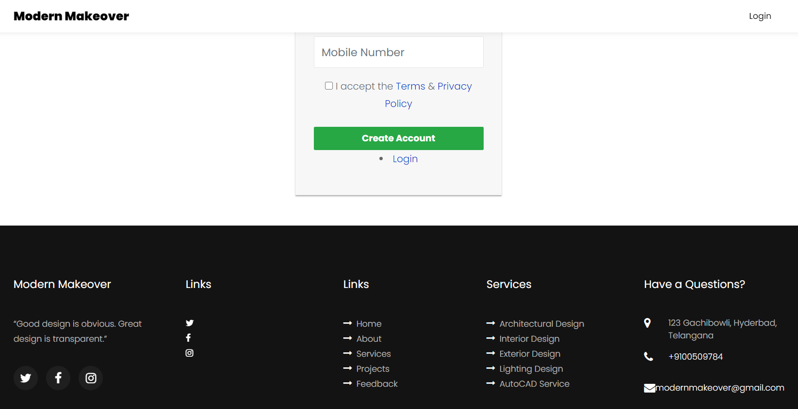

**INDEX PAGE:**

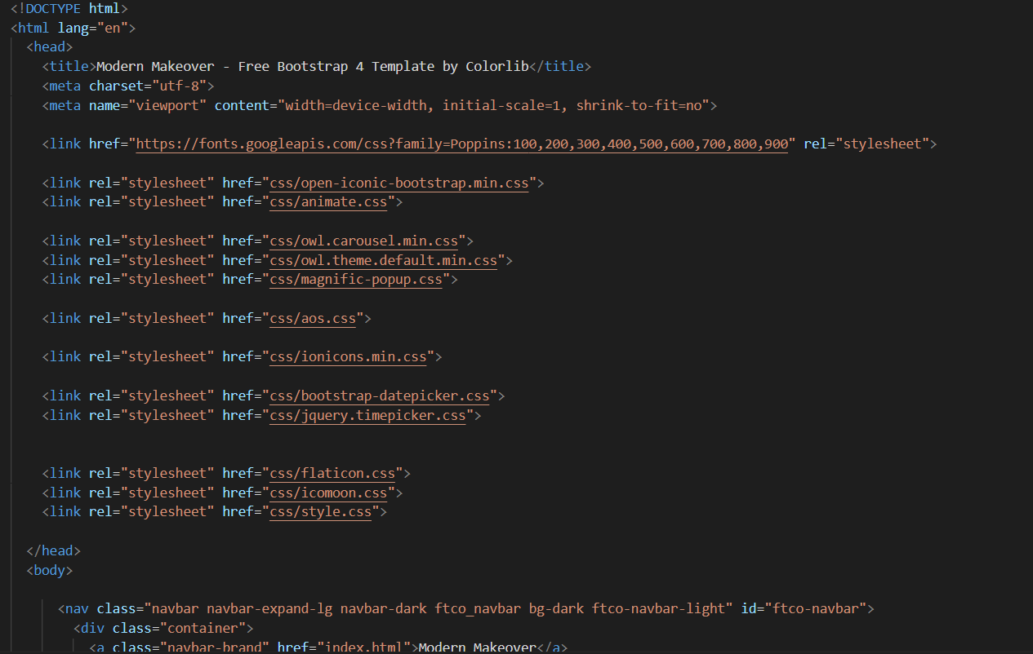

Fig: 7.2

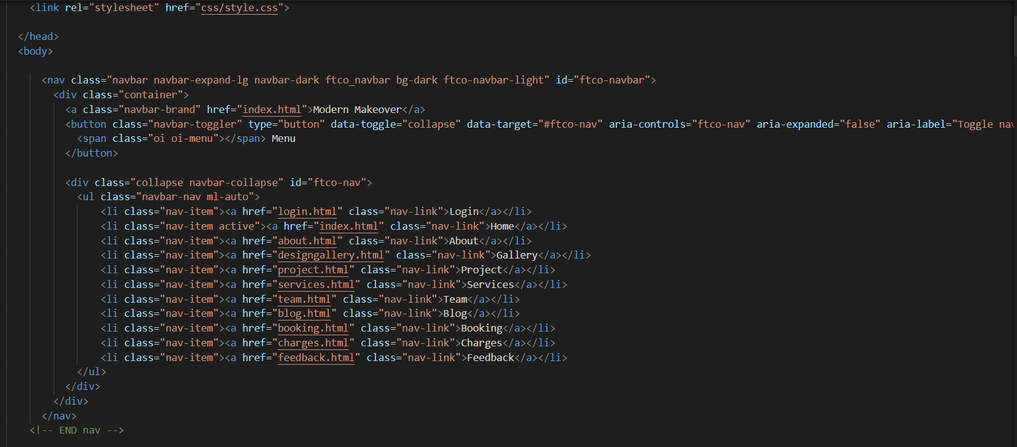

Fig: 7.2.1

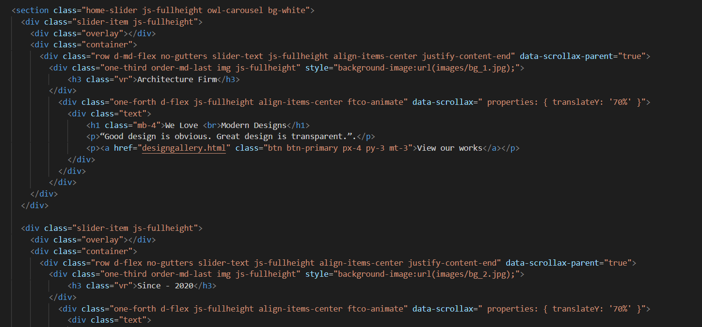

Fig: 7.2.2

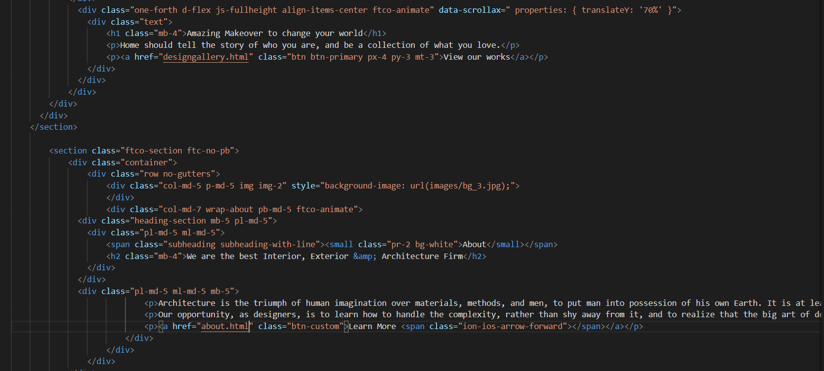

Fig: 7.2.3

**Wireframe for Home Page:**

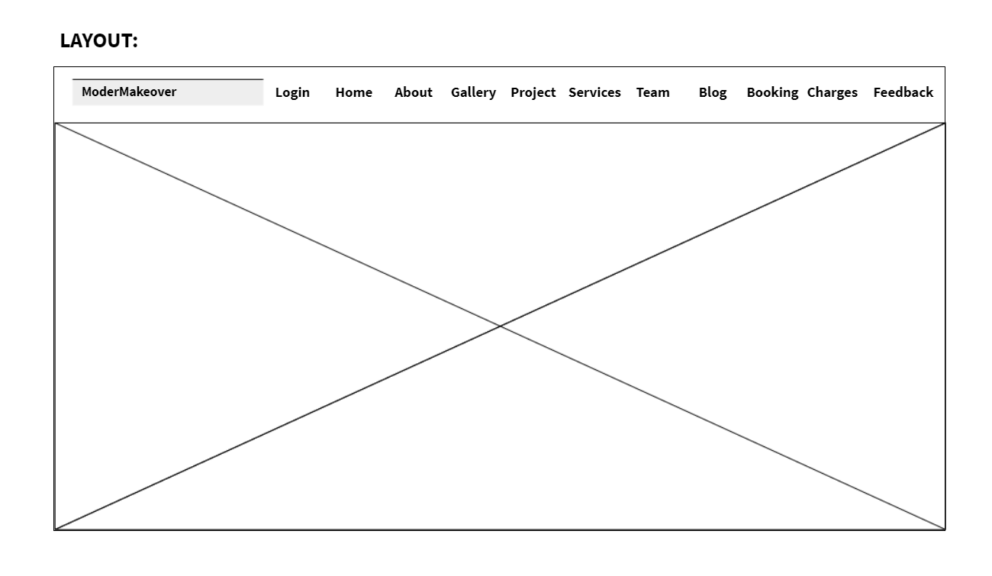

Fig: 7.2.4

Output:

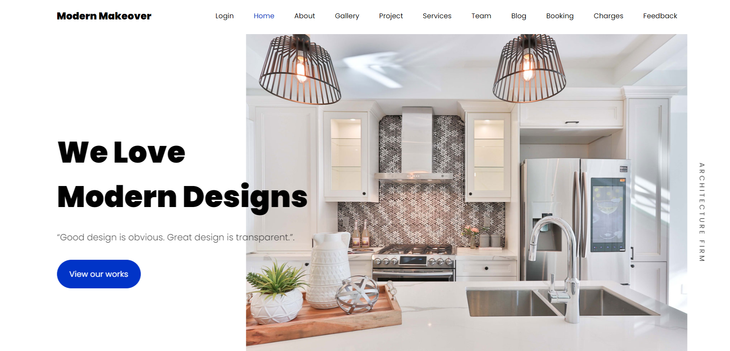

Fig: 7.2.5

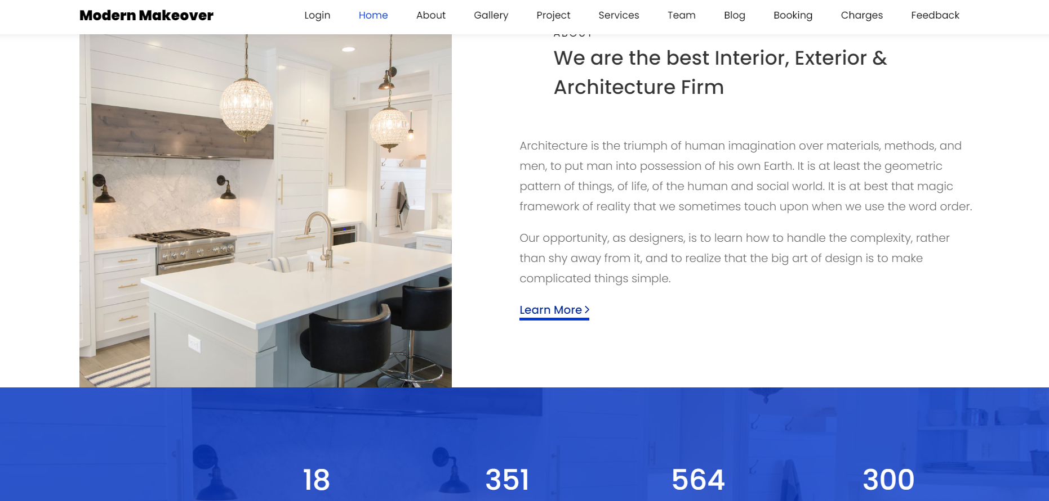

Fig: 7.2.6

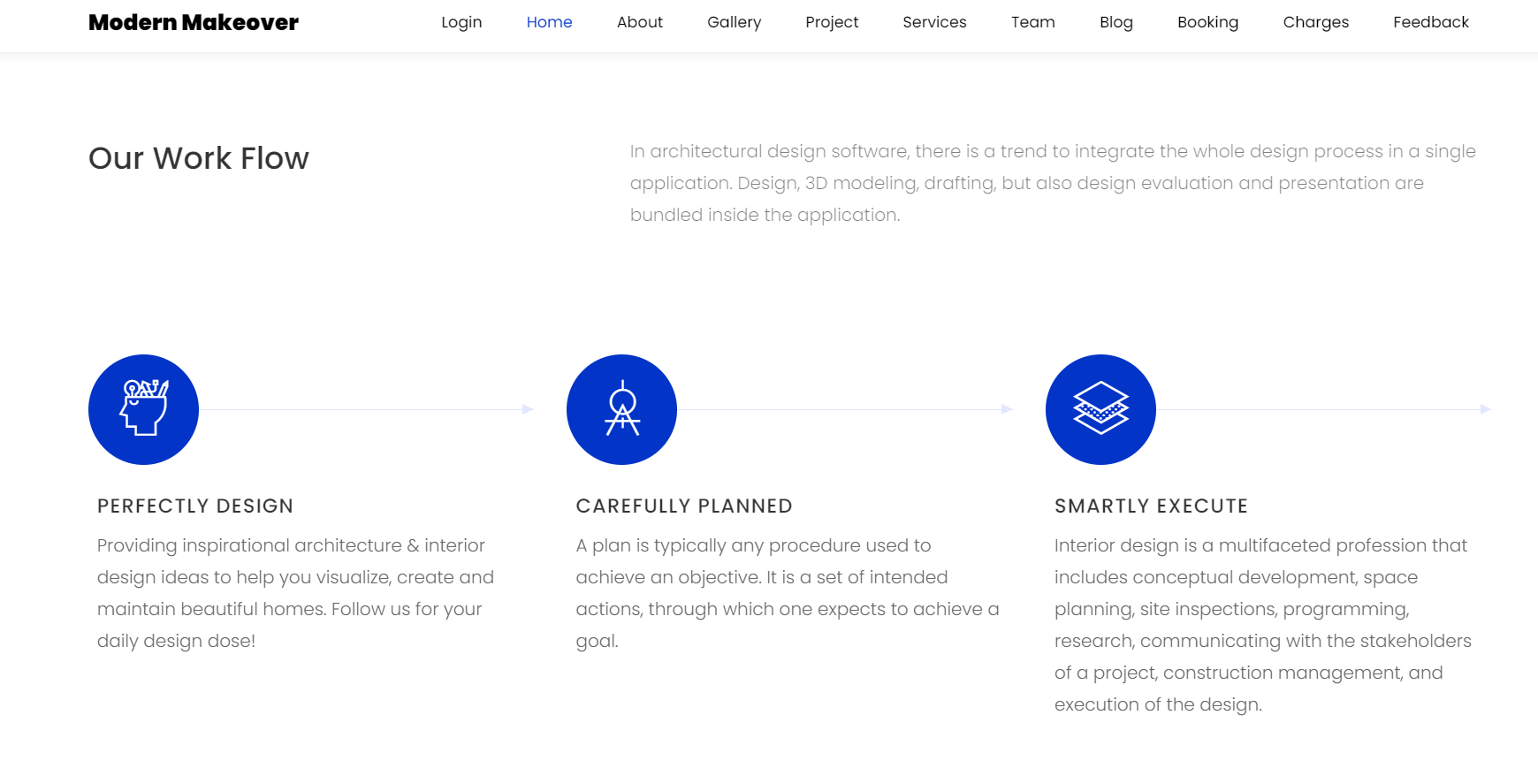

Fig: 7.2.7

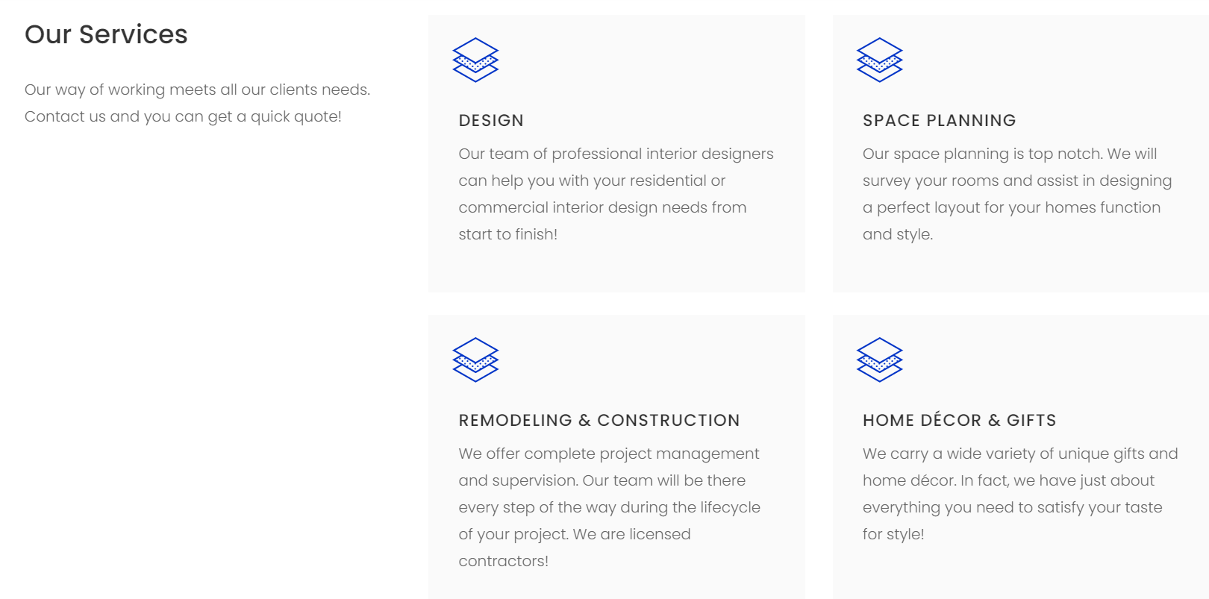

Fig: 7.2.8

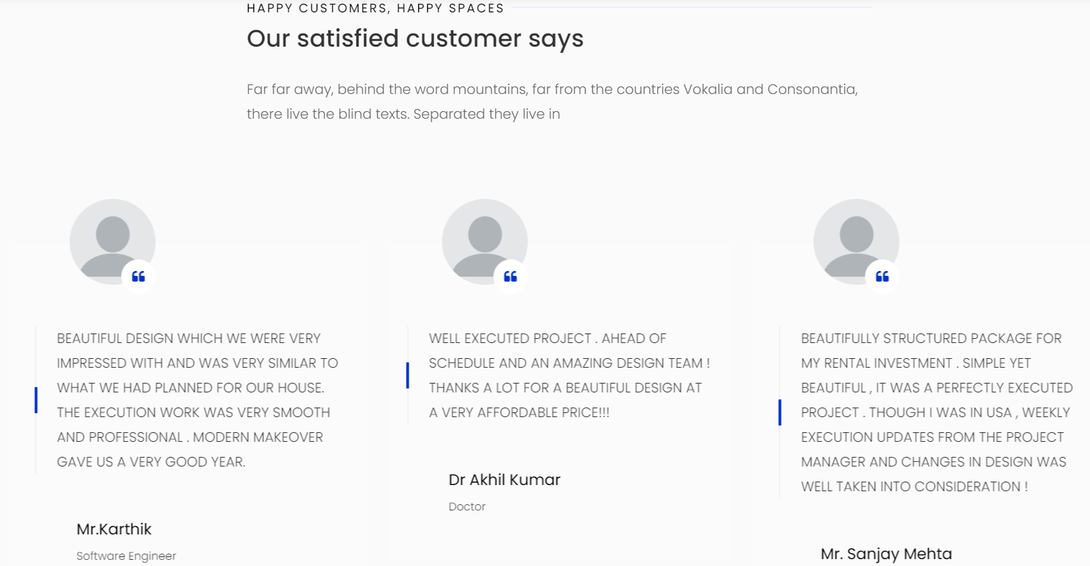

Fig: 7.2.9

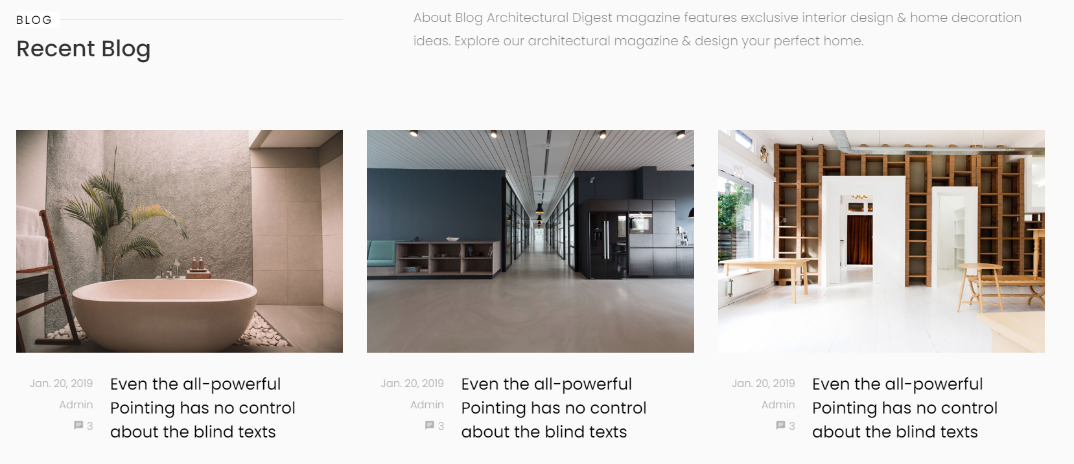

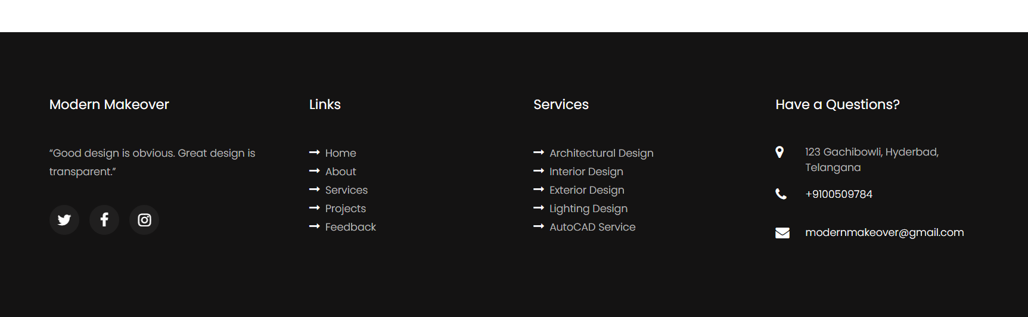

Fig: 7.2.10

**ABOUT US PAGE:**

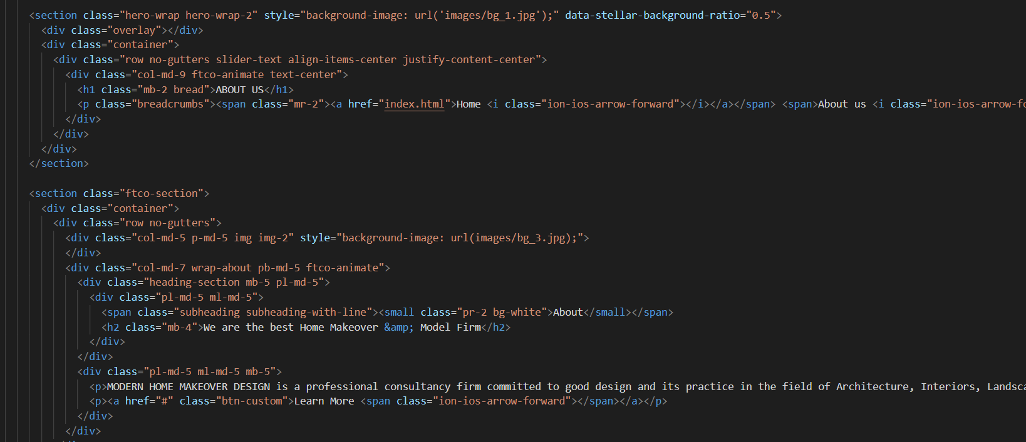

Fig: 7.3

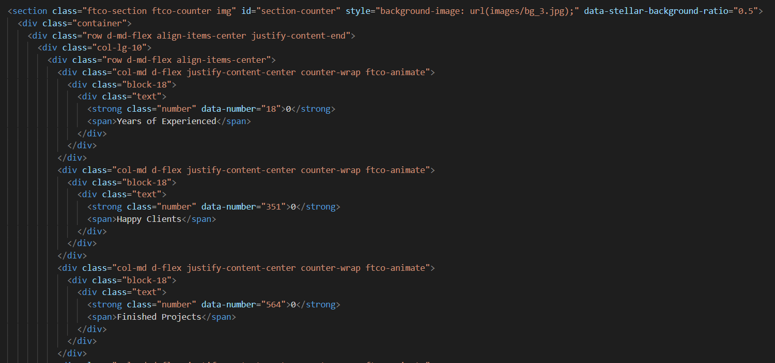

Fig: 7.3.1

**Wireframes for About us page:**

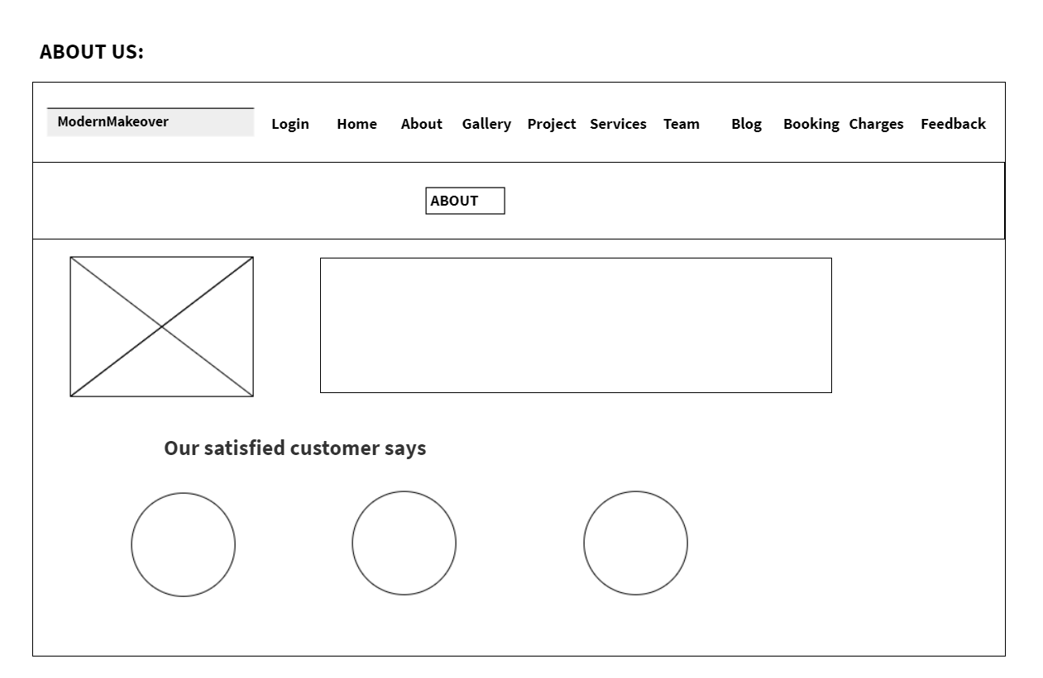

Fig: 7.3.2

Output:

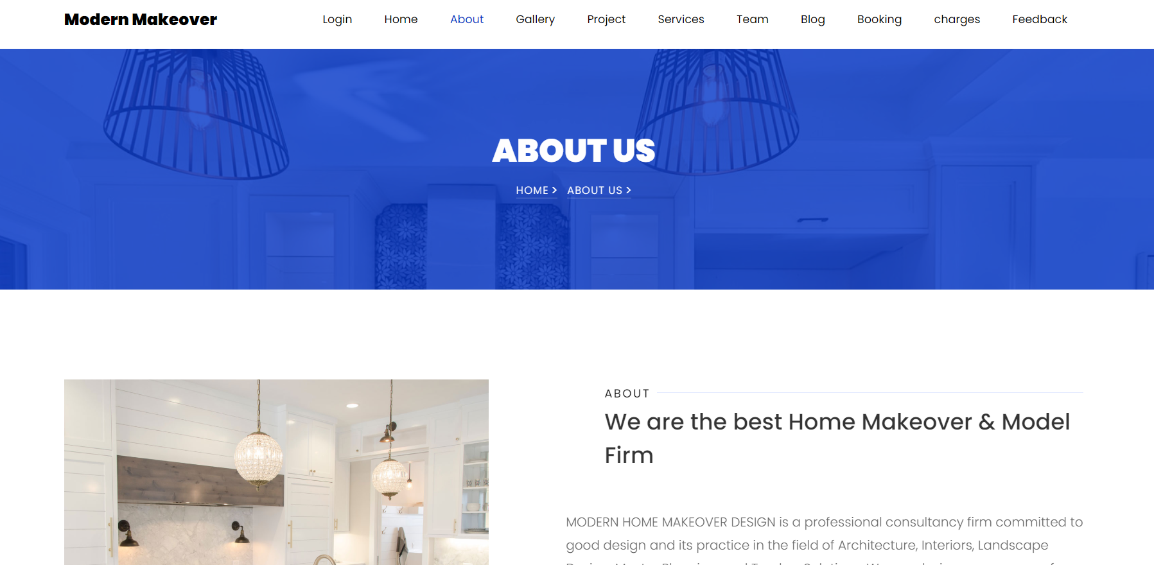

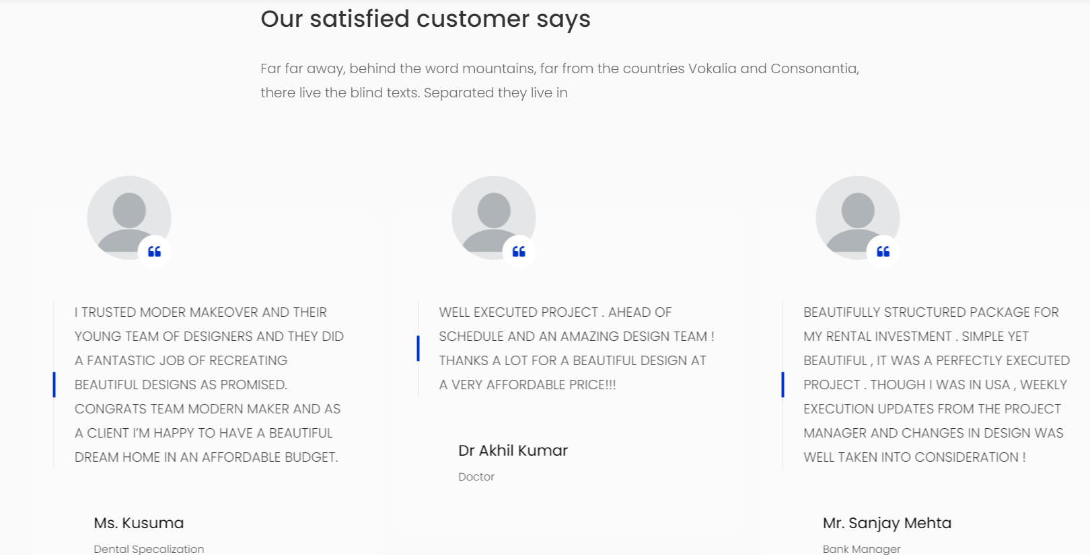

Fig: 7.3.3

**DESIGN GALLERY:**

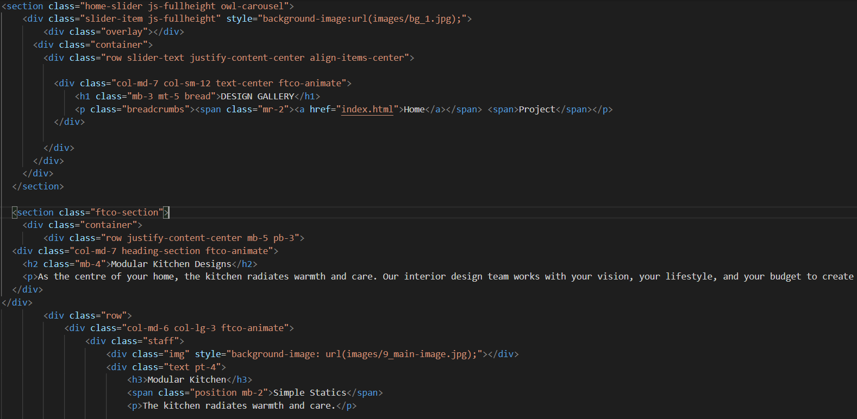

Fig: 7.4

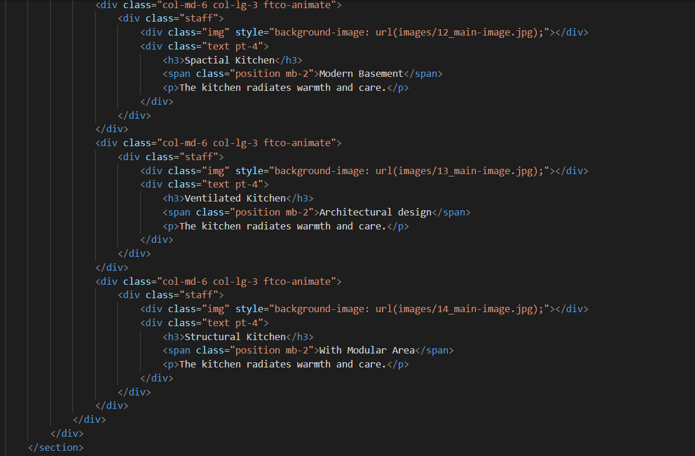

Fig: 7.4.1

**Wireframe for Design Gallery**

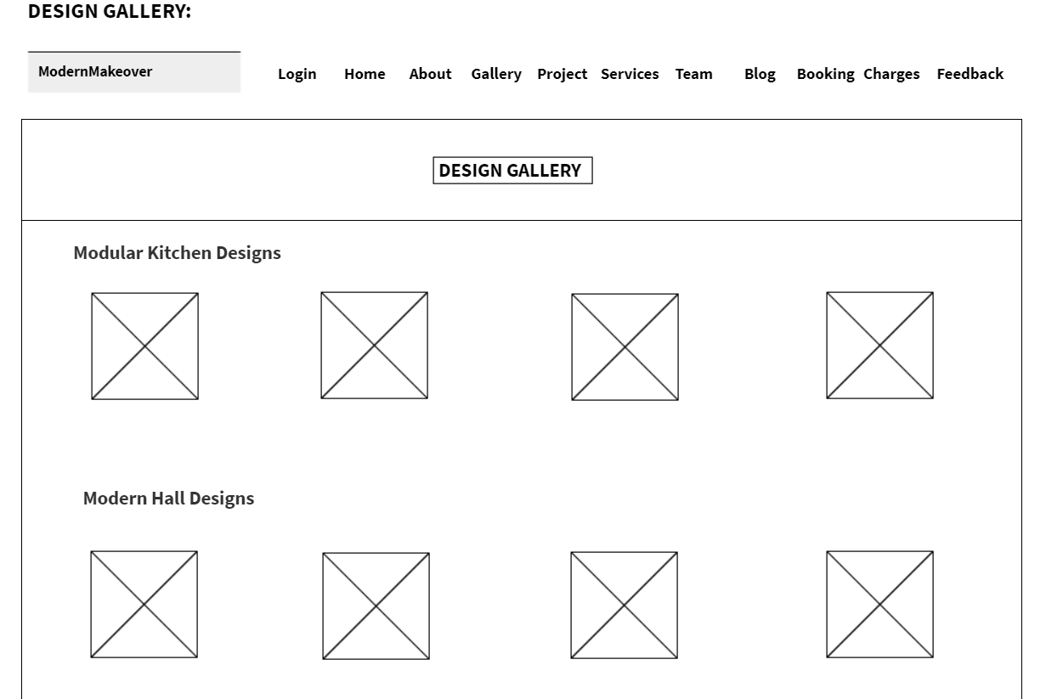

Fig: 7.4.2

Output:

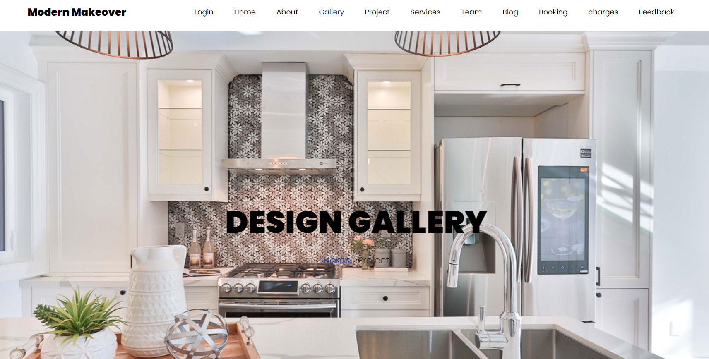

Fig: 7.4.3

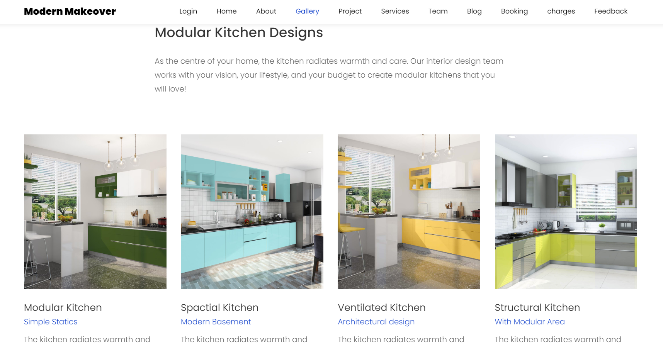

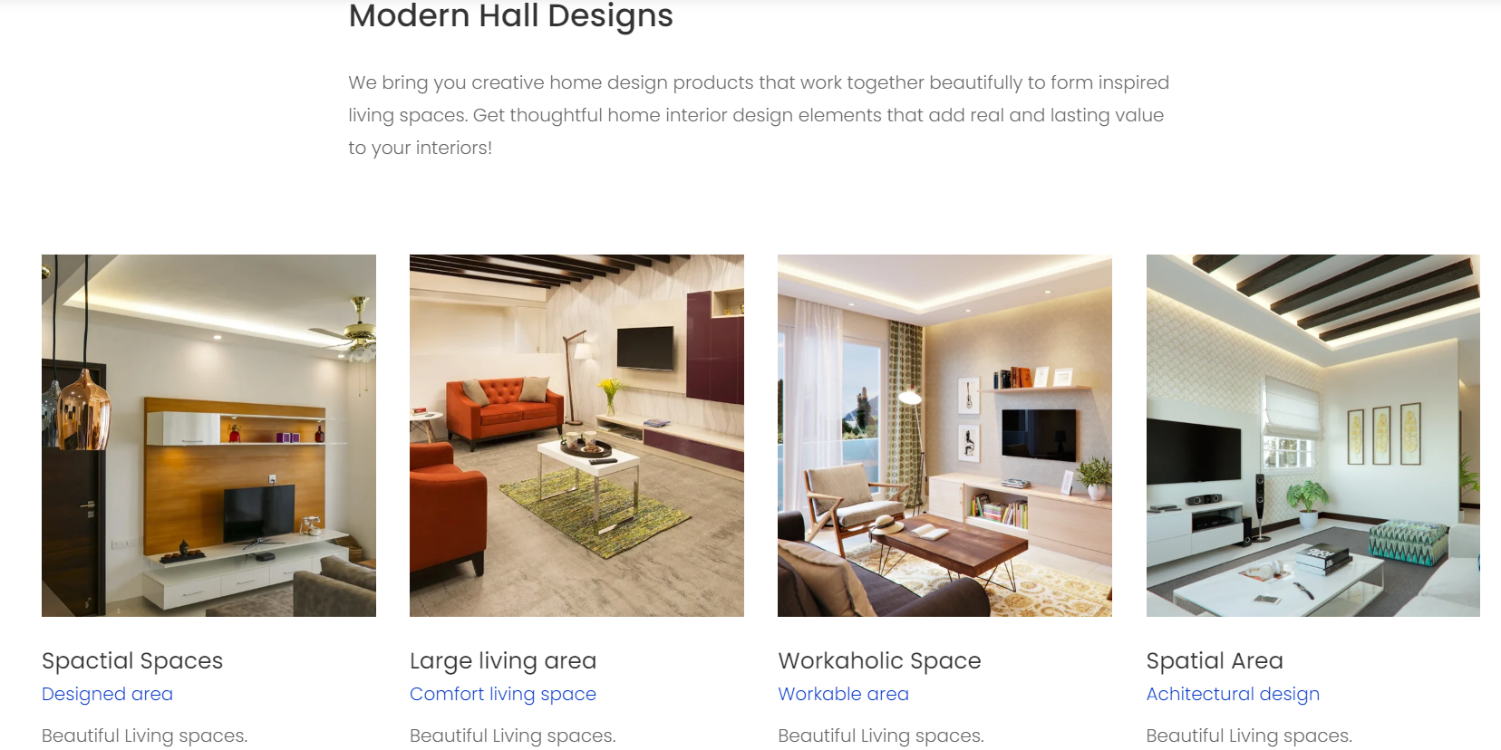

Fig: 7.4.4

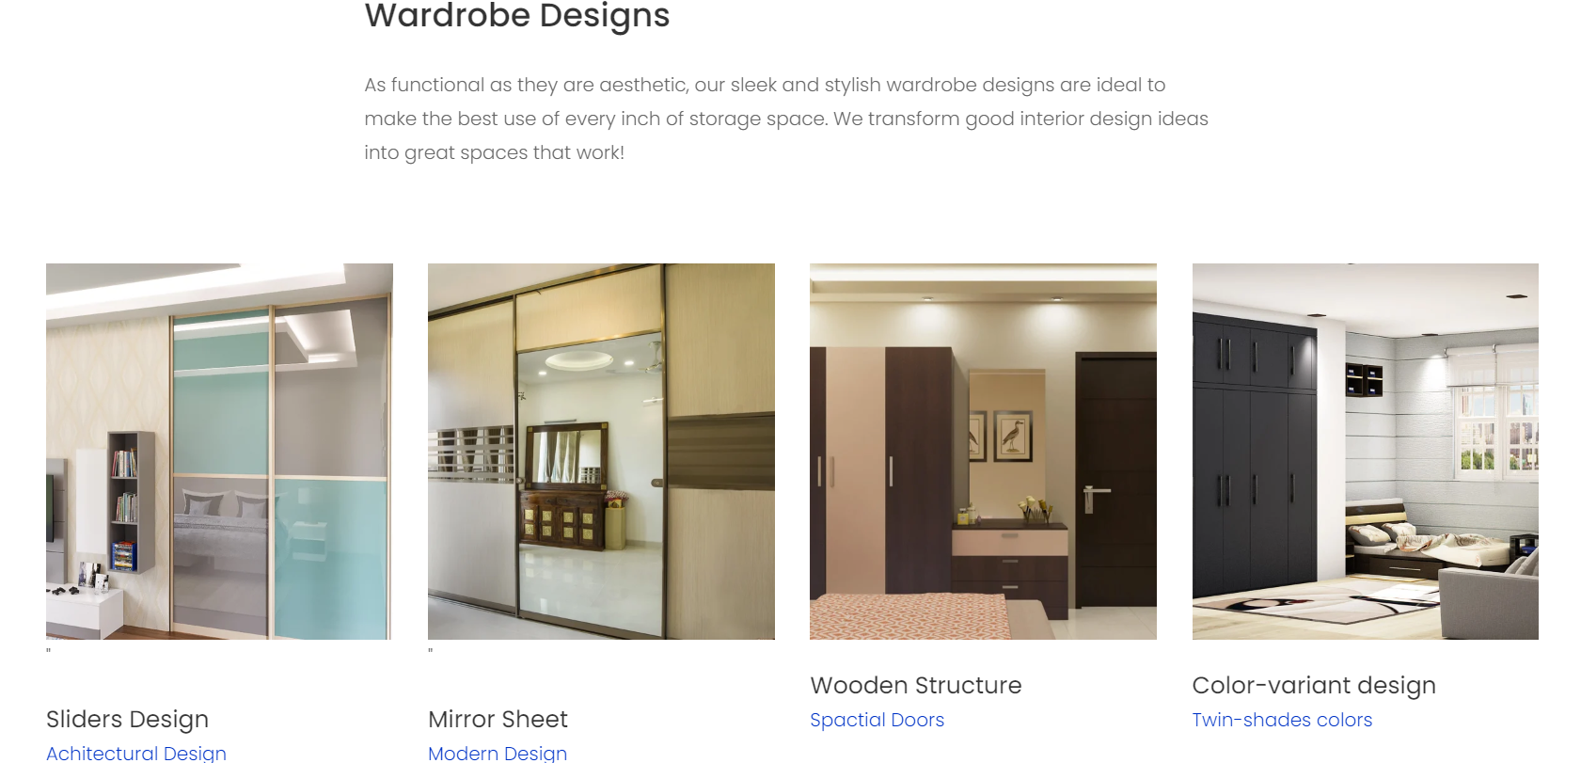

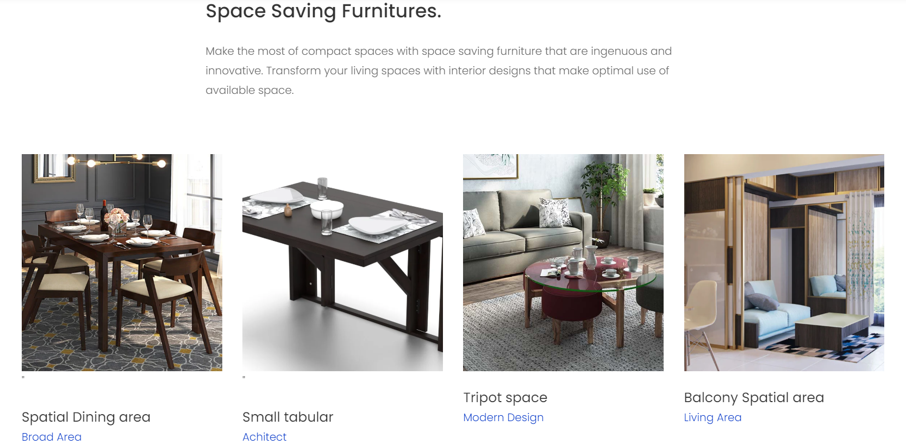

Fig: 7.4.5

**PROJECT PAGE:**

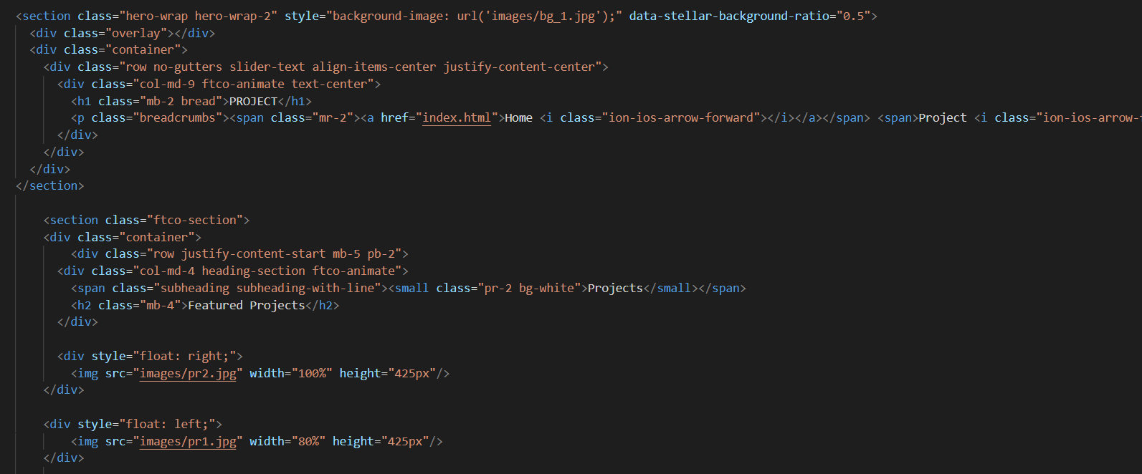

Fig: 7.5

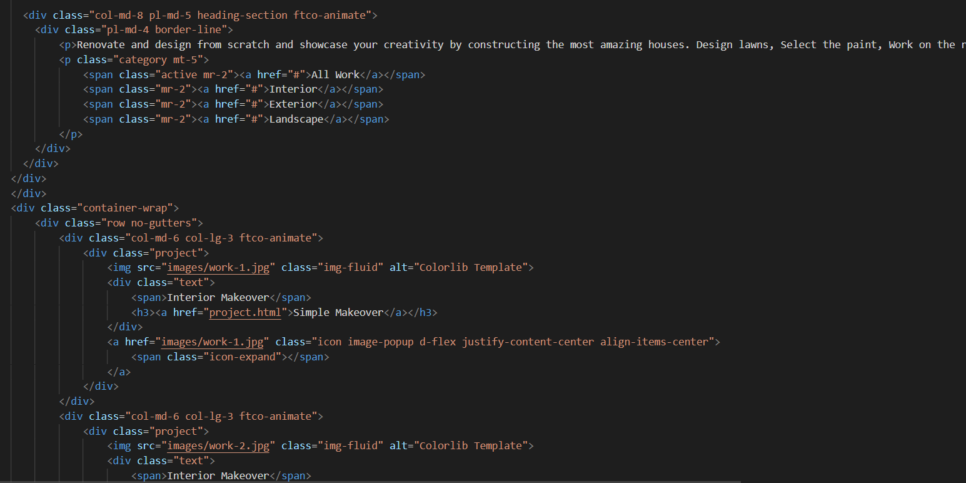

Fig: 7.5.1

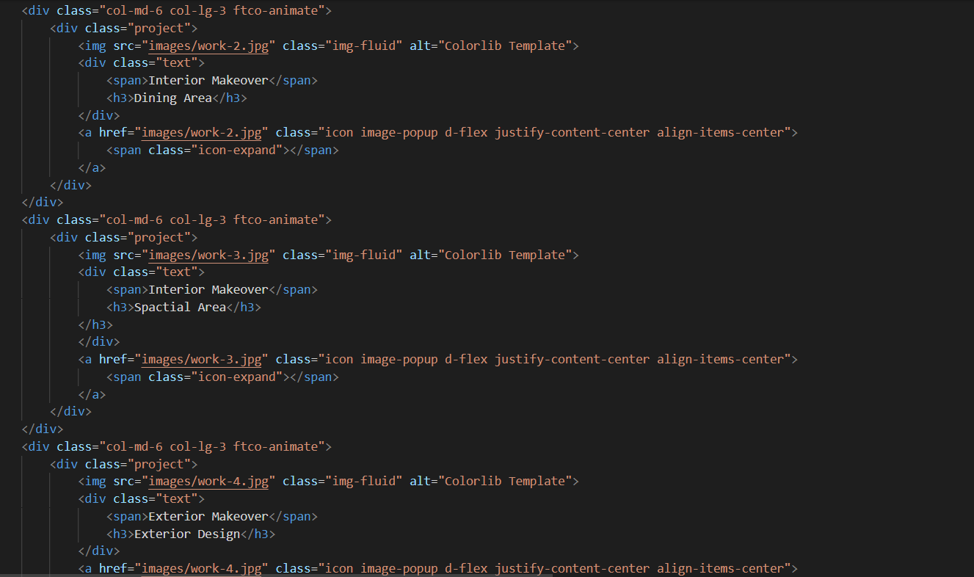

Fig: 7.5.2

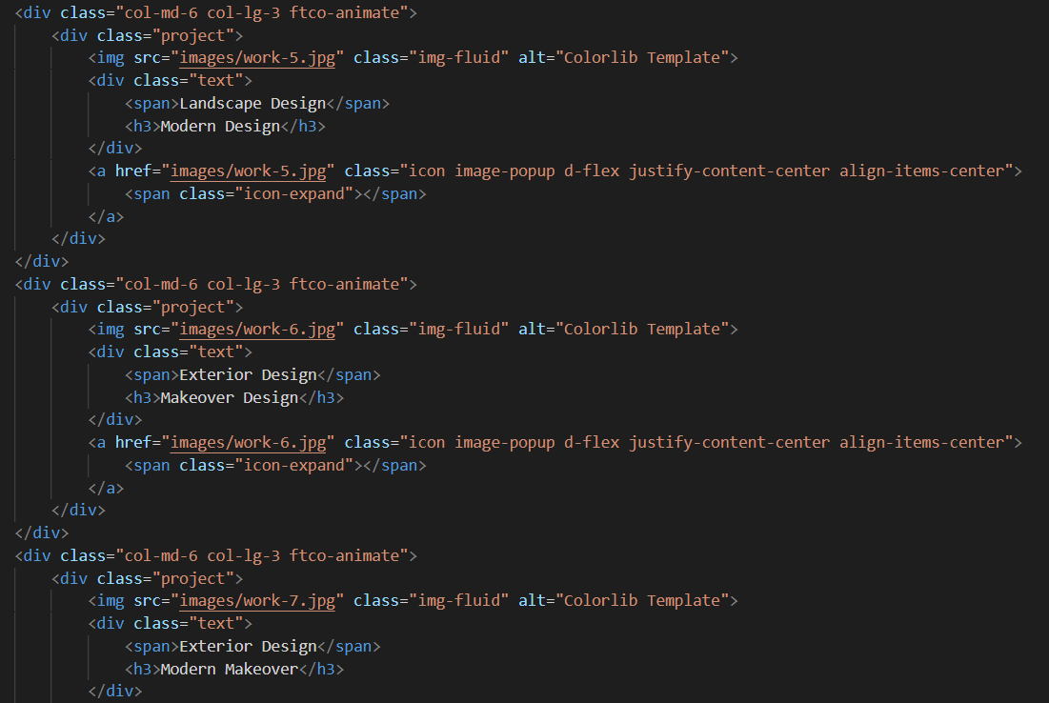

Fig: 7.5.3

**Wireframe for Project Page:**

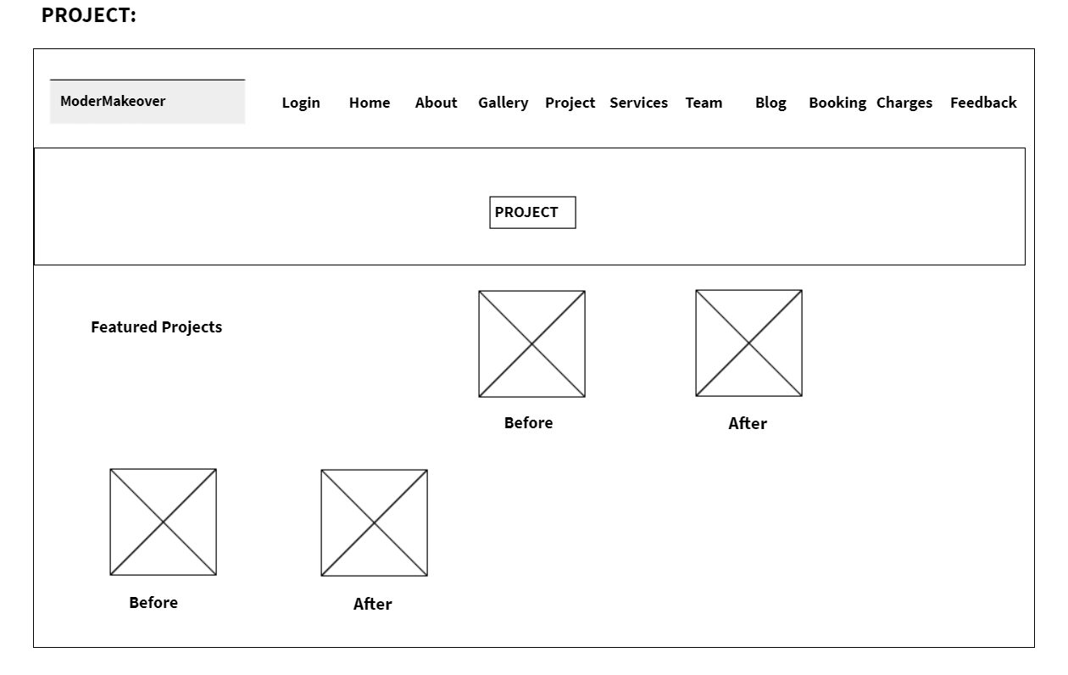

Fig: 7.5.4

Output:

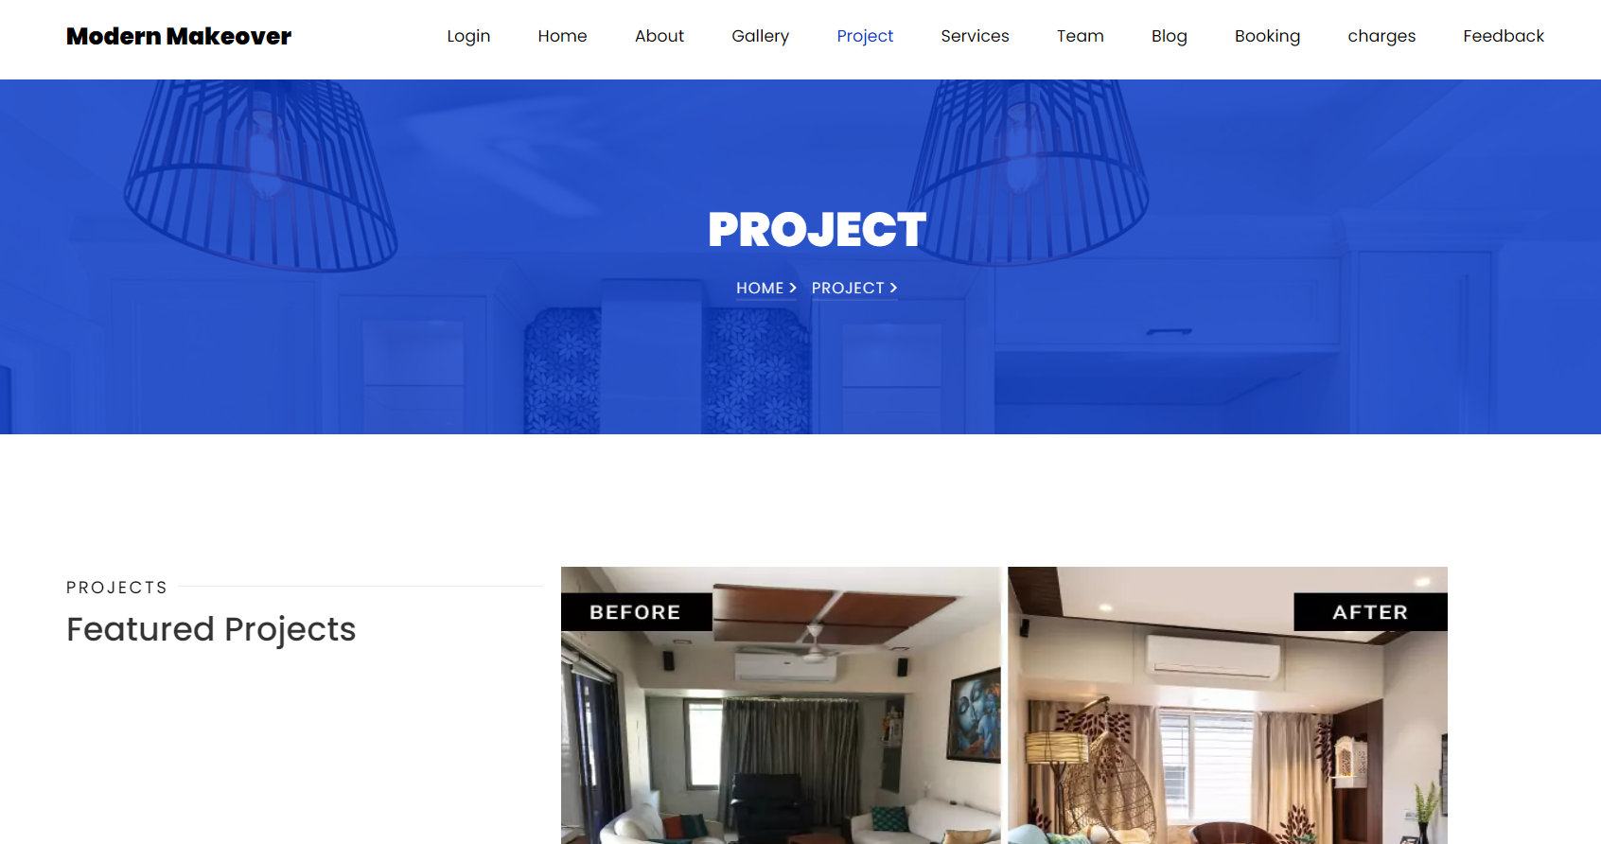

Fig: 7.5.5

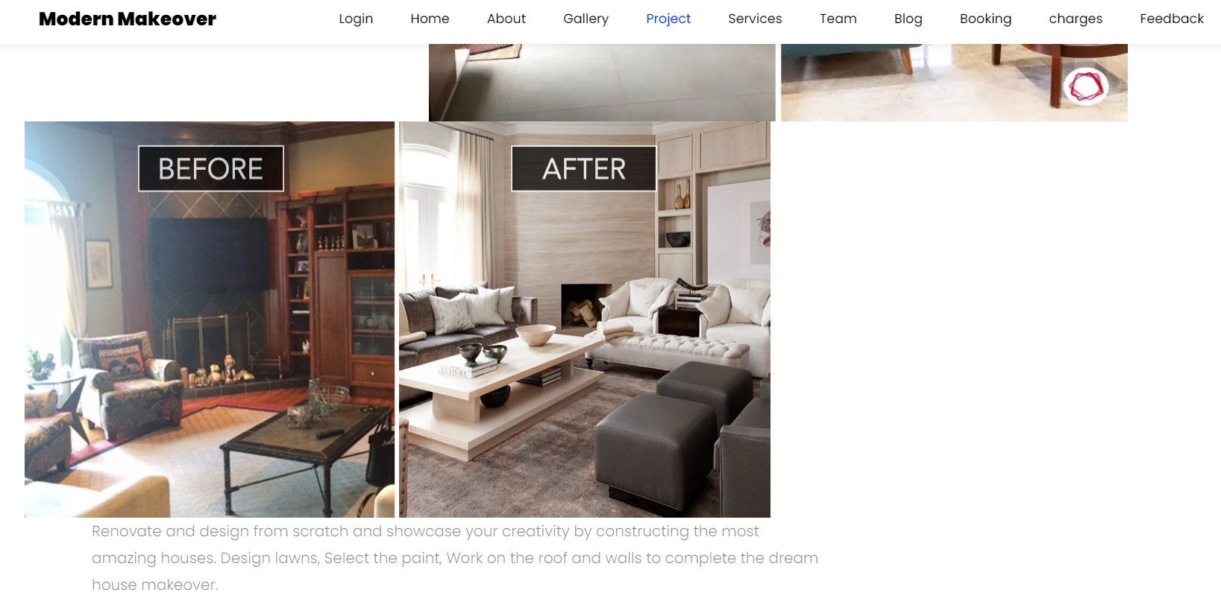



Fig: 7.5.6



Fig: 7.5.7

**SERVICES PAGE:**

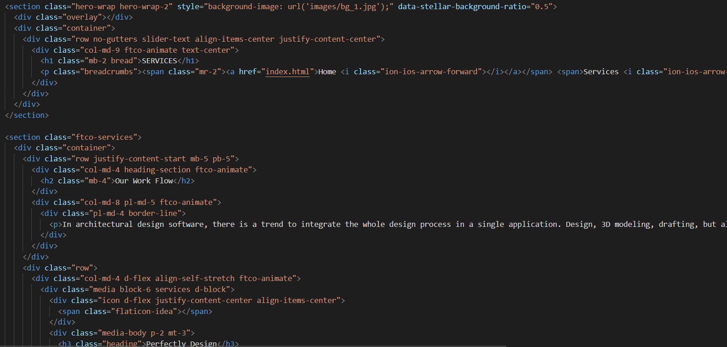

Fig: 7.6

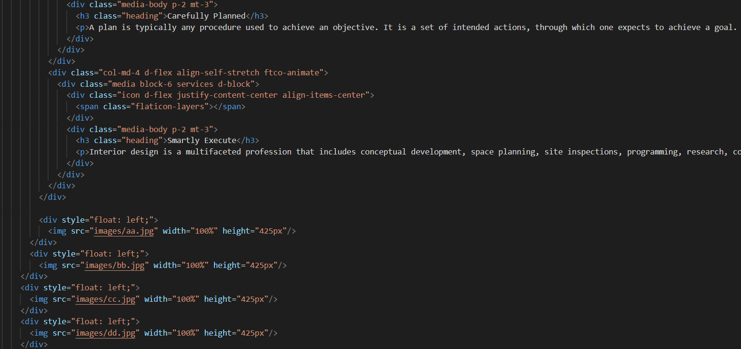

Fig: 7.6.1

**Wireframe for Services Page:**

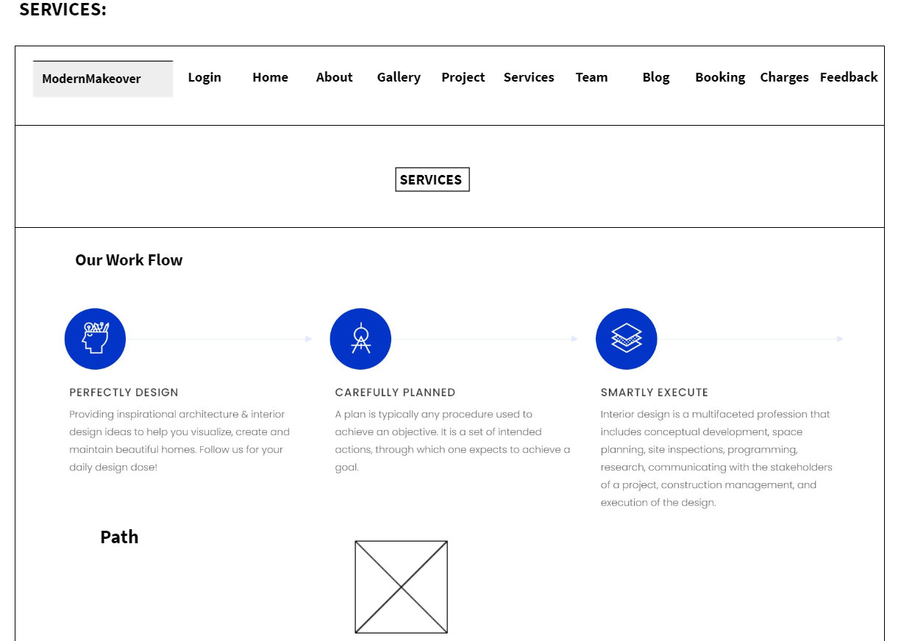

Fig: 7.6.2

Output:

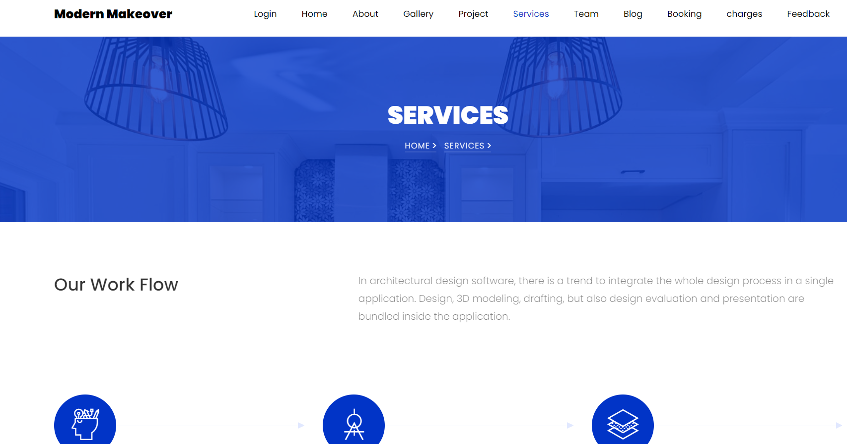

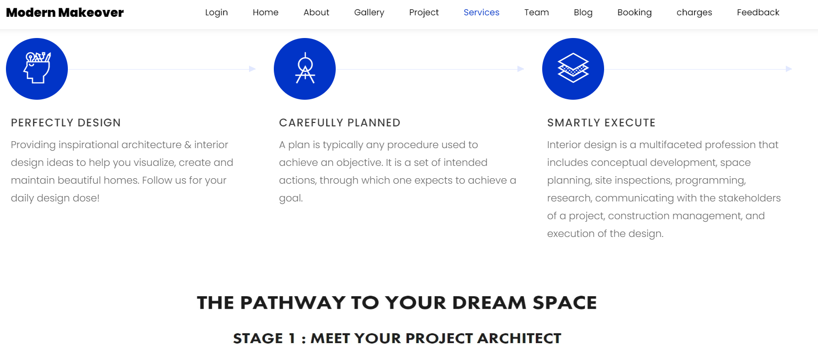

Fig: 7.6.3

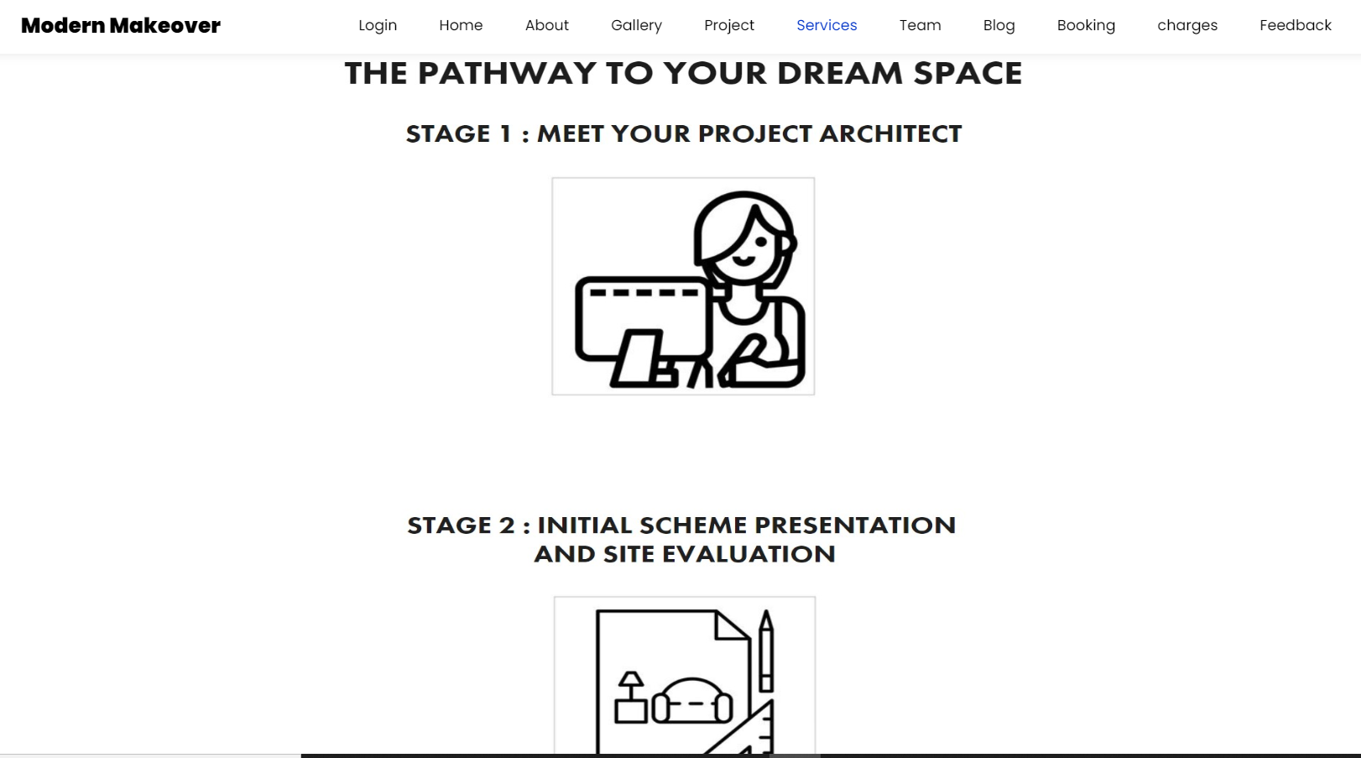

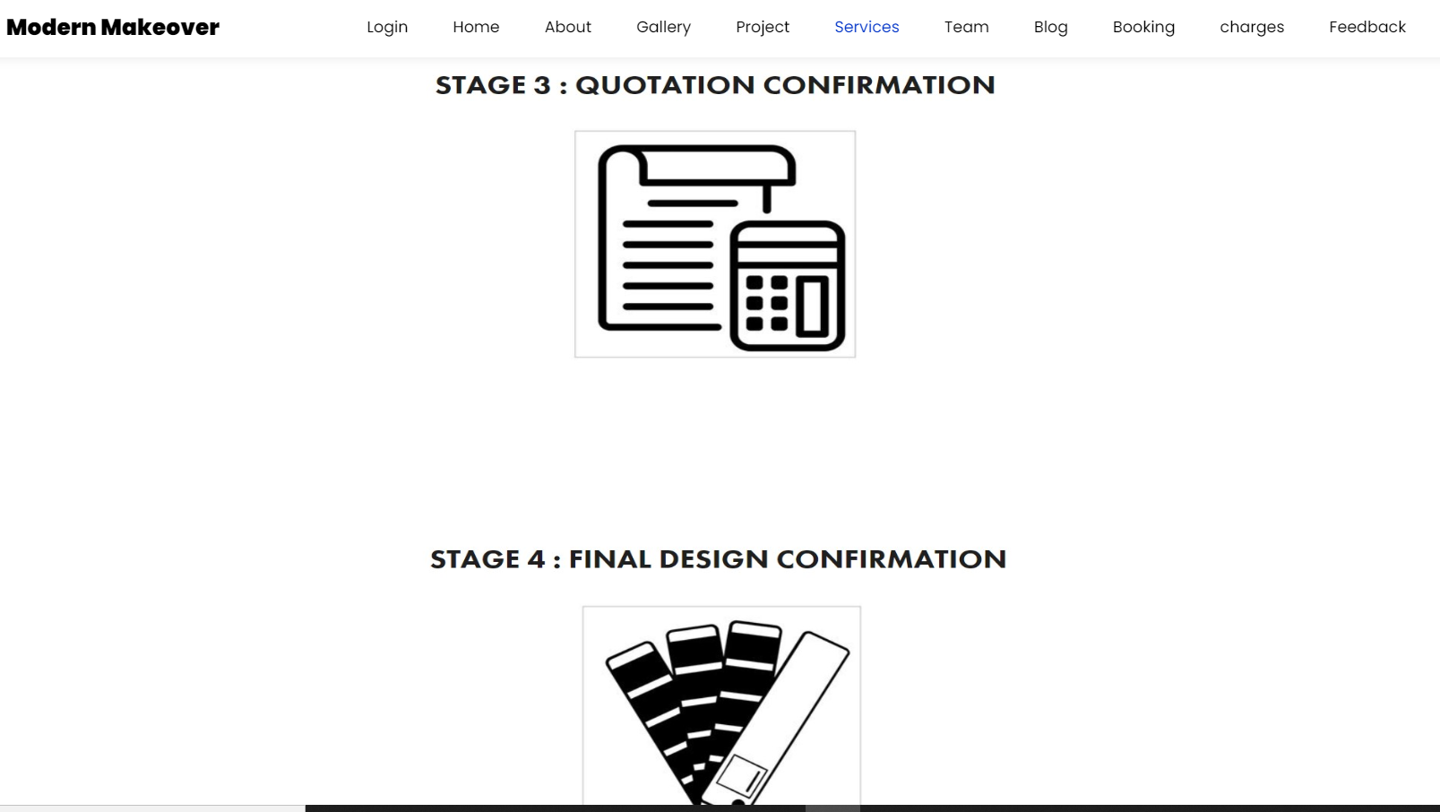

Fig: 7.6.4

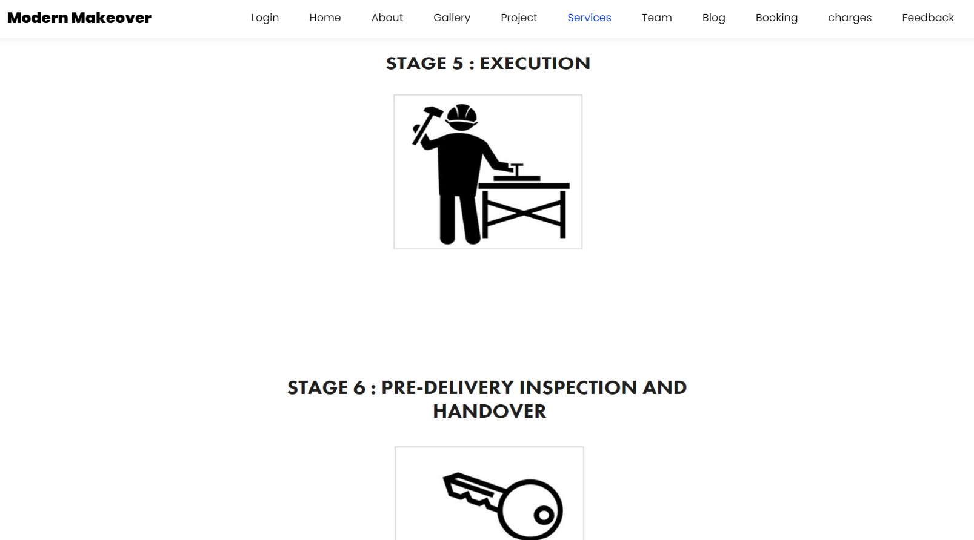

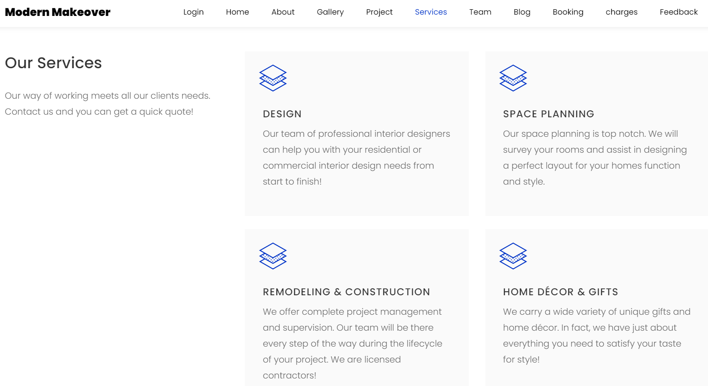

Fig: 7.6.5

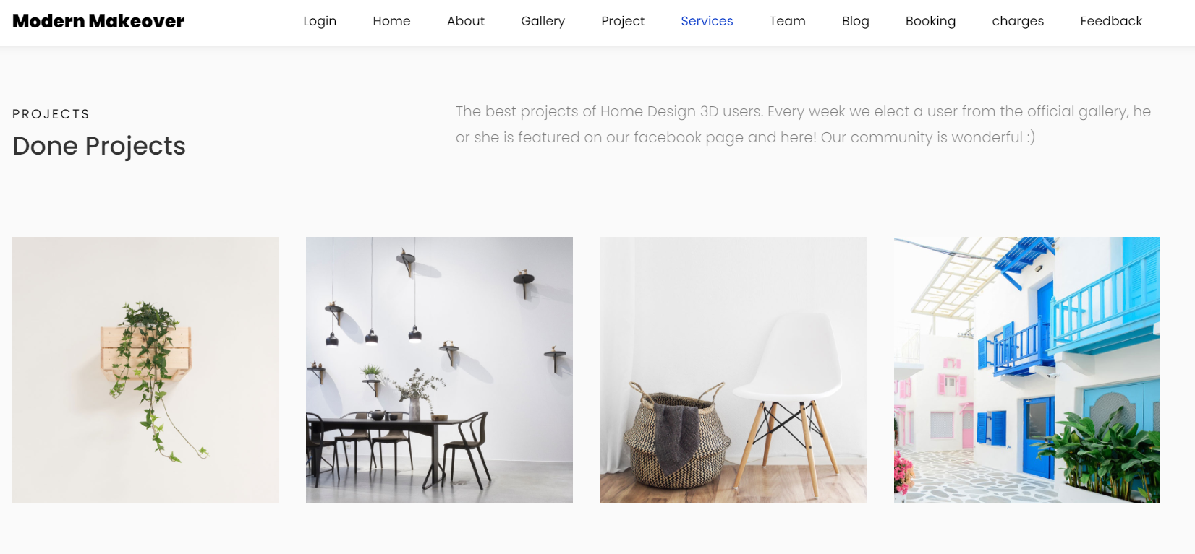

Fig: 7.6.6

**TEAM PAGE:**

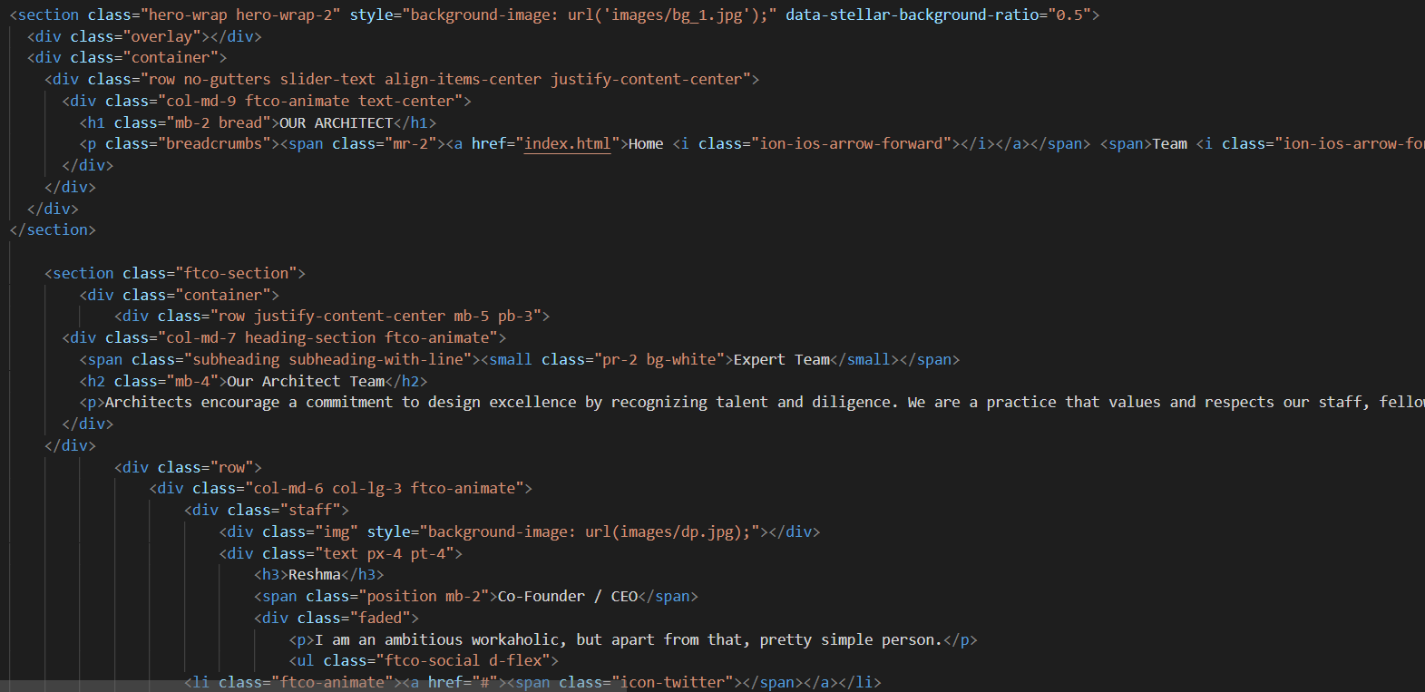

Fig: 7.7

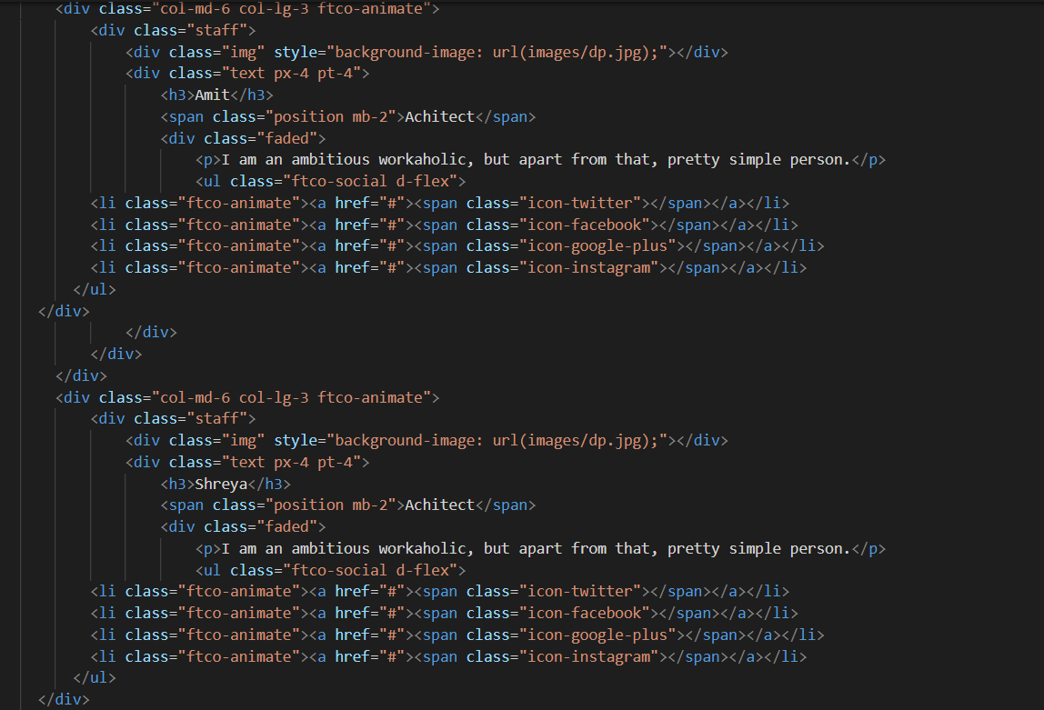

Fig: 7.7.1

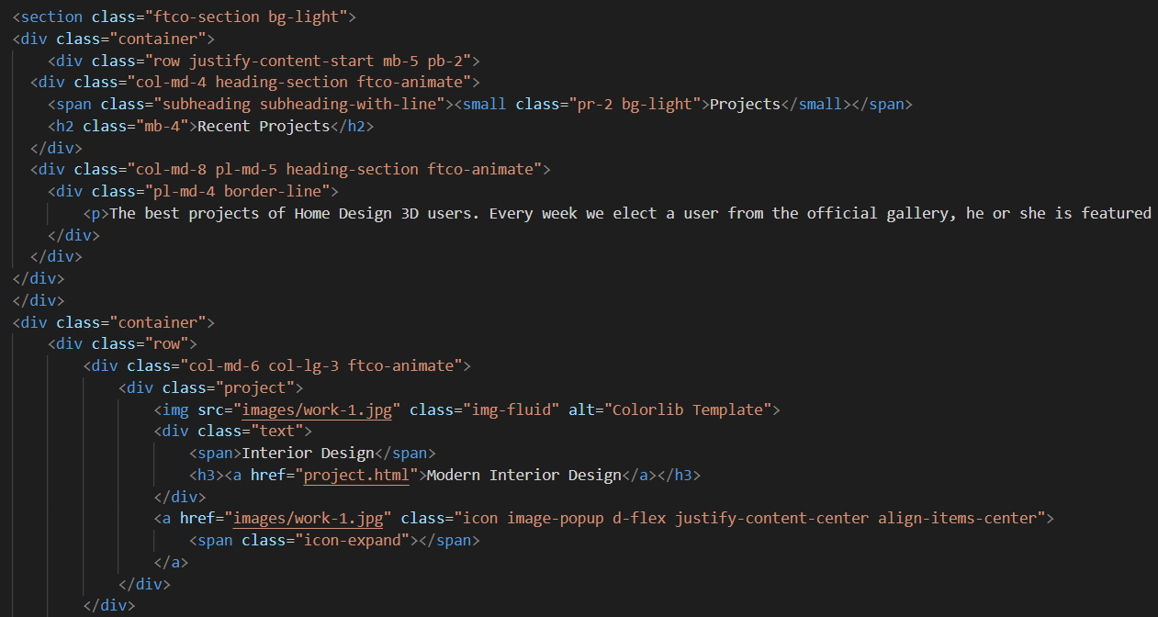

Fig: 7.7.2

**Wireframe for Team Page:**

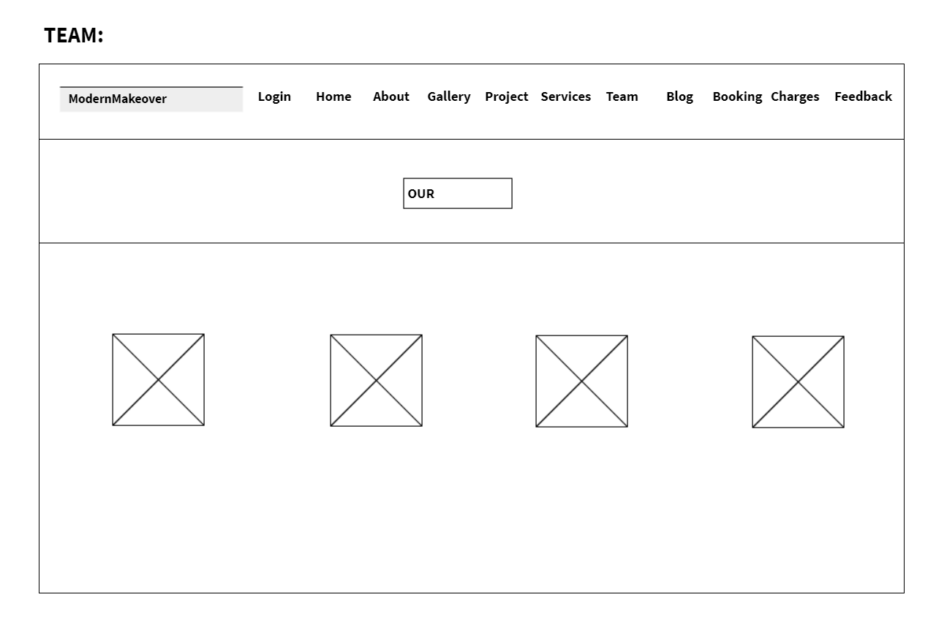

Fig: 7.7.3

Output:



Fig: 7.7.4

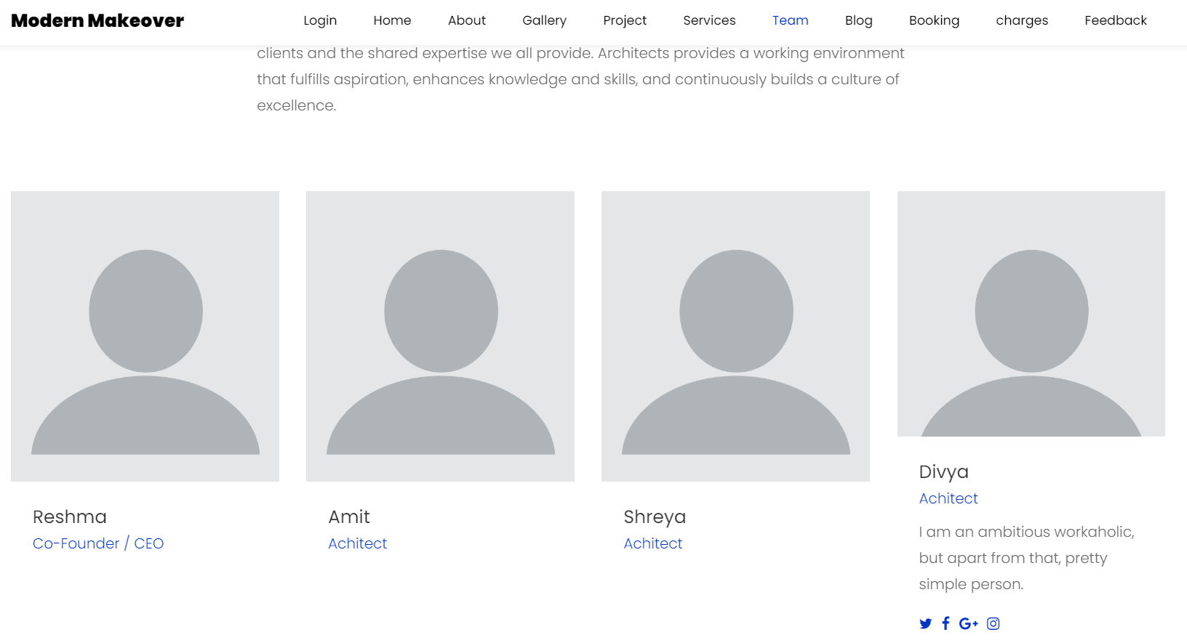

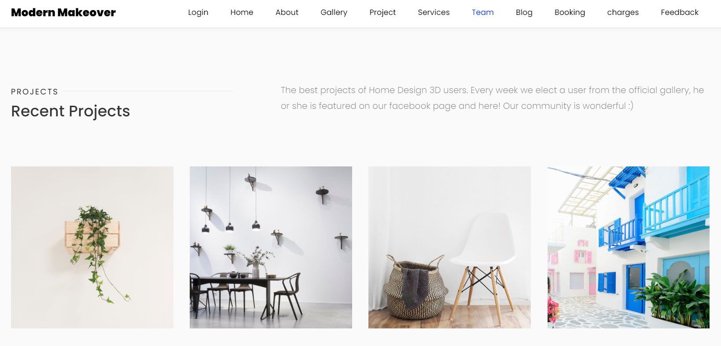

Fig: 7.7.5

**BLOG PAGE:**

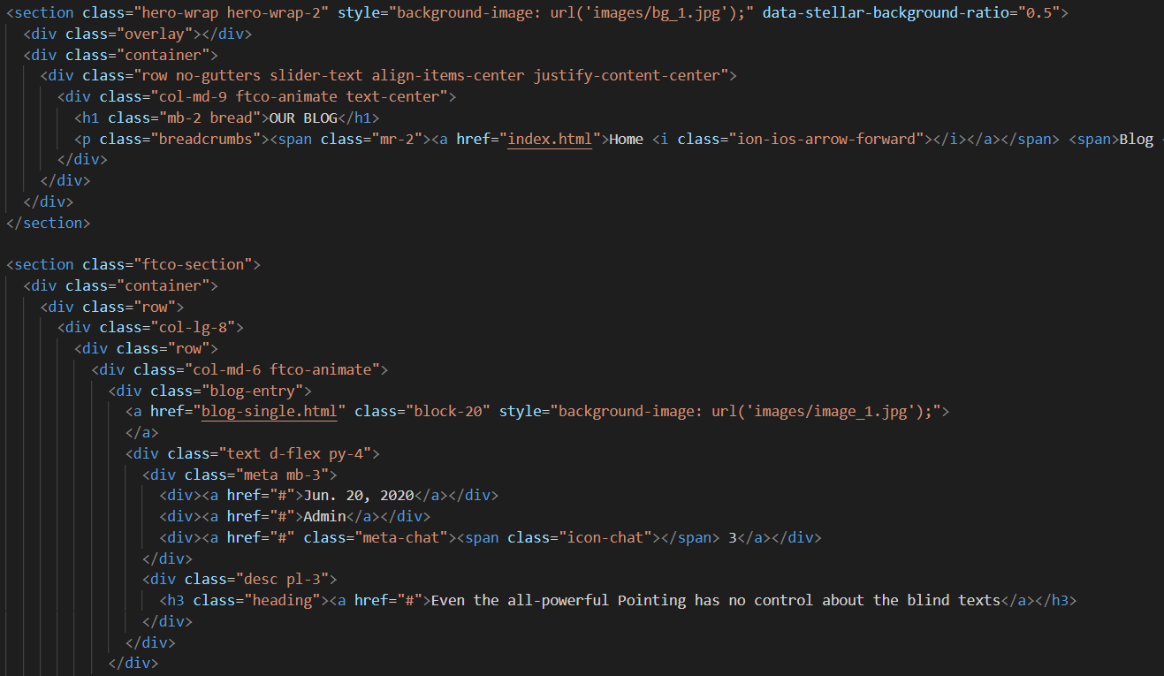

Fig: 7.8

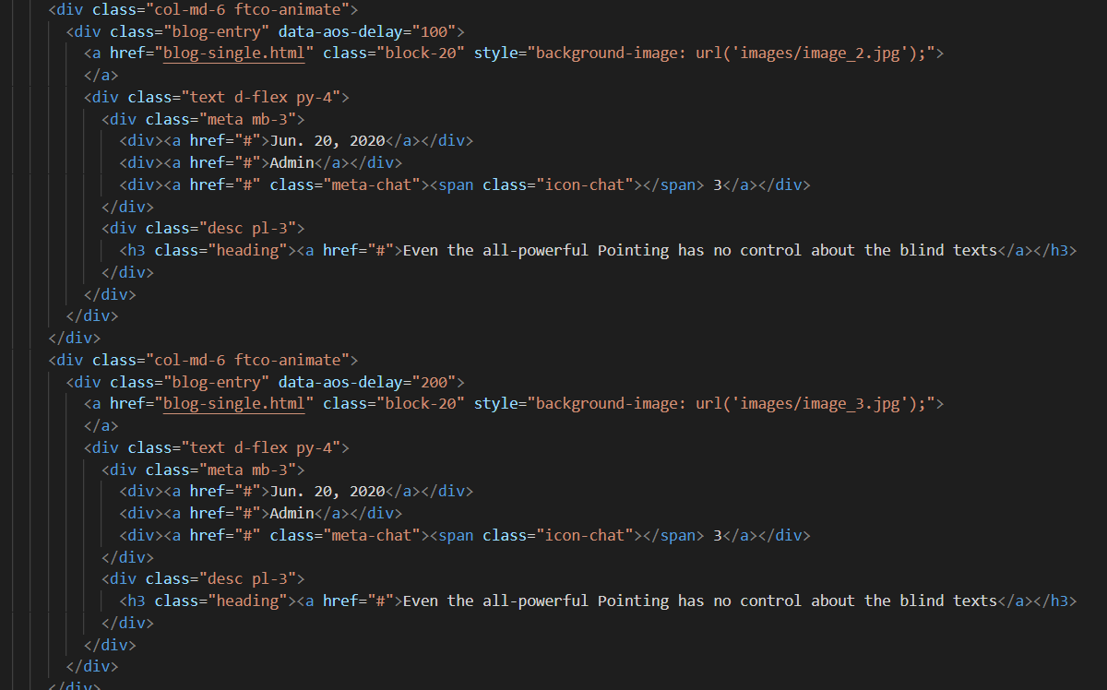

Fig: 7.8.1

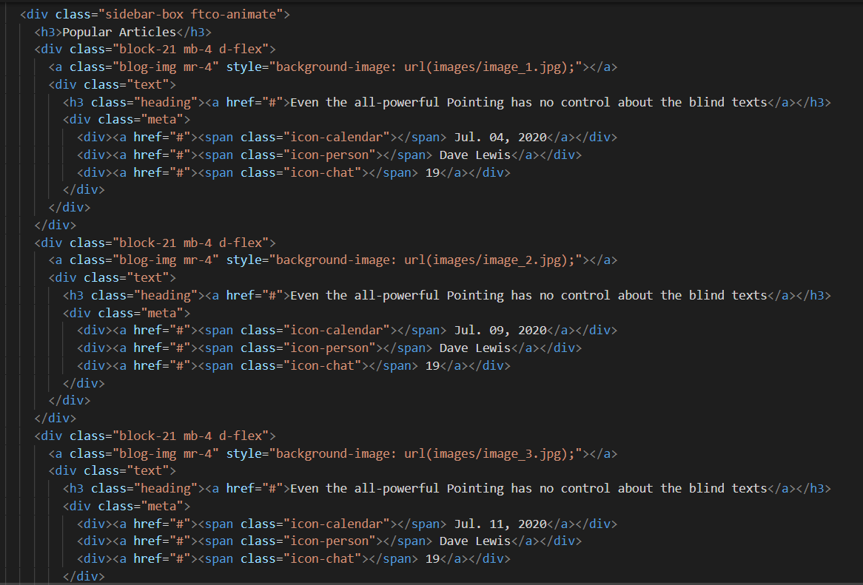

Fig: 7.8.2

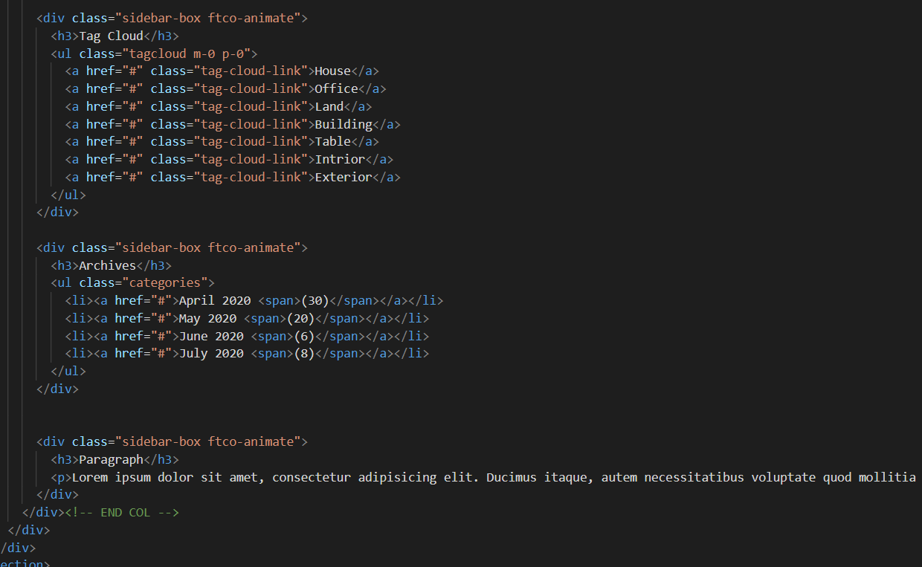

Fig: 7.8.3

Output:

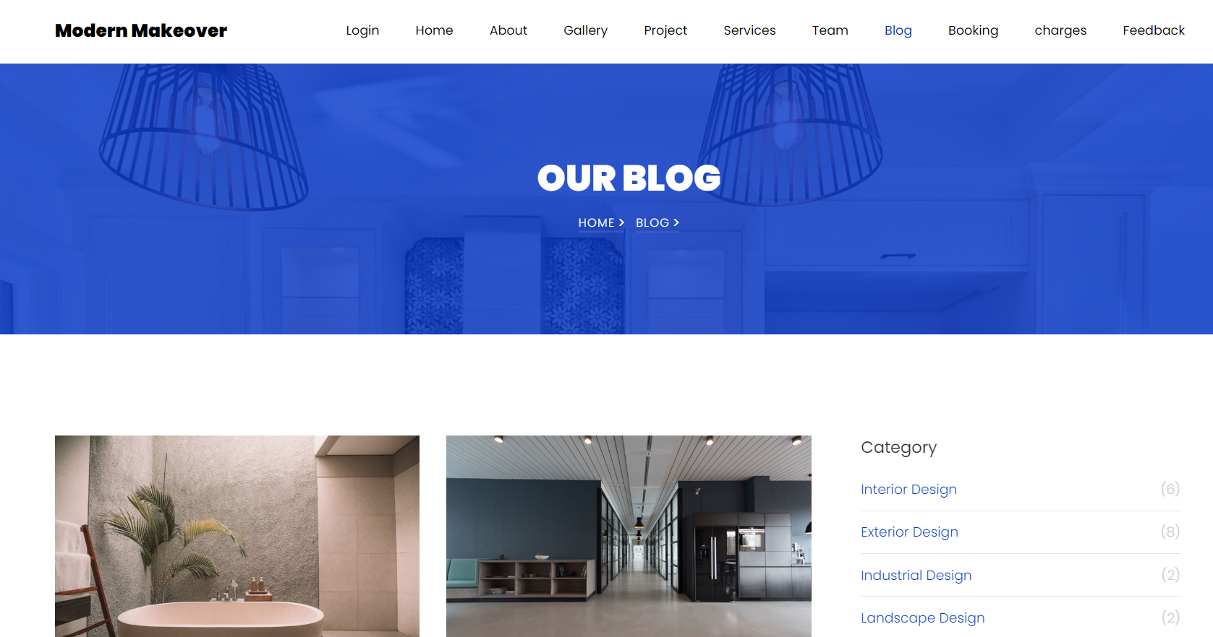

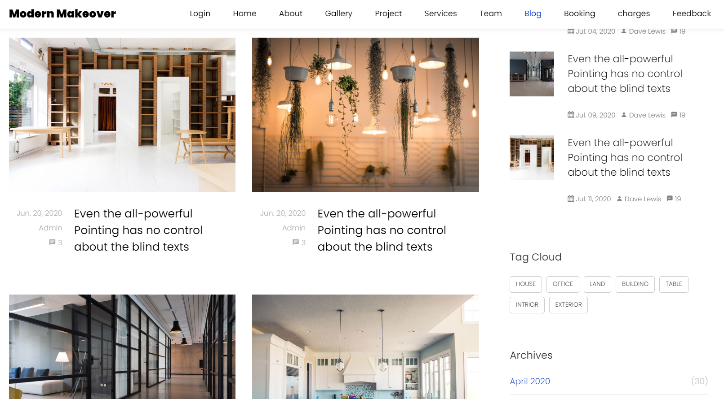

Fig: 7.8.4

**BOOKING PAGE:**

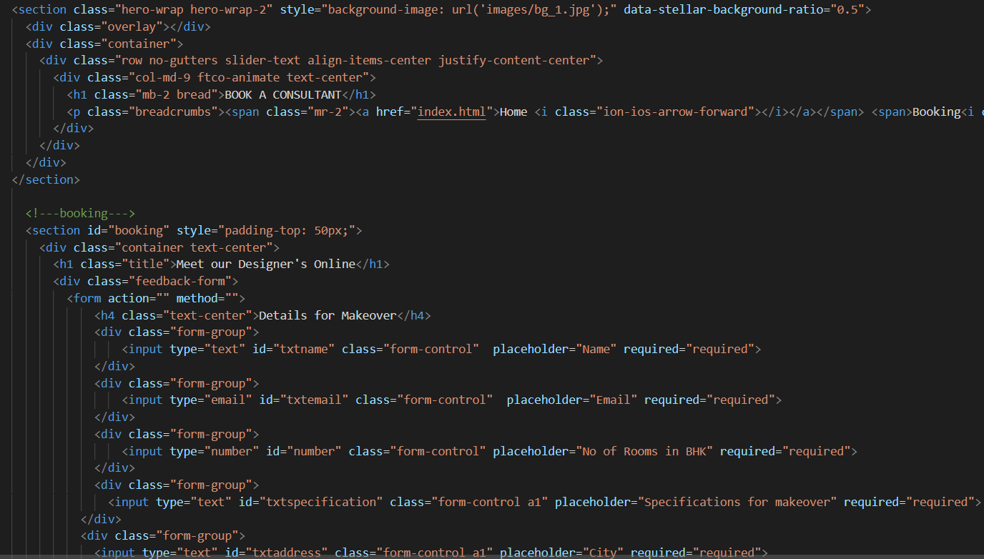

Fig: 7.9

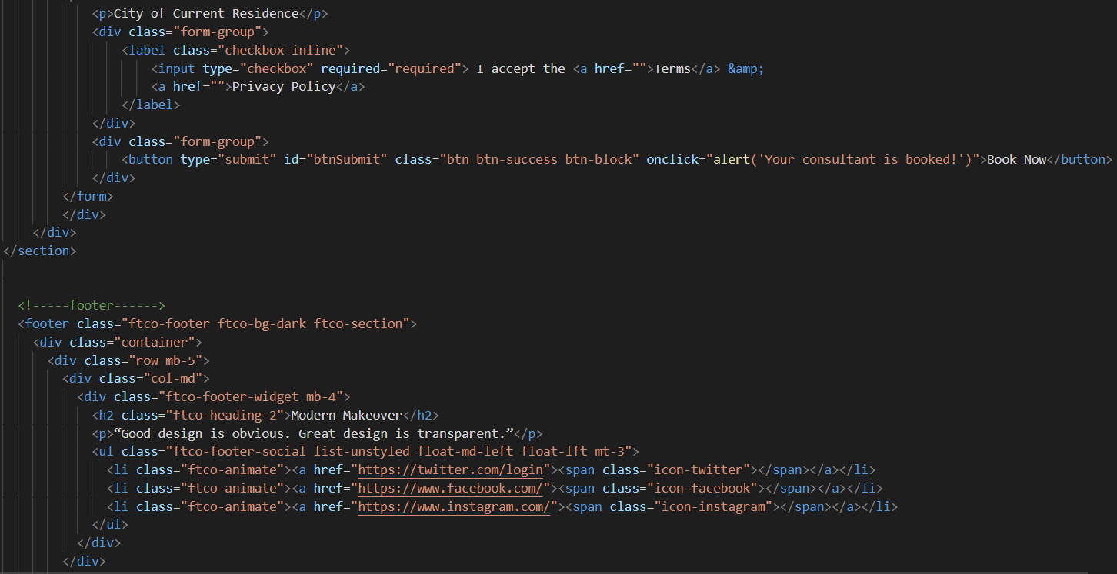

Fig: 7.9.1

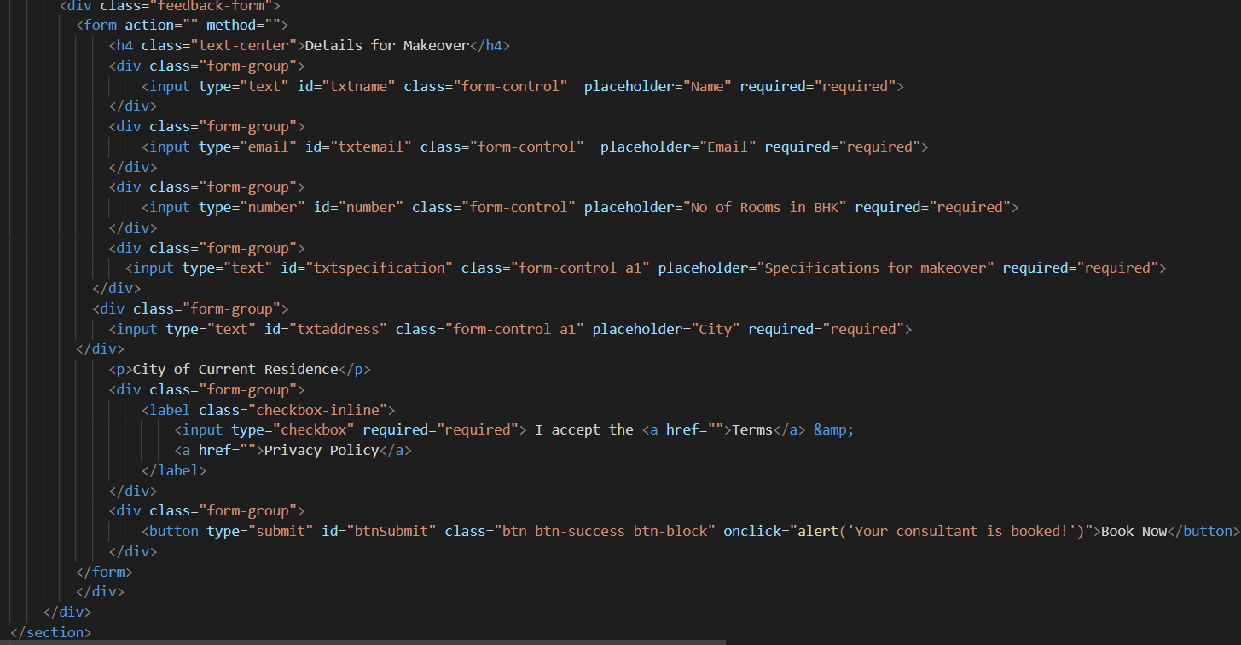

Fig: 7.9.2

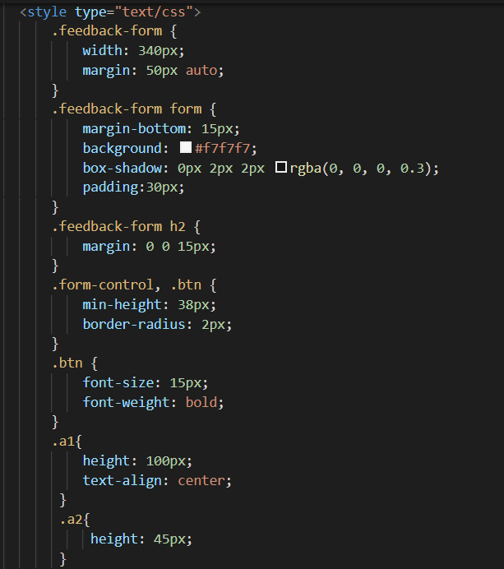

Fig: 7.9.3

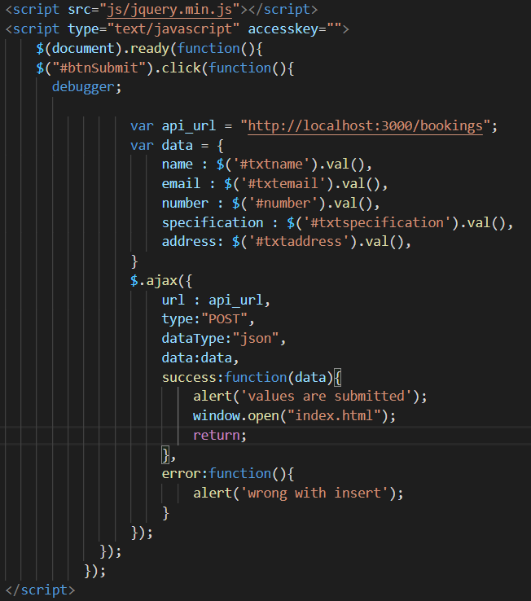

Fig: 7.9.4

**Wireframe for Booking Page:**

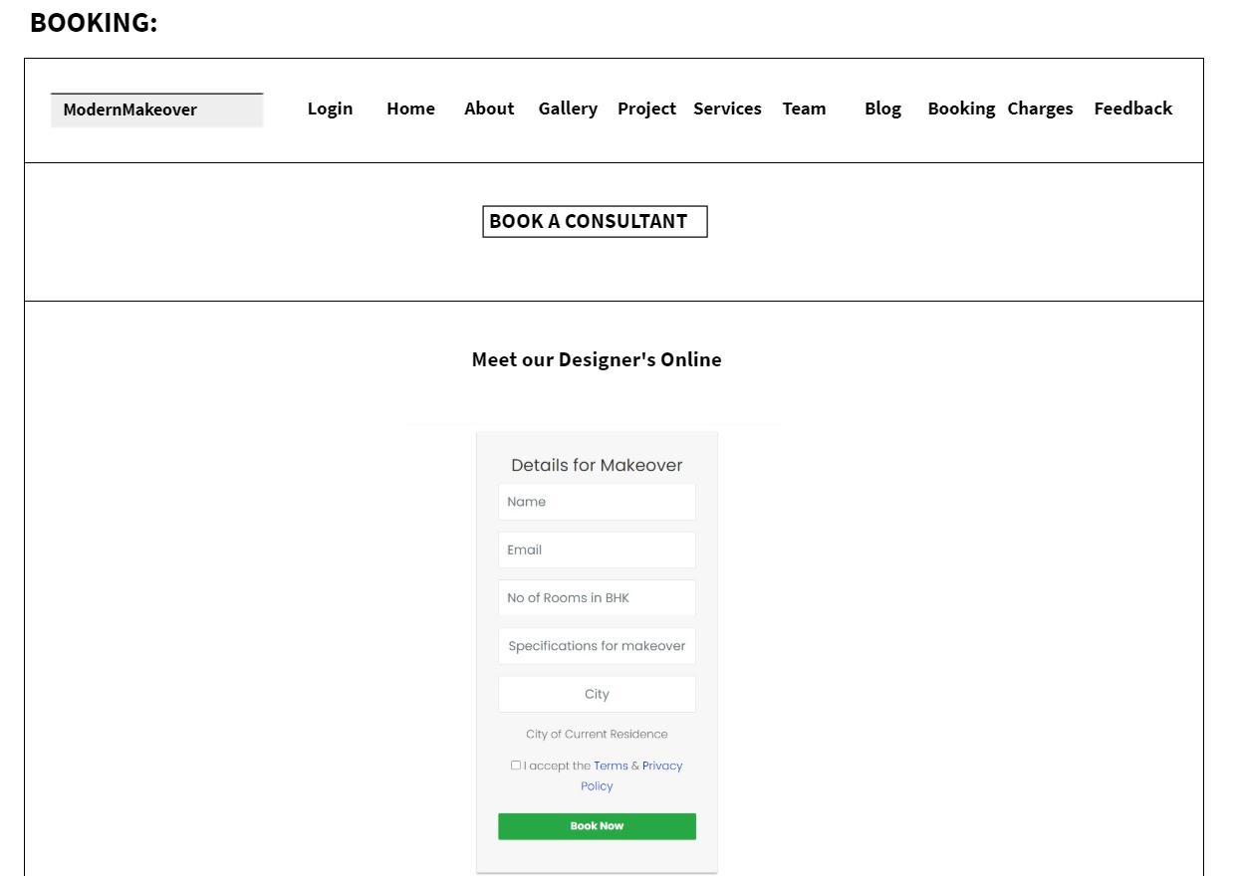

Fig: 7.9.5

Output:

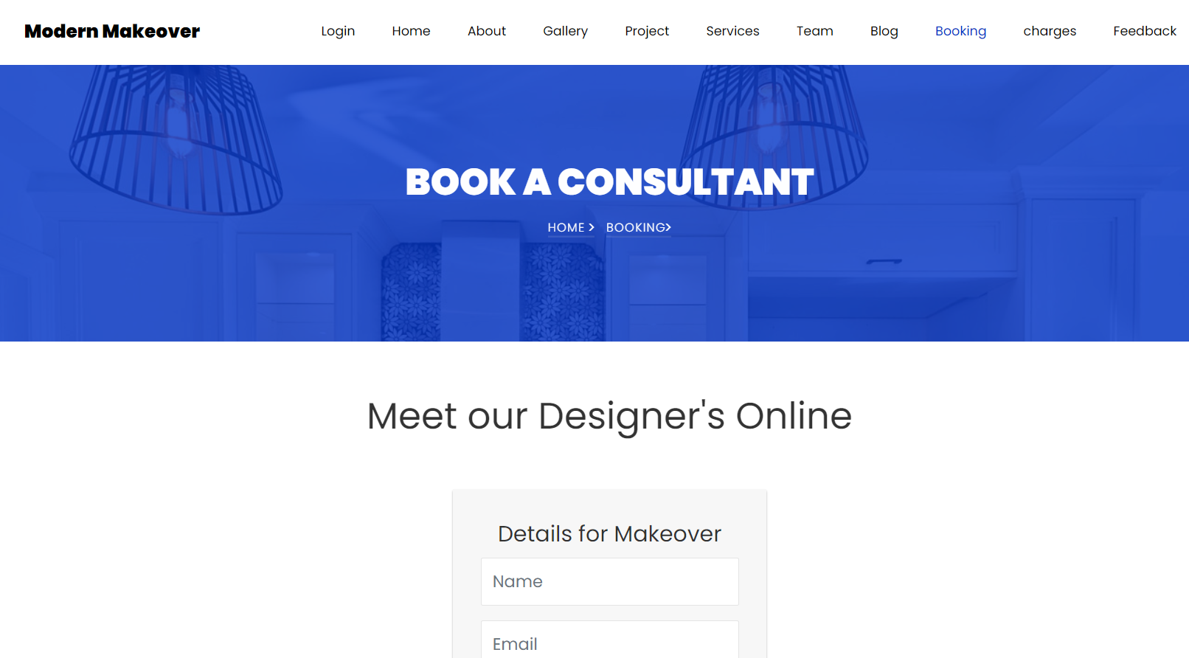

Fig: 7.9.6

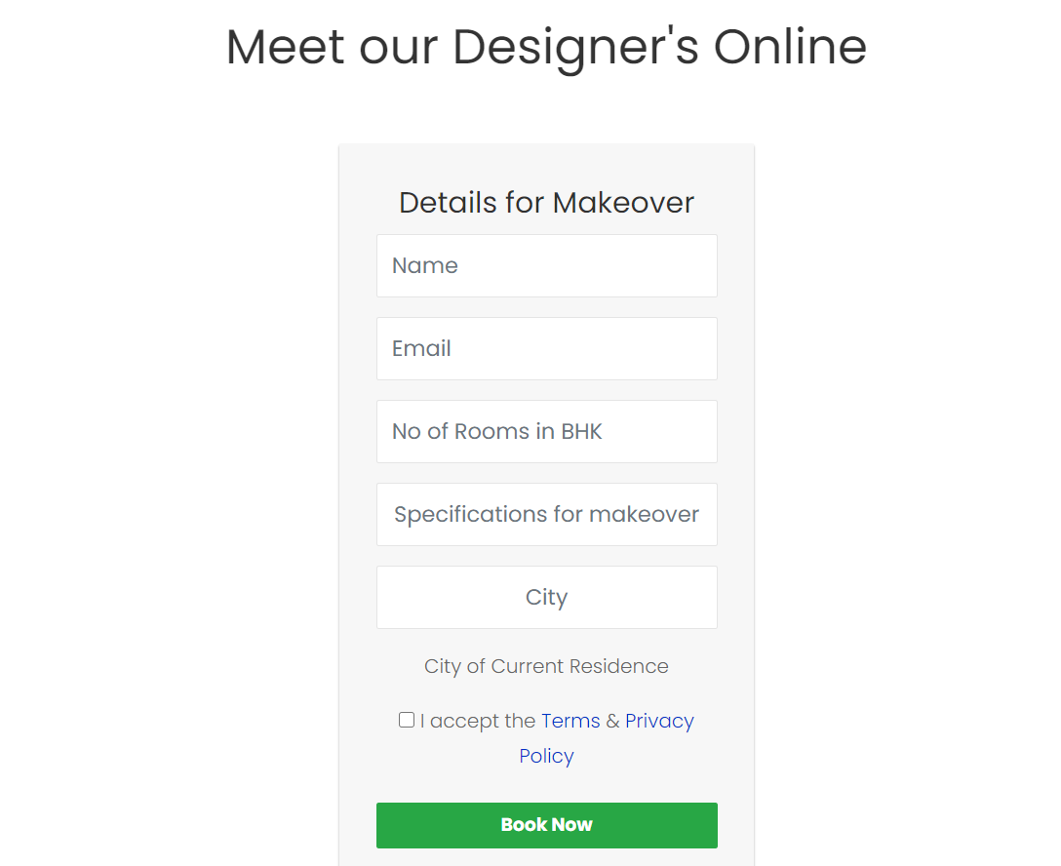

Fig: 7.9.7

**CHARGES PAGE:**

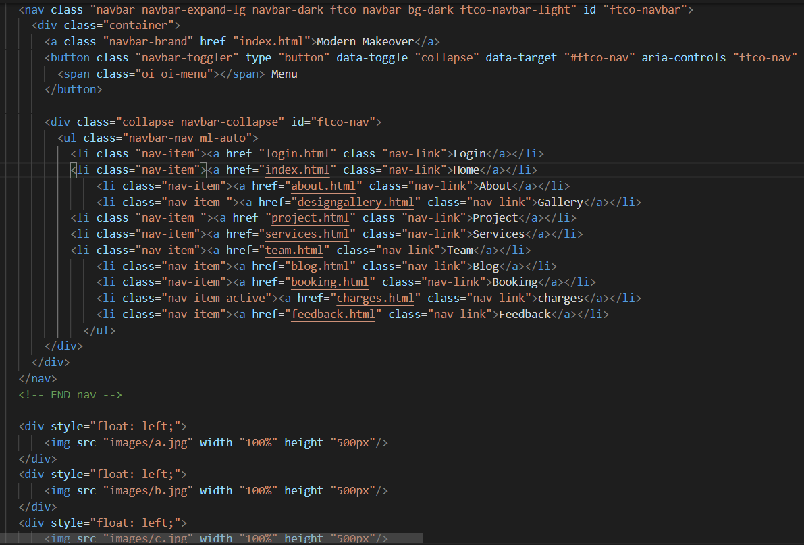

Fig: 7.10

**Wireframe for Charges Page:**

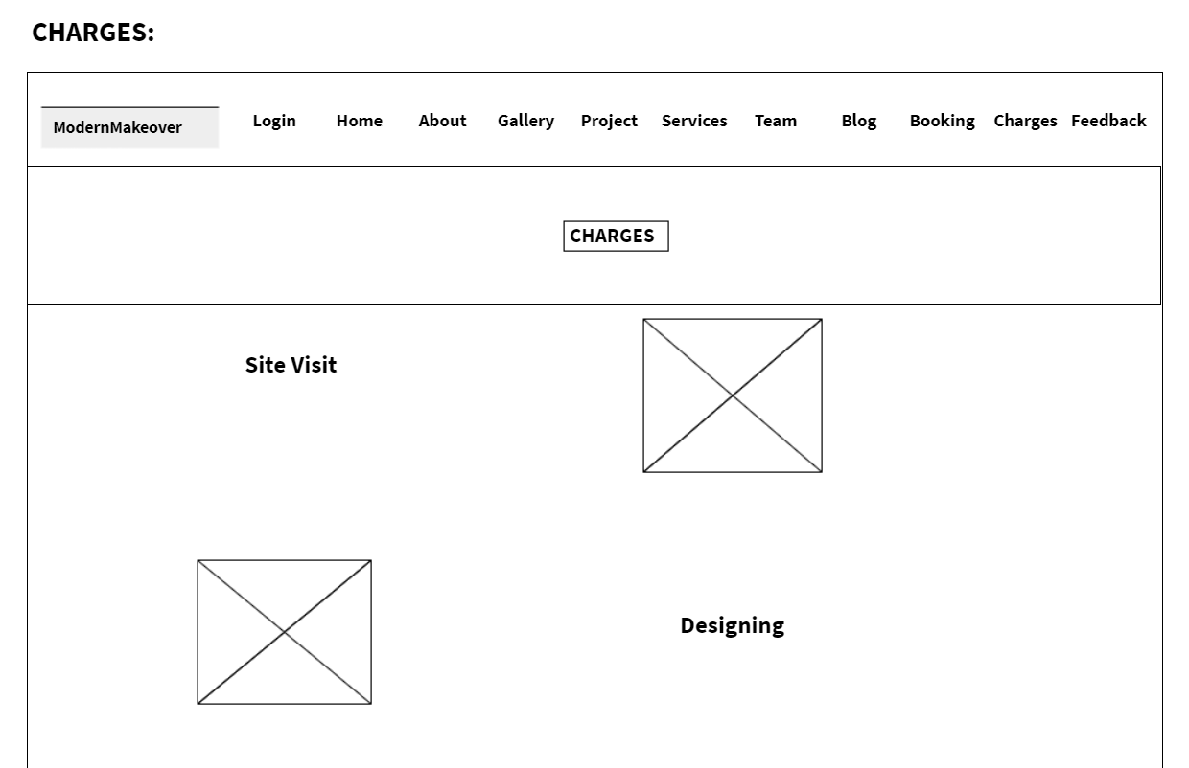

Fig: 7.10.1

Output:

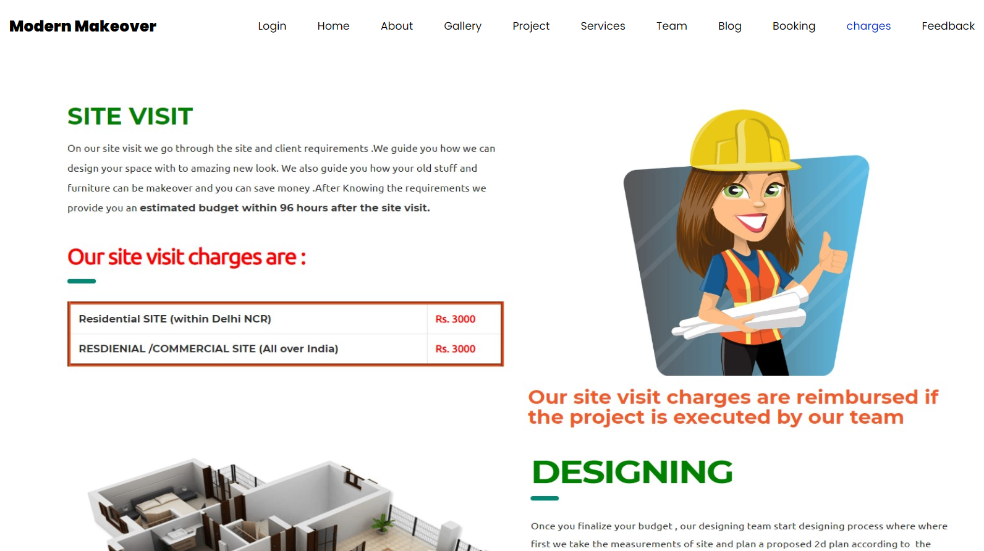

Fig: 7.10.2

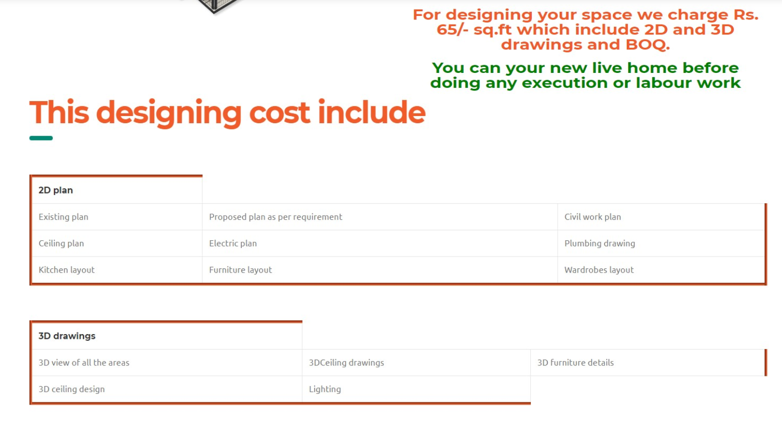

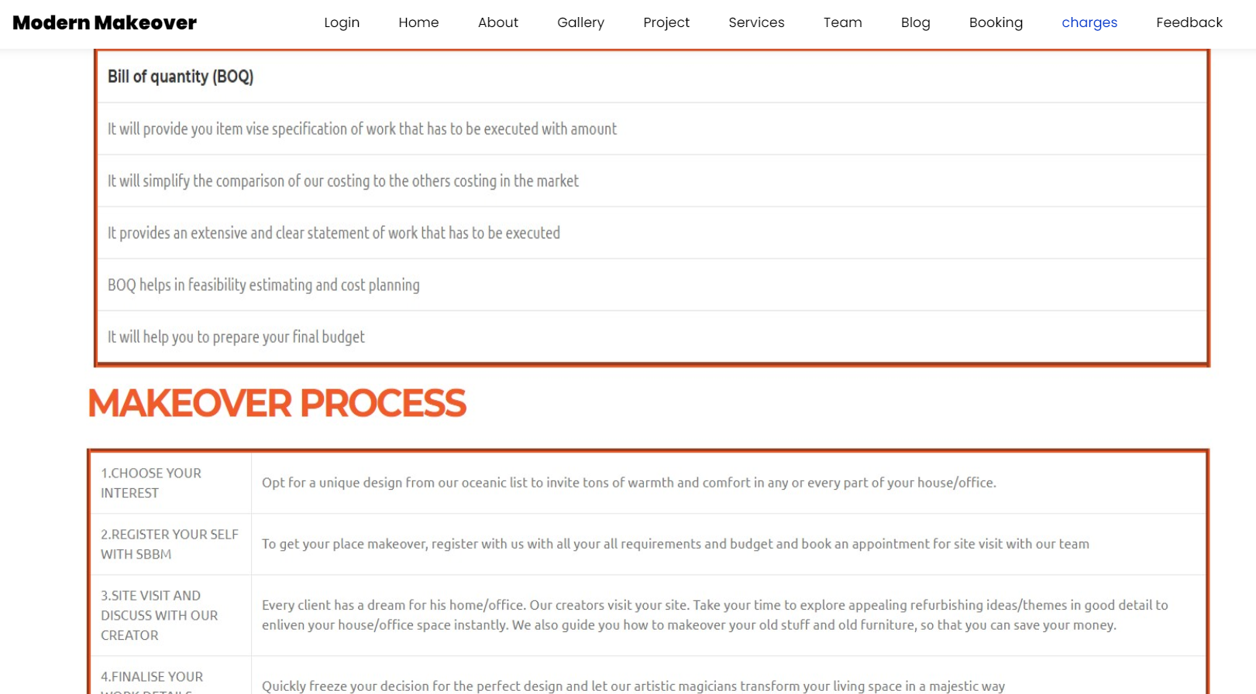

Fig: 7.10.3

**FEEDBACK PAGE:**

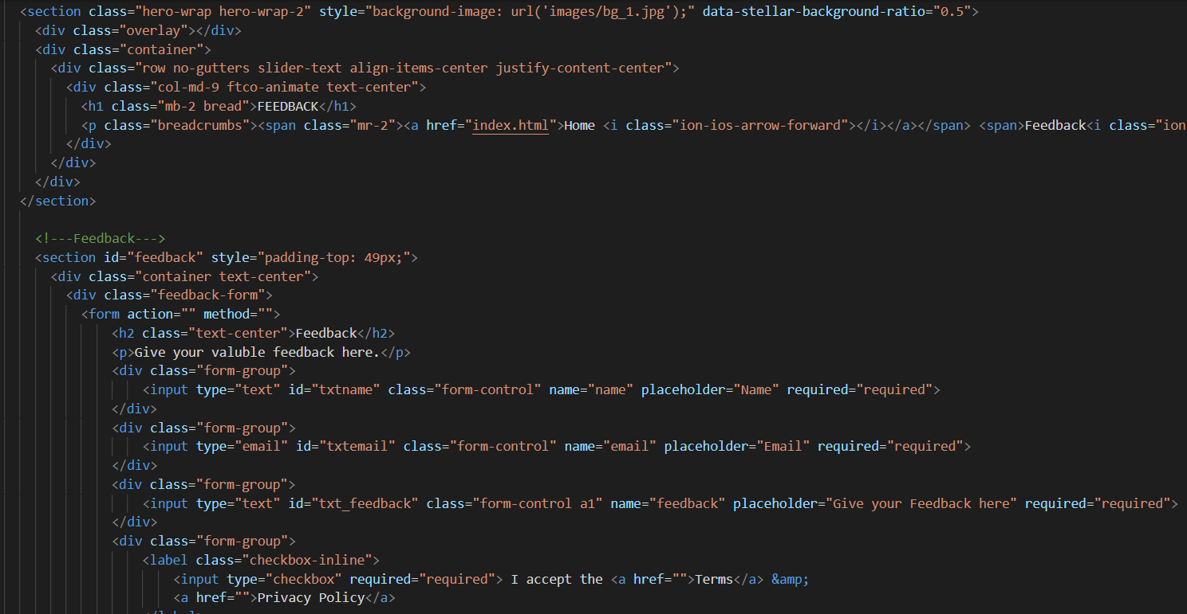

Fig: 7.11

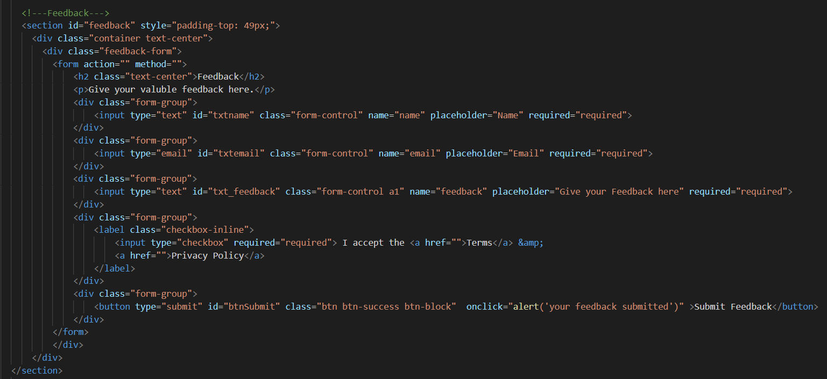

Fig: 7.11.1

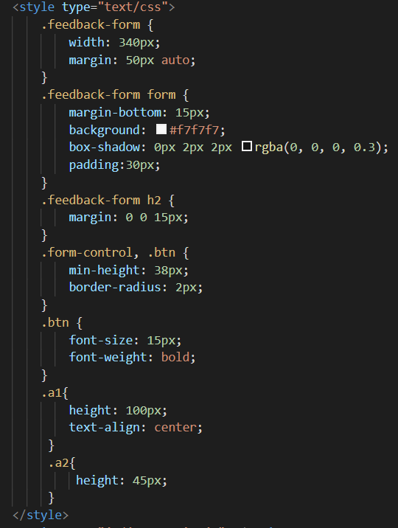

Fig: 7.11.2

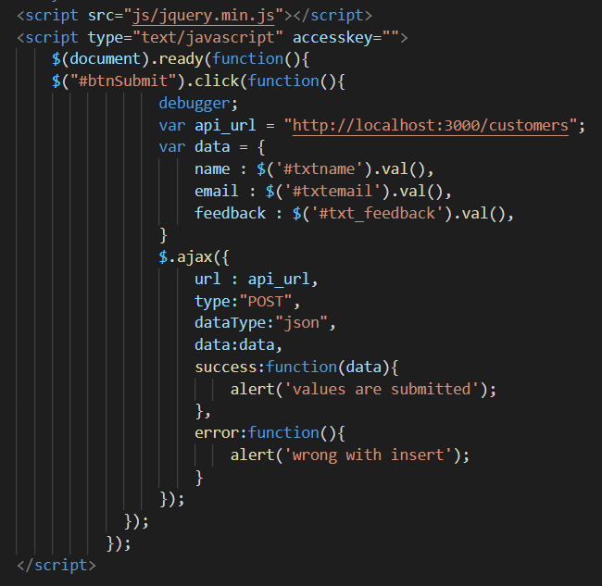

Fig: 7.11.3

**Wireframe for Feedback Page:**

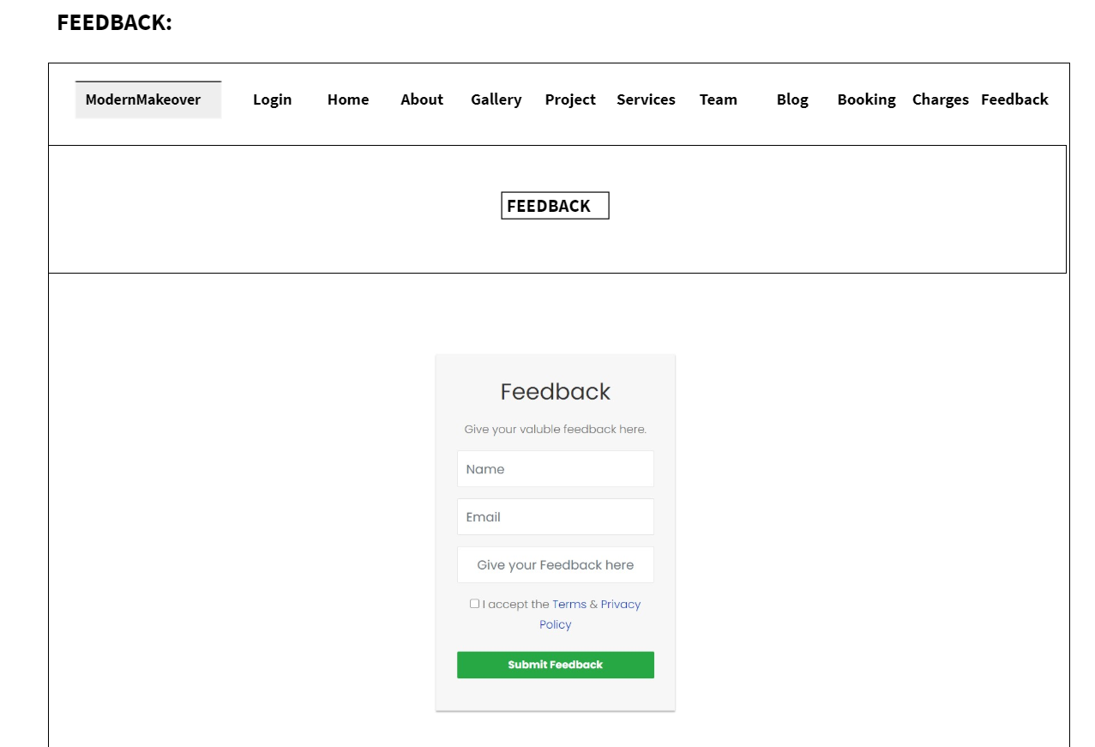

Fig: 7.11.4

Output:

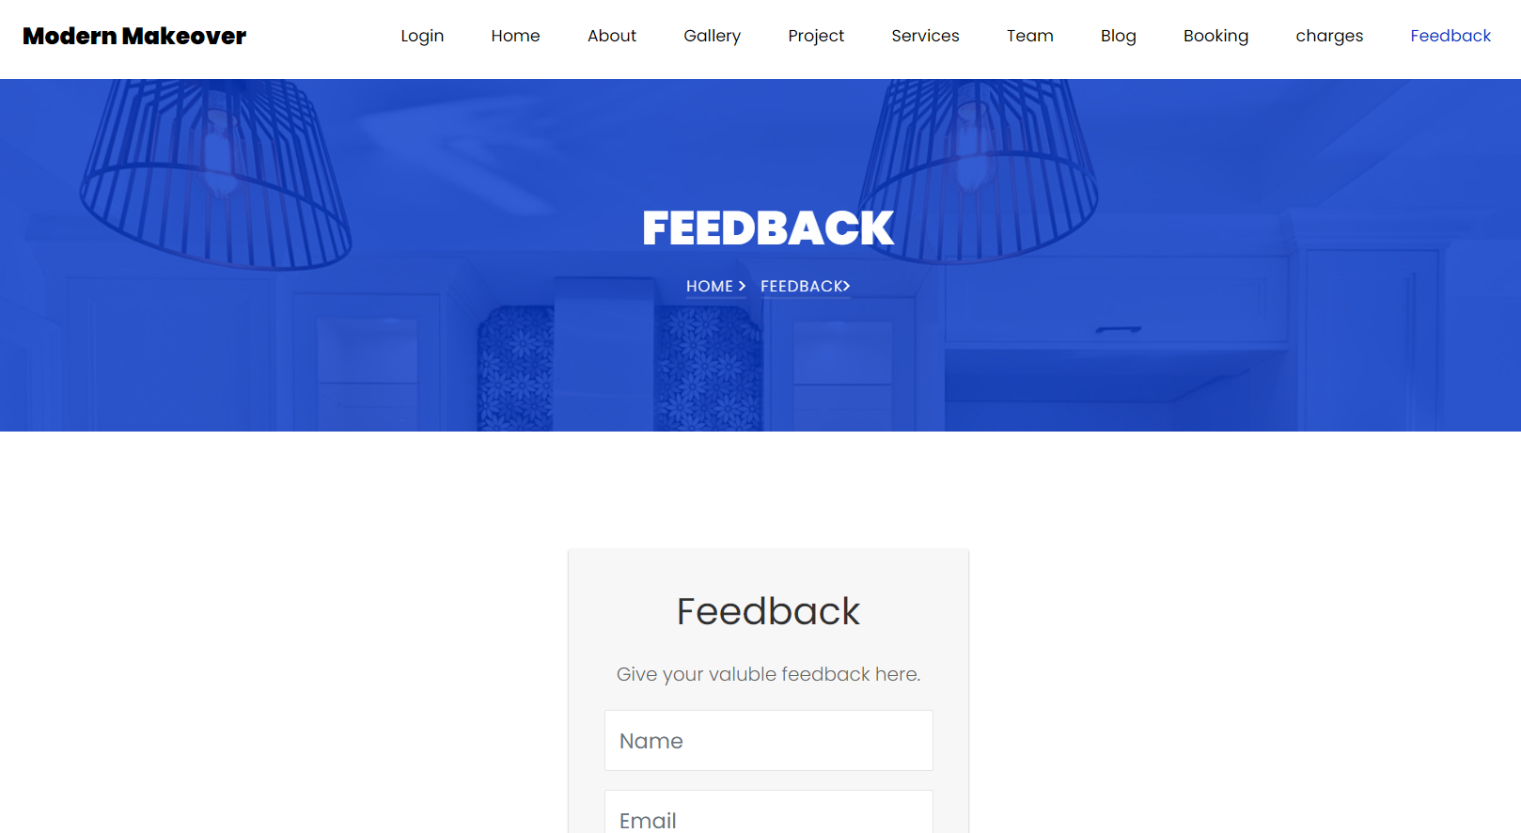

Fig: 7.11.5

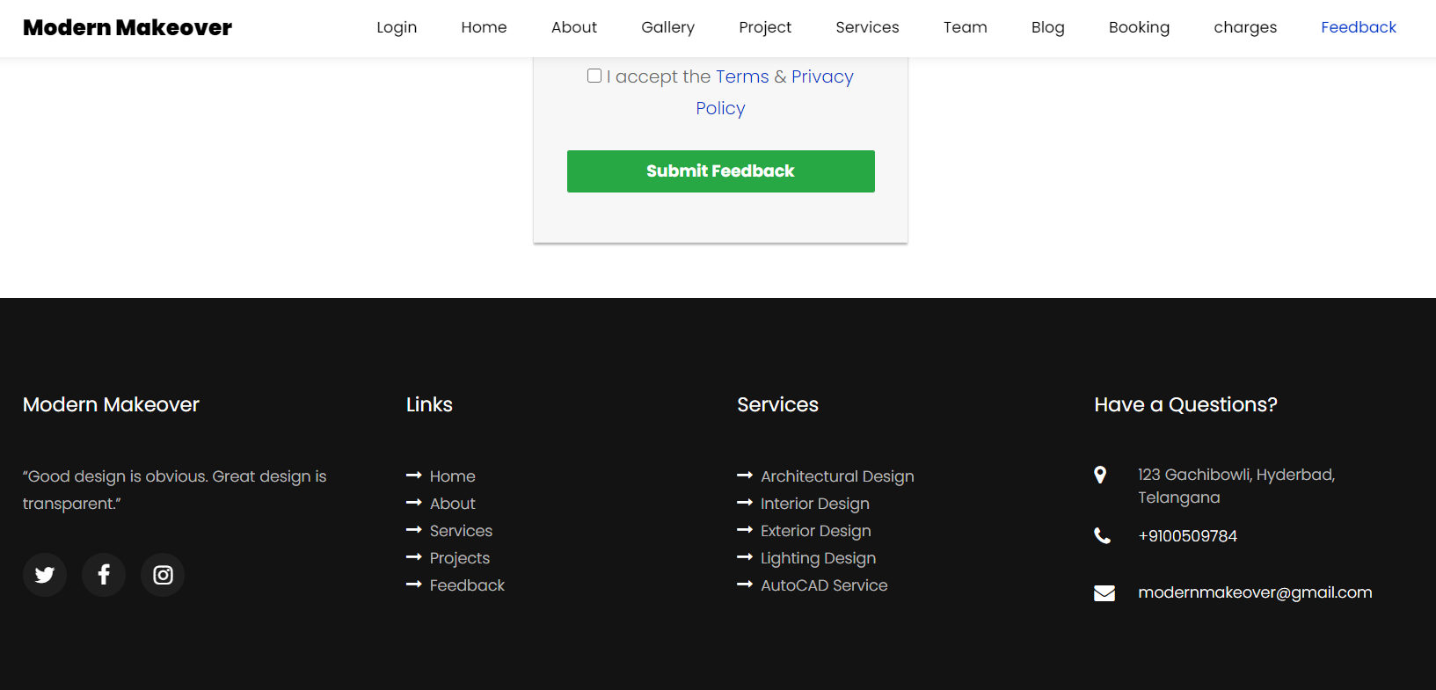

Fig: 7.11.6

**BACKEND (Nodejs):**

**Db.config.js**

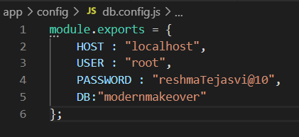

Fig: 7.12

**CONTROLLER:**

**Booking.controller.js**

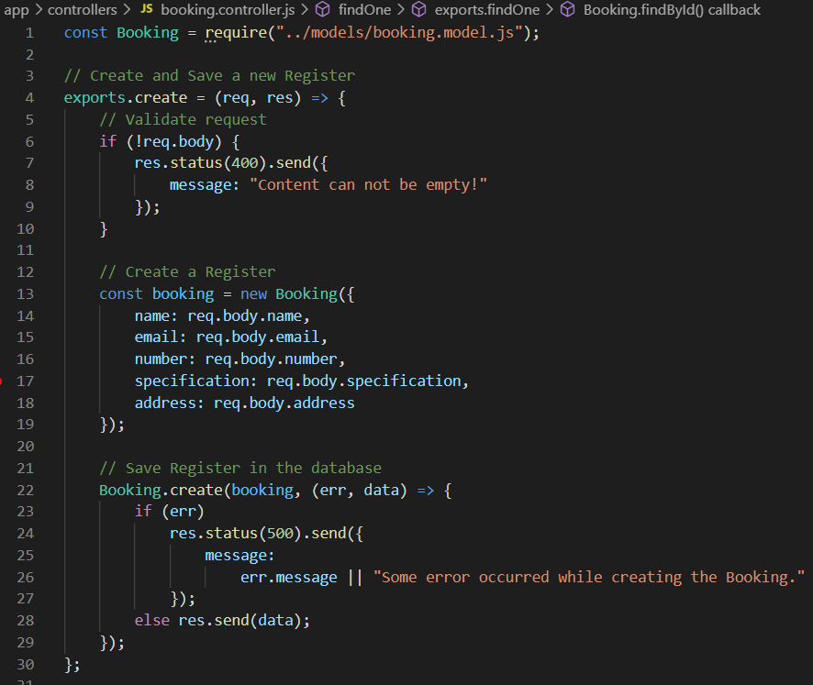

Fig: 7.12.1

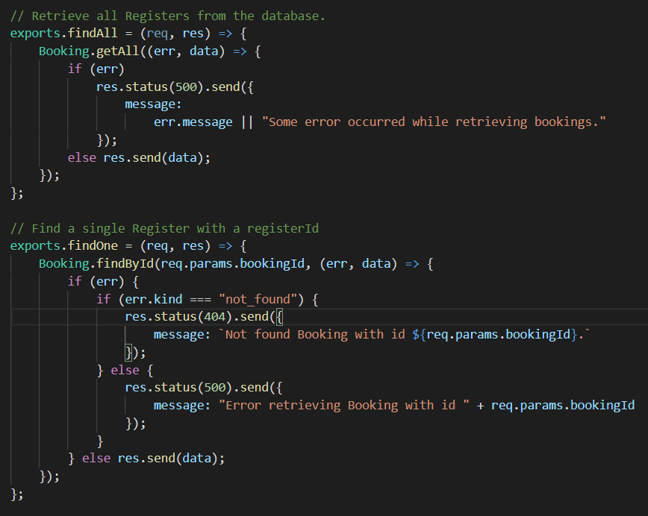

Fig: 7.12.2

**Customer.controller.js**

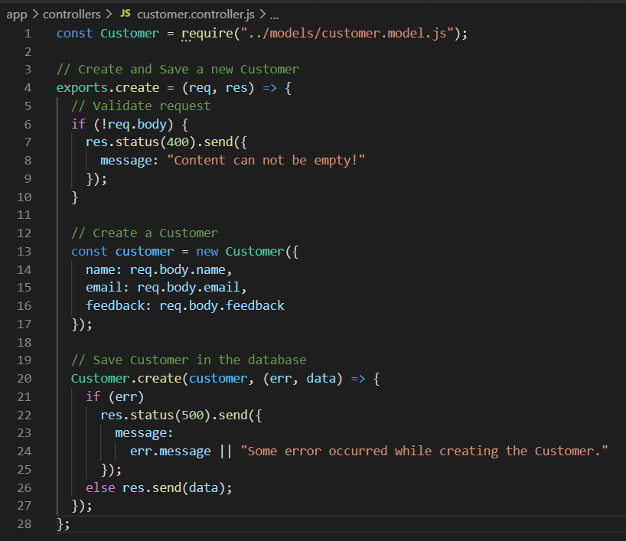

Fig: 7.12.3

**Logindetail.controller.js**

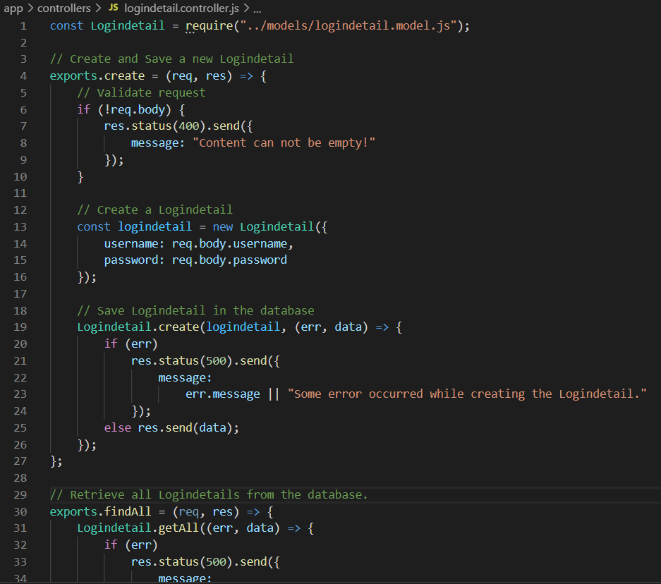

Fig: 7.12.4

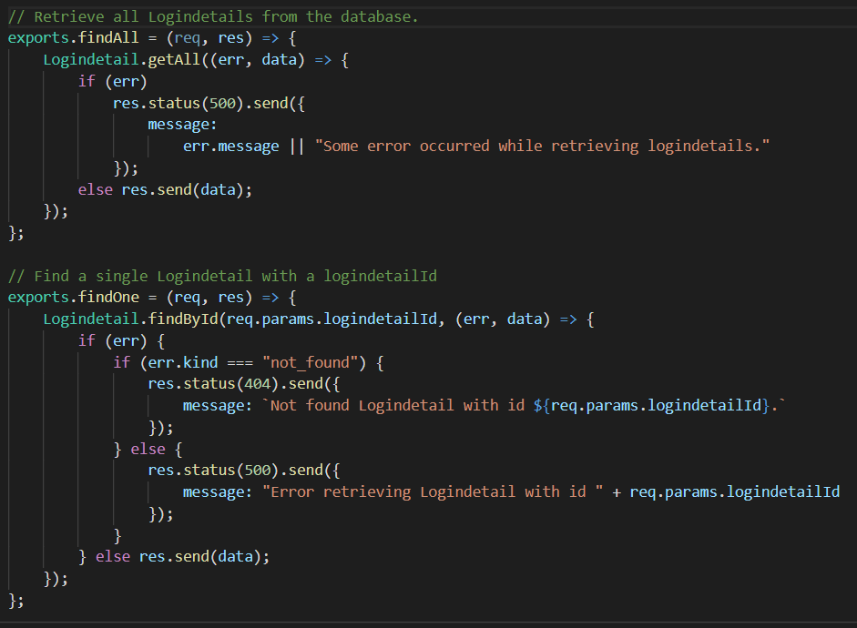

Fig: 7.12.5

**Register.controller.js**

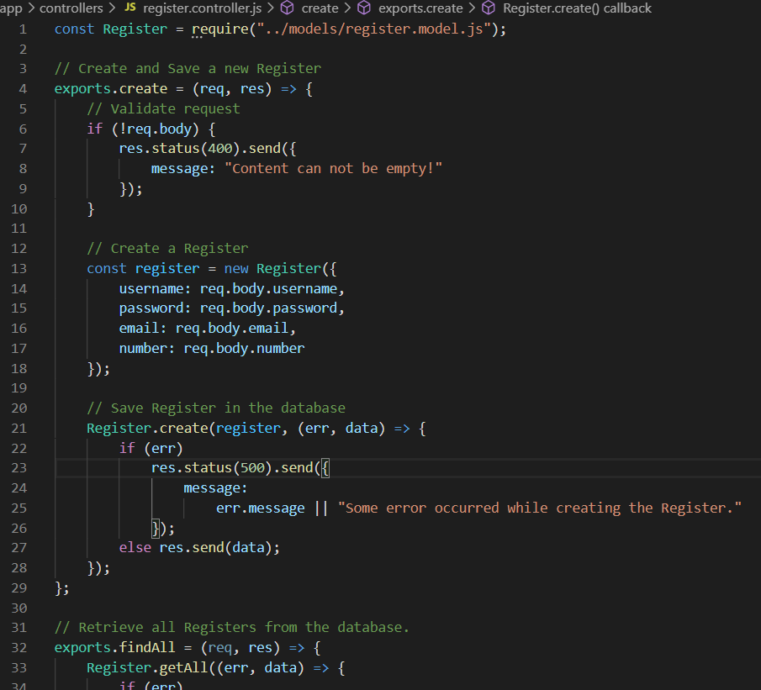

Fig: 7.12.6

**MODELS:**

**Booking.model.js**

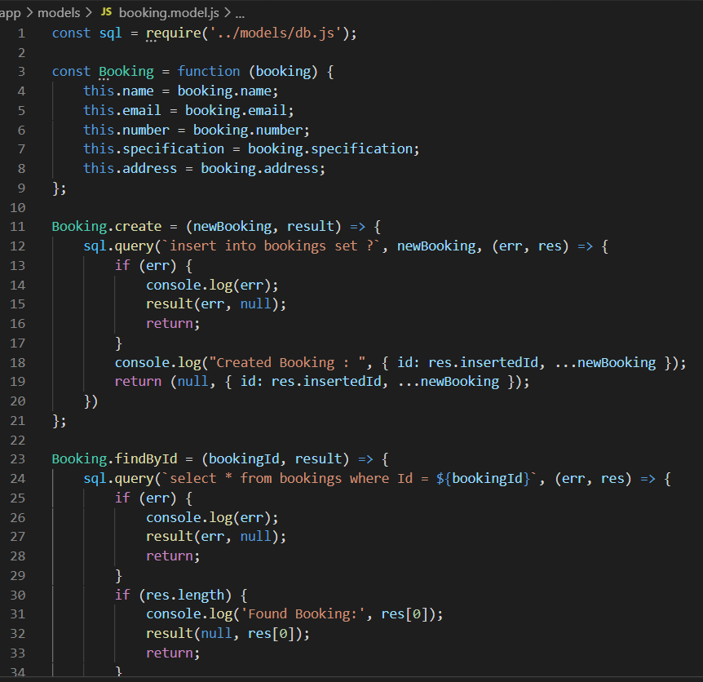

Fig: 7.12.7

**Customer.model.js**

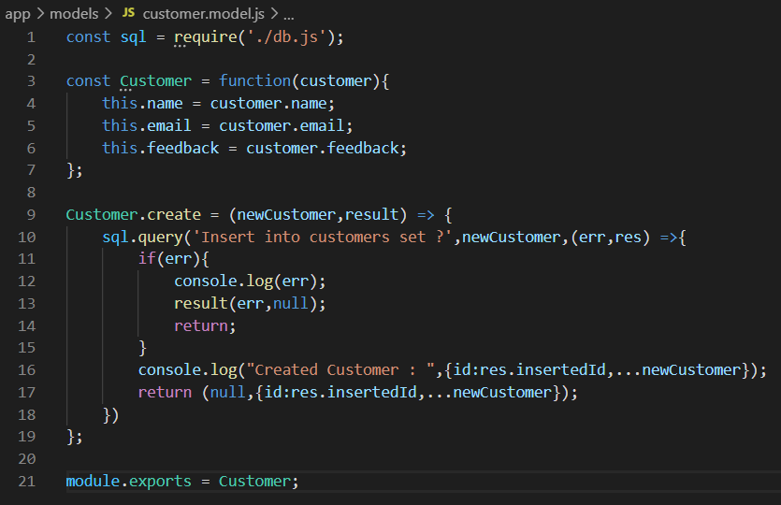

Fig: 7.12.8

**Db.js**

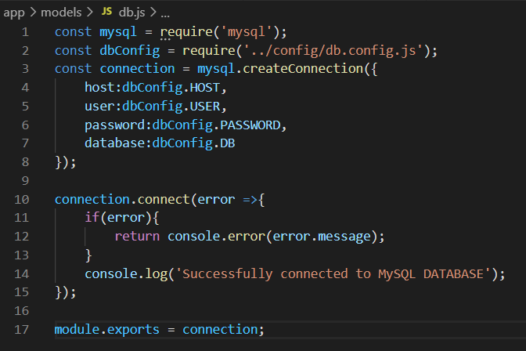

Fig: 7.12.9

**ROUTES:**

**Booking.routes.js**

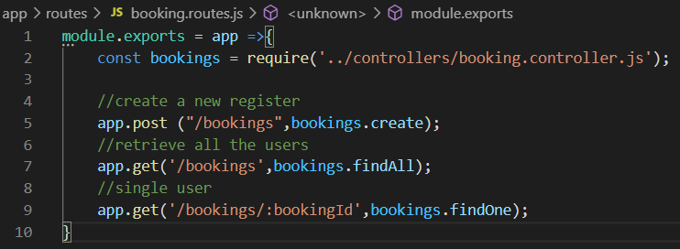

Fig: 7.12.10

**Logindetail.routes.js**

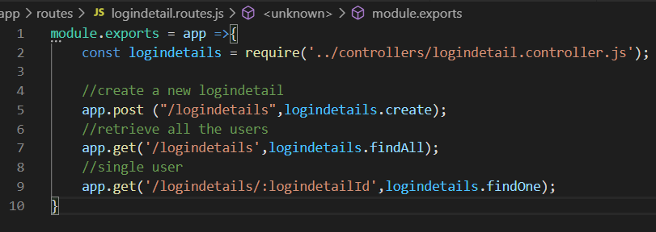

Fig: 7.12.11

**Register.routes.js**

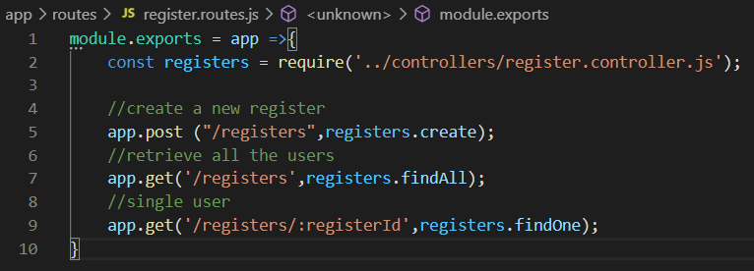

Fig: 7.12.12

**Using Database:**

**Creating a Database:**

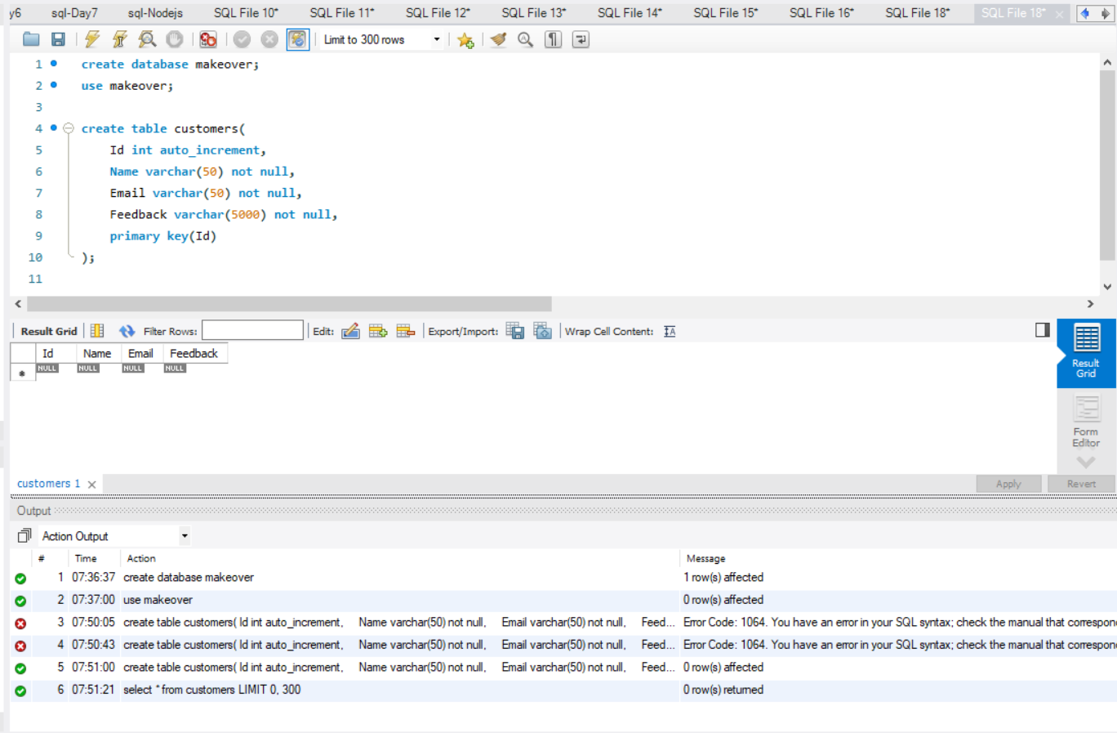

Fig: 7.13

**Creating a Feedback Table and inserting the values:**

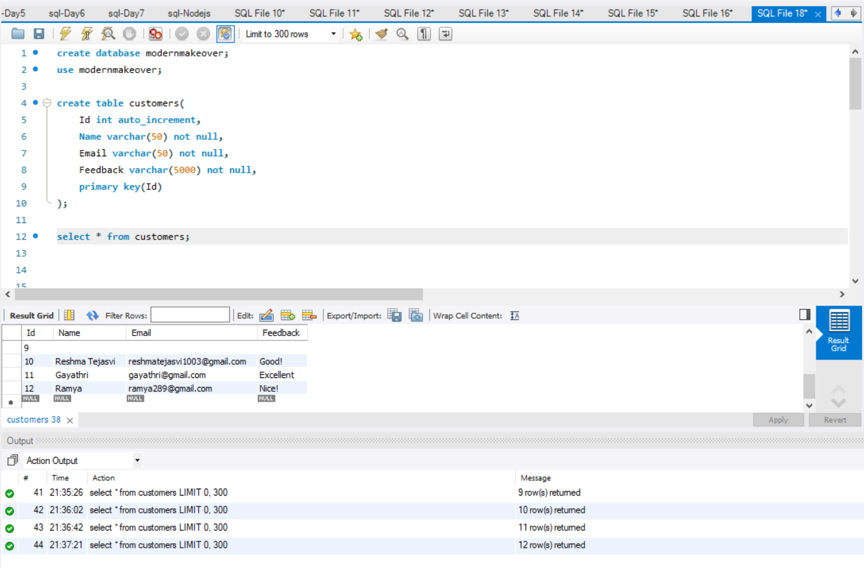

Fig: 7.13.1

**Creating a consultant booking table and inserting the values:**

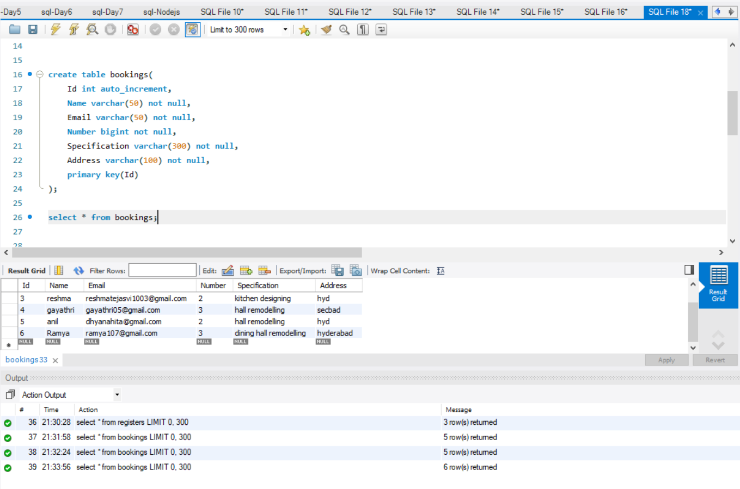

**Creating a Registration Table and inserting the values:**

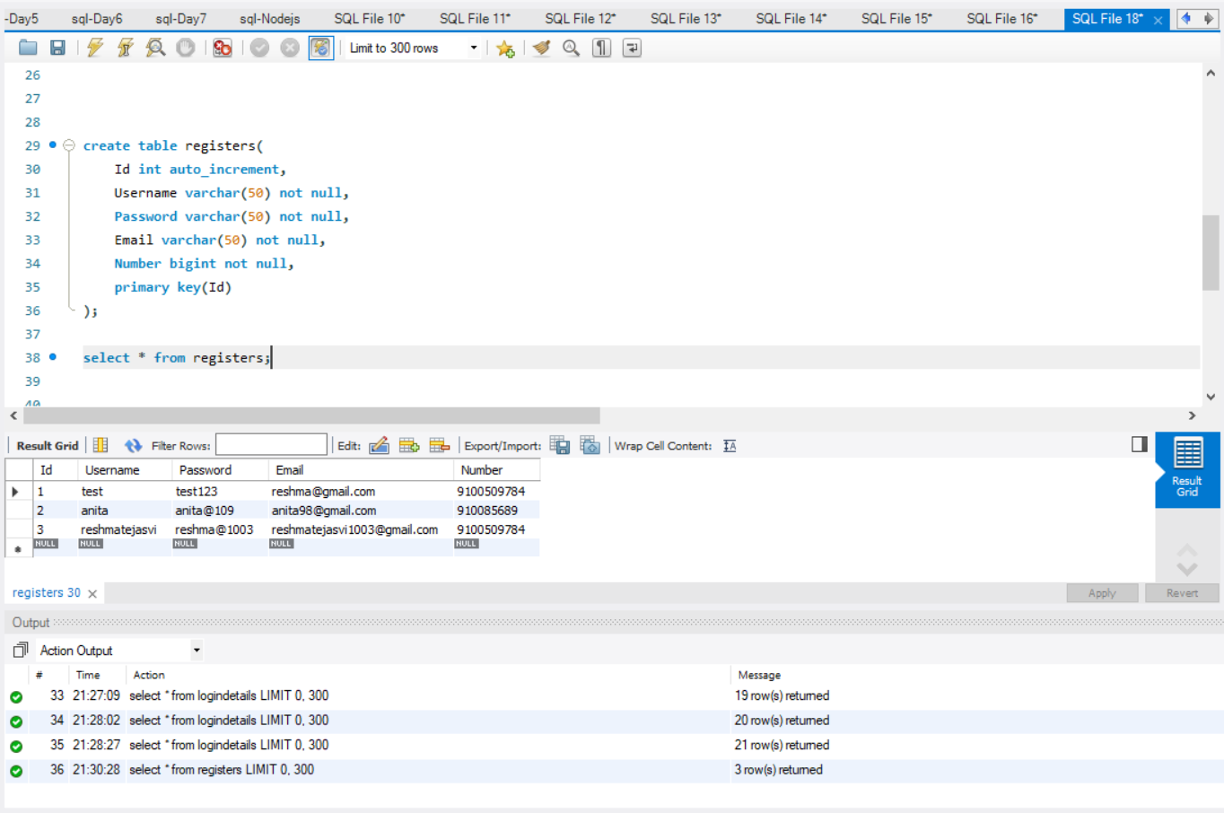

Fig: 7.13.2

**Creating a Login table and inserting the values:**

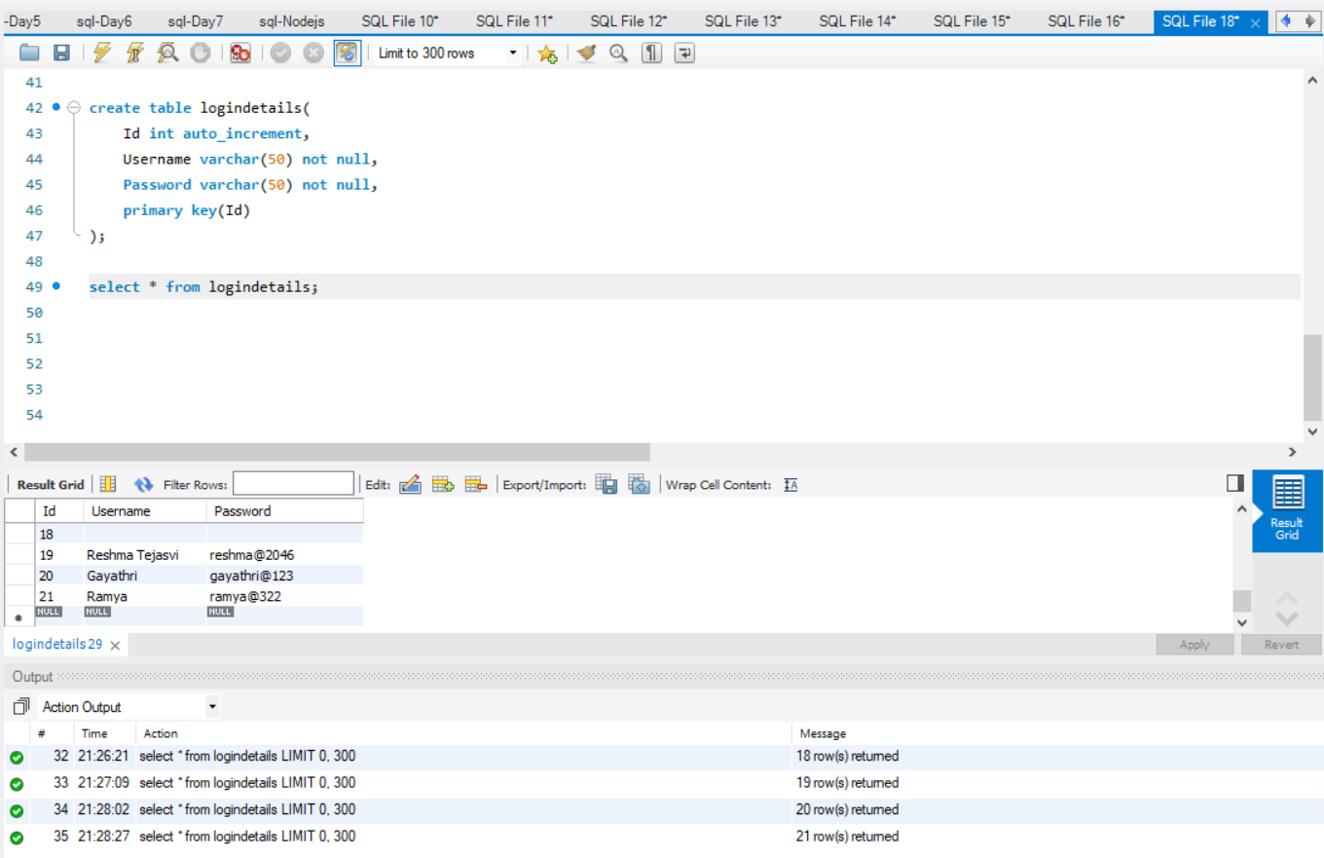

Fig: 7.13.3

**UML DIAGRAM:**

**Use case diagram:**

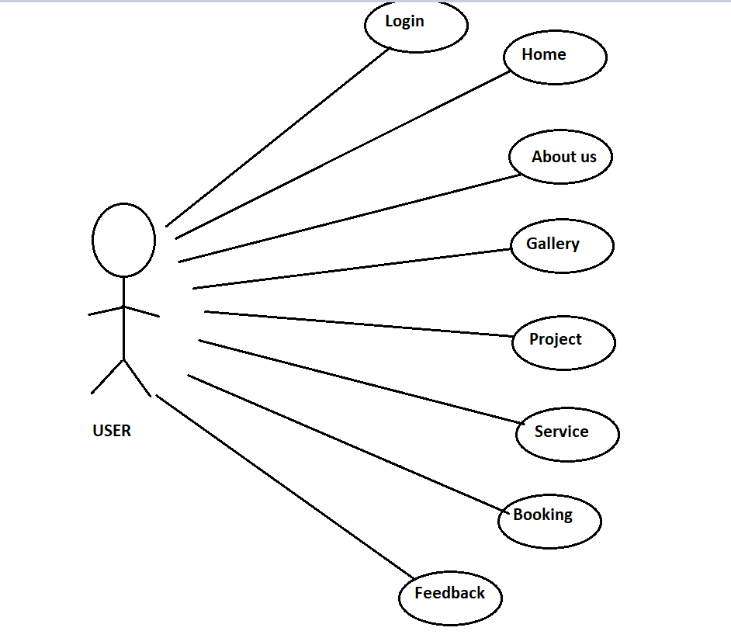

Fig: 7.14

**CHAPTER-8**

**MAINTAINANCE**

We made a lot of changes in regular intervals during the initial phase of our project to make the best we can do. The changes we did are mainly in creating the ui design as it requires the changes to better our design. We changed the whole ui design as its template is matching with some other project. We tried and made a lot of changes to make our design look fulfilled without missing anything. During the final stage of our project we made our backend. As backend is made in the final stage, we didn’t change anything because no changes are required. We don’t want to make anything complex so we didn’t change our backend. We also used the tools of the latest version by updating the available tool to make our work fast. We used the latest versions of MySQL and visual studio code to get the advanced information about it. We also made minor changes in our project documentation to look unique. The one complex change we made is we changed entire ui design to be the best. We also used an application named postman to check for backend so that our user should not find any difficulty while he is using it. If we want users to like our software, we should design it to behave like a likeable person: respectful, generous and helpful.

**CHAPTER-9**

**FUTURE SCOPE & ENHANCEMENT**

**PROJECT NAME:**

**MODERN HOME MAKEOVER WEBSITE**

* Our project will help each and every person to find the home makeover via our website.
* We are going to develop more creative ideas so that we will reach our customers choices in an accurate manner.
* We are going to enhance our interior design makeover in more modern way.
* In near future you can have the fully modern makeover interiors just by one click.

**CHAPTER -10**

**CONCLUSION**

We tried our best to design our website successfully. The main reason to complete this site is the tools we used. We wish we could take this site to the next level. We mainly concentrated on administration and end users because satisfying end user and administration is very important, but this is not enough we need to makeover many homes and make our customers more satisfied.

BIBLIOGRAPHY

* 1. www.getbootstrap.com
  2. [www.jquery-ui.com](http://www.jquery-ui.com)
  3. [www.fontawesome.com](http://www.fontawesome.com)
  4. [www.wikipedia.com](http://www.wikipedia.com)
  5. [www.w3schools.com](http://www.w3schools.com)
  6. [www.youtube.com/html](http://www.youtube.com/html)